University of New Mexico
2017-2018 Lobo Reading Experience
Just Mercy by Bryan Stevenson

Department of English - Core Writing Program
ENGL 110-111: Interview + Rhetorical Analysis + Profile Sequence
Created by Sofya Tarabrina

ENGL 110-111: Interview + Rhetorical Analysis + Profile Sequence
This sequence is aimed at raising students' awareness of the problems of prisoners. The author of Just Mercy, being an “undecided” lawyer, had no idea of what takes place on death row until he got the task to go there and deliver news to a prisoner. Likewise, many people have no idea of prisoners' problems until it becomes the fact of their own biography in one way or another. But even if it never concerns a person and/or one’s family directly, we need to understand that we are all connected and should support each other.

Skills to develop:
1. To read, understand, and analyze the narrative of Just Mercy, and discuss it in class (SLO A – “reflect on arguments”).
2. To conduct interviews (all steps: organization of the interview, preparation of questions, processing of the information, presentation of the information.) (SLO B - to take into account “the social nature of composing”)
3. To make rhetorical analyses of websites (SLO A – “compose … in a variety of genres”).
4. To make profiles of persons and organizations (SLO A – “compose … in a variety of genres”).
5. To work with ENGL 110 SLOs (all, except I and J.)

MWA 2 – an organization’s profile - asks students to make a complete profile of an organization that serves prisoners, former prisoners, and their family members in Albuquerque. Here the students will use the material from their SWAs. This profile is meant for publishing in a local newspaper for the purpose of attraction of the public's attention to the problems of prisoners and their family members.

SWA 3 - an interview write up plus a person's mini profile - asks students to interview staff of an organization in Albuquerque that helps prisoners, former prisoners, and their families (these organizations can be easily found via Google.) This organization should have a website that needs to be studied during the preparation to the interview. Having studied the activity of this organization through the website, students make a call or visit the organization and arrange an interview. After that, they come up with a set of questions for a worker of the organization based on the activities of the organization and of concrete duties of their interviewee and personal interest. The results of the interview should be summed up in an interview write up that begins with a mini profile of the interviewee.

SWA 4 - Rhetorical Analysis of the Website - asks students to study the website of the organization chosen for their SWA 3 and to analyze it rhetorically from a certain angle (angle should also be chosen: if the problem this organization deals with is really a serious one; does it make sense to make a donation to this organization; would you prefer to come to this organization for help if you and your family have this problem, etc.)

Sequence 2: Profiles (Course Calendar)

Week | Date | In-class topic | Reading Due | Assignment Due
Week 1 | Monday  / | Intro to Sequence 2  Intro to Just Mercy by Bryan Stevenson  “Walter McMillian on 60 Minutes”  https://www.youtube.com/watch?v=shzMjyuijRU  Intro to SWA 3 | “Introduction” Just Mercy (on Learn)
 | Wednesday  / | Interviews  “Katie Couric on How to Conduct a Good Interview”  https://www.youtube.com/watch?v=AZTGcx8hmIo&feature=youtu.be | Creating Good Interview Questions  http://owl.english.purdue.edu/owl/resource/559/06/  Performing Interviews  http://owl.english.purdue.edu/owl/resource/559/04/  Example Interview Transcript  http://www.u.arizona.edu/~kimmehea/purdue/421/exampleinterview.htm
 | Friday  / | Interview Transcript  Voice-to-Text Software (Dragon, etc.)  Interview Write-Up | Interview Transcription Guidelines  (see Appendix 1)  Sample Interview Write Up (see Appendix 2)
Week 2 | Monday  / | Choosing a Style |  | REVEL Chapter 17  Deadline for conducting the interviews
 | Wednesday  / | Work Time |  | SWA 3 is due by midnight via Learn  REVEL Chapter 17 Quiz
 | Friday  / | Rhetorical Analysis | SWA4 prompt on Learn  Rhetorical analysis of Match.com (WT, Ch. 9, p. 138-139) | REVEL Chapter 9
Week 3 | Monday  / | Inventing Ideas and Prewriting |  | REVEL Chapter 15  REVEL Chapter 9 Quiz
 | Wednesday  / | Organizing and Drafting |  | REVEL Chapter 16  First draft of SWA 4 is due by midnight to your peer’s email
 | Friday  / | SWA 4 Peer Review (in-class discussion)  Work Time |  | At-home peer review of SWA4  REVEL Chapter 15 Quiz  REVEL Chapters 16 Quiz
 | Saturday  / |  |  | SWA 4 and peer review follow up are due by midnight via Learn
Week 4 | Monday  /6 | Intro to MWA 2  Profiles  Features of a Profile | MWA2 prompt on Learn  Brother, Life Coach, Friend (WT, Ch. 9, p. 69) | REVEL Chapter 6
 | Wednesday  / | Profiles. Continuation | The Serial Rapist Is Not Who You Think (Writing Today, p. 79-81) | REVEL Chapter 6 Quiz
 | Friday  / | Profiles. Continuation | “Introduction” Just Mercy (on Learn)
Week 5 | Monday  / | Presentations |  | Get ready with your presentations of your organizations
 | Wednesday  11/15 | Presentations |  | Get ready with your presentations of your organizations  First draft of MWA 2 is due by midnight to your peer’s email
 | Friday  11/17 | Presentations |  | Get ready with your presentations of your organizations  At-home peer review of MWA2. Email your review back by midnight.
 | Saturday  11/18 |  |  | MWA 2 and peer review follow up are due by midnight via Learn

Day by Day Calendar (chronological)
Week 1 M: / Intro to Sequence 2. Lobo Reading. Intro to SWA 3.

SLO B: Students get acquainted with a book that has a strong social message and learn how writing can enhance the world-changing effect of actions; they also learn that to write something really strong and mind-shaping, one needs to be part of it; that is, to write a good profile on a resource, one should be highly interested in this resource and be really inspired by it.

- Class Discussion on Sequence 2 and Just Mercy (15 minutes):
- What is Lobo Reading (http://lre.unm.edu/);
- Bryan Stevenson and his book (www.bryanstevenson.com): he received numerous awards for his civil rights activity, and his book is a widely recognized bestseller;
- The problems raised in the book
- What are your impressions of the book? (based on the “Introduction”)
- The structure of the book;
- “Walter McMillian on 60 Minutes” (24 minutes): the main characters of the book in the flesh plus the main plot of the book
https://www.youtube.com/watch?v=shzMjyuijRU
- The problem of death row prisoners who were sentenced due to insufficient legal support and prejudice towards the black population is just one problem in the American penal system. But there are many more. Your task for this sequence is to find an organization in Albuquerque that helps prisoners, former prisoners, and their families. The problem this organization deals with should be important personally to you (or even relevant to this or that extent). Also, it has to have a website.
- SWA 3: to read individually (3 minutes), them discuss in groups questions and confusions.
- Class Discussion of SWA 3 (5 minutes).

H/W:
On the Internet, look through the websites of organizations in Albuquerque that deal with the problems related to the American penal system and to choose one of them to work with for this sequence.
Read on Learn:
Creating Good Interview Questions
http://owl.english.purdue.edu/owl/resource/559/06/

Performing Interviews
http://owl.english.purdue.edu/owl/resource/559/04/

Example Interview Transcript
http://www.u.arizona.edu/~kimmehea/purdue/421/exampleinterview.htm

Week 1 W: / Interviews

SLO A: Students continue studying the genre of interview, this time learning about the peculiarities of the very process of conducting inteviews; besides, new aspects of the interview genre come into the limelight – an interview transcript and an interview write-up – with their own features and technologies.

- Class Discussion on Interviews (Have you ever conducted an interview or been interviewed yourself? What were the challenges? – (write them on the board); creating good interview questions http://owl.english.purdue.edu/owl/resource/559/06/ (10 minutes).
- Practicing interviews with a partner (15 minutes).
For this assignment,
1) you need to have a brief talk with your partner about the resources for convicts and their families. The resources that you have chosen will be the topics of your interviews.
2) think of the questions you will ask him/her during the interview (5 minutes). You should come up with around 10 questions that would help you understand what exactly this resource offers.
3) interview each other in turn and briefly write down the answers.
4) discuss challenges.
- Class Discussion on challenges (5 minutes).
- Class Discussion on Performing Interviews
http://owl.english.purdue.edu/owl/resource/559/04/: to write the main points on the board (5 minutes).
- Katie Couric on How to Conduct a Good Interview (5+5 minutes).
https://www.youtube.com/watch?v=AZTGcx8hmIo&feature=youtu.be
During: Take notes on what you find new or different about interviewing, unlike what you have just learned.
After: What can we add to what we already know? (creating good interview questions, overall preparation, and the actual conducting?)
- Questions?

H/W:
- Come up with your interview questions.
- Arrange and conduct an interview with a worker of the chosen organization (the deadline for conducting interviews is Tuesday).
- Interview Transcription Guidelines (see Appendix 1)
- Sample Interview Write Up (see Appendix 2)

Week 1 F: 10/20 Interview Transcripts. Interview Write Ups

SLO A: Students study the features of an interview write-up trying to grasp the main moves of the interviewer’s thought in the sample.

- Class Discussion on Interview Transcripts. Purpose. Interview Transcription Guidelines. (7 minutes). To record an interview is mandatory, but the transcript will help group the material according to the topics raised in it (by copying and pasting the text under different subheadings).
- Voice-to-Text Software (5 minutes) (Options: to download an app onto your devices OR, if you fail to do it for some reason, come to my office hours with your digital record and I will help you do it.)
- Group Discussion on Interview Write Up. Purpose. The difference from transcript (5 minutes). (See Appendix 2) (7 minutes).
- Class Discussion of interview write-up (5 minutes).
- Close reading of the sample interview write up from Appendix 2 (20 minutes). Features (on the board).
- Questions? (3 minutes)

H/W:
Work on interview transcripts.
Revel Chapter 17

Week 2 M: 10/23 Choosing a Style

SLO A: Students learn how to better express their ideas in writing.
SLO B: As this chapter advocates plain style, it is clear that this manner of writing serves to bring home ideas to readers more effectively. It is necessary to explain to students that they need to fight their temptation to seem smarter in their writing by using complicated style that is abundant with confusing syntax structures and words that few people know. Another error is: do not think that if your writing is clear to you, it is clear to others as well. Students should understand that if they want to be heard, they should follow certain rules that will make their writing intelligible.

- Class discussion on the main points of the chapter (10 minutes).
- Individual Work: Find a document on the Internet that demonstrates a good style. Explain to yourself why you like this style. Be specific: analyze the text on the basis of its figurative language, descriptions, or other stylistic strategies. (7 minutes)
- Group Work: Join your group members. Discuss the texts you just found. Formulate the principles of a good style you could add to the ones you read about in the chapter (7 minutes)
- Individual Work: Find a text or author that you would like to imitate. Then, when you have that text on your screen, analyze it from the position of what features you would like to reproduce in your imitation; that is, what features you would like to take to your personal arsenal of a writer. Write a recommendation to yourself. (10 minutes)
- Class Discussion: share your findings with class. Are similes and metaphors helpful in formulating the main point of your writing? (5 minutes)
- Questions?

H/W:
Work on interview transcripts.

Week 2 W: / Work Time (Interview Transcripts and Interview Write Ups)

SLO C: Students practice the process of transformation their interview transcripts into interview write ups.

SLO D: Students learn that there are cases when they should not stick to good grammar and correct it during the editing stage. Interview transcript is this very case when they should transcribe their interviewee’s speech exactly as it is. They should fight the temptation to correct spoken grammar because it reflects the individual speech of their interviewee.

Work on interview transcripts and interview write ups.

H/W:
SWA 3 is due at the end of the day by Wednesday midnight via Learn.
REVEL Chapter 17 Quiz
Revel Chapter 9

Week 2 F: / Rhetorical Analysis

SLO A: Students get acquainted with a new genre – a rhetorical analysis – and learn its main features and moves.
SLO B: Students study their campus resources websites and determine their audience. Then they try to detect how (through what means) this effect is achieved by the website creators.

- Intro to SWA 4. Group discussion of questions/confusions (5 minutes).
- Class Discussion of questions/confusions (5 minutes).
- Class discussion on the basis of the presentation (from Revel) (7 minutes).
- Close Reading of “Rhetorical Analysis of Match.com” (Revel). Features and moves on board (15 minutes).
- Individual Work (10 minutes): Go to your campus resource websites and study them for a while. Then, freewrite for 5 minutes about the intended audience of the website; why you have come to this conclusion; and what the website allows you to know about its audience. Upload your freewrite to your Reflective Journal.
- Class Discussion: Share your findings with class. Do the websites address their audience properly? Explain. (7 minutes)

H/W:
REVEL Chapter 15
REVEL Chapter 9 Quiz

Week 3 M: / Inventing Ideas And Prewriting

SLO A/C: Students discuss invention strategies that they have been familiar with before and that are new to them. These strategies will help them, in particular, to start their rhetorical analyses and, in general, any other writing in the future.

- Freewrite (7 minutes).
What kinds of invention strategies have you learned previously (at school), and what has worked for you in the past (including for this class)?
- Class Discussion: Share with the class what you have written about (5 minutes) (on board).
- Class discussion on the basis of the presentation (from Revel) (7 minutes).
- Individual Work (7 minutes): Create a concept map about your SWA4. Then, identify the one or two most interesting issues in your concept map. Put one of these issues in the middle of the next page and create a second concept map on this narrower version of the topic. Then, discuss with your partner: how has this technique changed the angle of your rhetorical analysis?
- Individual Work (10 minutes): Formulate Journalist’s Questions (see Writing Today, Chapter 15) regarding your SWA4 Rhetorical Analysis (5 W and 1 H). For example, Then answer them yourself.
- Individual Work (10 minutes): Do the same with cubing. Formulate 6 questions using six sides of a cube: describe, compare, associate, analyze, apply, argue for or against it. For example,
Describe: Describe the design of the website and how it affects the overall impression of it.
Compare: Compare this website with other organizations’ websites you have seen before: how does this website differ from others? What makes it similar?
Associate: What does the content or design of this website remind you of? How can you connect the new information you got from this website with what you already know?
Etc.
After you are ready with your questions, freewite for 7 minutes answering them.

H/W:
REVEL Chapter 16
First draft of SWA 4 is due by midnight to your peer’s email.

Week 3 W: / Organizing and Drafting

SLO A/C: Students discuss organizing and drafting strategies that they have been familiar with before and that are new to them. These strategies will help them, in particular, to write their rhetorical analyses and, in general, any other paper in the future.

- Freewrite (7 minutes): Describe how you currently draft your papers. How much time do you usually devote to drafting? Which strategies or routines help you draft a paper? Next, offer some ideas for improving how you draft your documents. Which techniques for overcoming writer’s block in this chapter would be most helpful to you?
- Class Discussion: Share with the class what you have written about (5 minutes) (on board).
- Class discussion on the basis of the presentation (from Revel) (7 minutes).
- Group Work (7 minutes): Find a document on the Internet and identify its introduction and conclusion. Discuss whether you think the introduction and conclusion are effective and how they could be improved. Present your findings to the class (to write them down into a table on board in bulleted points).
- Work Time (20 minutes): Regarding introduction and conclusion, consider particularly your SWA 4. Revise them on the basis of information you have learned from this chapter.

H/W:
Get ready for tomorrow’s peer review as a reviewer (assess electronic version of your peer’s paper according to the rubric writing comments in the margins and providing an overall feedback at the end; send the evaluated paper back to your peer AND to your instructor by the next class by email) and a reviewee.

Week 3 F: / SWA 4 Peer Review. Work Time

SLO A/B: Students continue learning to use peer review as a good resource for improvement of their papers and get a chance to talk to their audience in person getting their feedback on the spot and immediately changing their texts accordingly.

- Individual Work: Read your peer’s feedback on your SWA 4 and formulate questions to them (7 minutes).
- Work in Pairs: Discuss your papers with your reviewers (10 minutes).
- Work Time: Work on your SWA 4 till the end of class.

H/W:
SWA 4 and Peer review Follow Up are due on Saturday (November 5, 2017) by midnight via Learn.
Revel Chapter 6 Profiles

M: / Intro to MWA 2. Profiles

SLO A: Students get acquainted with a new genre – profile – and learn its basic forms and features.

- Intro to MWA 2. Individual reading of the prompt. Group discussion of questions/confusions (10 minutes).
- Class Discussion of questions/confusions (5 minutes).
- Class discussion on the basis of the presentation (from Revel) (7 minutes).
- Close Reading of “Brother, Coach, Friend” by Katie Koch (Revel). Features of a profile on board (25 minutes).

H/W: REVEL Chapter 6 Quiz

W: / Profiles. Continuation

SLO A: Students continue studying profiles and discovering their features and fortunate moves.

- Freewrite (7 minutes): What do you find most interesting, surprising, or important? As you researched your organization through your interview and their website, what did you discover that you weren’t expecting? How can you make this discovery interesting to your readers?
- Close Reading (25 minutes) of “The Serial Rapist Is Not Who You Think” by Tim Madigan (on Revel).
- What else can we add to the features of a good profile we singled out yesterday?
- What makes this profile similar/different to the one we discussed last time?
- Class Discussion (15 minutes) on “The Serial Rapist Is Not Who You Think” by Tim Madigan (on Revel).
- Profiles often use narrative to engage readers and make their points. A good narrative involves some kind of conflict. What exactly is the conflict here? Is the conflict resolved in any sense?
- Profiles often use design strategies such as photography and pull quotes. What kind of photography could have been used to augment this profile’s effectiveness, and how would those photographs be captioned? Also, which two or three passages from the text would make the most effective pull quotes?
- Is this profile effective/persuasive?

H/W:
“Introduction” from Just Mercy (on Learn)

F: / Profiles. Continuation
SLO A: Students continue studying profiles and discovering their features.

- Freewrite (7 minutes): What important conflicts does your organization face? People are mostly interested when they face important challenges. Similarly, places and events are scenes of conflict and change. What is the principal conflict for your organization?
- Close Reading (25 minutes) of “Introduction” from Just Mercy (on Learn).
- What else can we add to the features of a good profile we singled out before?
- What makes the profiles from this chapter similar/different to the one we discussed last time?
- Class Discussion (15 minutes) on “Introduction” from Just Mercy (on Learn).
- What’s the difference between “separate” profiles (written by journalists for their articles) and profiles incorporated into a serious literary work?
- What is the central idea of the profile that the author makes of himself before his meeting with his first death row prisoner?
- What is the function of the second profile – that one of Steve Bright? What is its central idea in the narration?
- How is the place profile – that of SPDC – different from “human” profiles?
- How does the passage about the author’s childhood and his grandmother that comes after the scene of his first meeting with a death row prisoner strengthen the impression of this meeting?
- Another profile in this chapter is the one on the problem of mass incarceration and extreme punishment (p. 14). What purposes does it serve here?

H/W:
Work on your organization’s profile.
Get ready with your presentations of your organization’s profile.
Sign up for presentations on Learn.

MWF: / Presentations of Organizations’ Profiles

SLO B: Students learn to transform their written profiles to visual presentations. They solve problems on how to enhance the meaningfulness of their ideas through visual devices and audial accompaniment.

Guidelines:

- Make sure that you get quick access to your PowerPoints, Prezis, Google Slides, etc. To this purpose, post them on the forum “Organizations’ Profiles” on Learn.
- Each presenter will have 5 minutes to talk about his/her resource. Time your speech accordingly.
- The board (that I will assign from your peers) will need to ask the presenter at least 2 questions (on the basis of whether they got a clear idea of what this resource is, its mission, services, etc.) Other students need to come up with a question for the author on what else they would like to learn about this organization, or with a constructive idea concerning the resource. Write these questions or ideas on the provided sheets of paper and give them to the author after their presentation.
- You may use any notes during your presentation.
- Do not use any videos (just to save time.)
H/W:
First draft of MWA 2 is due by Wednesday midnight to your peer’s email.
At-home peer review of MWA2. Email your review back by Friday midnight.
MWA 2 and peer review follow up are due by Saturday midnight via Learn.

SWA 3: Interview

Due dates:
First Draft:
Final Draft:

Length: 500-700 words (interview); 150 words (reflection)

Points worth: TBD

For this assignment, you will write a full-scale interview with an employee of an organization in Albuquerque that serves prisoners, former prisoners, and their families (some parts of this interview will later be incorporated into your MWA #2). Both the interview and its write up are intended for publication in the Albuquerque Journal or a like medium. This assignment is a look at the resource from a more personal perspective. Additionally, your final draft will include a brief description of your interviewee and the physical space the resource occupies.

The interview itself and your write up will later become part of your MWA2.

Your audience is your peers, your instructor, and the readers of the Albuquerque Journal.

To conduct the interview, you will need to find a person who has been working at the resource for at least half a year (it does not have to be the resource’s administrator/director or anybody at a top position; it can be a more junior staff member); contact this person and arrange a meeting (it would be better to do it in the next 2 days and conduct the interview by the end of the week or on Tuesday at the latest to have enough time to get prepared with the transcript). Also, as you will need to get prepared with the transcript of the interview, do not forget to ask your interviewee for permission to record. Explain to them that it is a part of your writing assignment. If they refuse to give you this permission, you will have to find another person who won’t be against being recorded.

Prior to the interview, you will compose a list of interview questions based on the materials from http://owl.english.purdue.edu/owl/resource/559/04/ (performing interviews) and http://owl.english.purdue.edu/owl/resource/559/06/ (creating good interview questions), and those you have come up with in collaboration with your partners in class. You can use the questions from Appendix 3 for inspiration.

Your final product – the interview – should provide answers to the following questions:
- Who is this person?
- What is her/his role at the organization?
- How long has the person worked there?
- What is his/her reason/motivation for working there?
- What is the person’s background? (educational, personal, etc.)
- What are some of the interesting facts about this person?
- What is the environment the person works at like?
- What is a typical day of work for that person like?
- What categories of people use this organization?
- Does this person know any success stories of the organization’s users (when it played a crucial part in somebody’s life)?
- What is the overall mission of this organization?
- What drawbacks in the American penal system does this organization help solve?
- etc.

Your interview can also include pictures, external links, and other resources that could help present your material.

The second part of your SWA 3 – interview write up – should be made according to the sample we analyzed in class and is designed to help you learn to emphasize certain topics that will break surface during your interview.

In a second section write 150 words on what aspects of this assignment were challenging to you, how you finally solved these problems and what conclusions you made about these genres. This part of the exercise can be less formal in tone than the interview.

SWA 3 Evaluation Rubric

Element | Description and Point Value (tentative)
Content | 9-10 points  The introduction presents the individual and the physical space in detail, providing a focused, vivid picture of both of them. The interview questions are well-focused; both the questions and the interviewee’s answers reflect not only the person’s role in and relationship with the resource, but also the person’s background. | 7-8 points  The introduction describes the individual and the space in some detail, providing a fairly clear picture of them. The interview questions are well-selected but may lack focus or clear purpose. | 5-6 points  The introduction describes the individual and the space, but more detail or a clearer focus is necessary. The interview questions provide some sense of direction, but do not provide a clear picture of the individual’s role in the resource and his/her background. | 0-4 points  The individual and the space are not clearly described in the introduction, or the description does not address the prompt. The interview questions are poorly constructed and do not serve the assignment purpose.
Audience | 5 points  The tone, level of detail, and register are geared specifically toward readers of the interview. | 3-4 points  The tone, level of detail, and register are appropriate for readers of the interview. | 1-2 points  The tone, level of detail, and register are sometimes but not always appropriate for readers of the interview. | 0 points  The tone, level of detail, and register are not appropriate for readers of the interview.
Organization and Clarity | 9-10 points  The paragraphs and sentences progress logically from one idea to the next. All sentences are easy to follow. The writer provides sufficient detail to explain his or her main points. | 7-8 points  The paragraphs and sentences progress logically from one idea to the next for the most part. Most sentences are easy to follow. The writer generally provides sufficient detail to explain his or her main points. | 5-6 points  Some of the paragraphs and sentences progress logically from one idea to the next. Some sentences are easy to understand, but many are unclear. The writer provides some detail to explain his or her main points, but more is necessary. | 0-4 points  The ideas lack clarity due to flaws in sentence structure and organization and lack of detail.
Grammar and Mechanics | 5 points  The writing is free of distracting spelling, punctuation, and grammatical errors. | 3-4 points  The writing is mostly free of distracting spelling, punctuation, and grammatical errors. | 1-2 points  The writing contains some spelling, punctuation, and grammatical errors, major and minor. | 0 points  The writing is distracting and/or hard to follow due to numerous spelling, punctuation, and grammatical errors.
Reflection | 5 points  The reflection section is a clear and thoughtful consideration of your writing process. | 3-4 points  The reflection section shows your writing process in understandable terms. | 1-2 points  The reflection section includes some useful insights, but needs deeper consideration or clarification. | 0 points  The reflection section is unclear, superficial, and/or of insufficient length
Total | /35

SWA 4: Rhetorical Analysis of an Organization’s Website

Due dates:
First Draft:
Final Draft:

Length: 600-800 words (analysis); 150 words (reflection)

Points worth: TBD

Websites are the main tool used by the modern Internet. Daily we go to numerous websites for different purposes: whether we need to solve a problem, buy a product to satisfy our needs, find information, look for sources for our school research, or socialize with our virtual friends. And, of course, none of these websites is unique but belongs to a group of typical websites with common purposes. To make their websites attractive to visitors, their creators and owners try to make them as attractive and convenient as possible. To make us choose their websites among others, they use rhetorical discourse that affects our final conscious or unconscious choice. So, not to be unconscious consumers of digital products, we need to develop a critical understanding of rhetorical devices used in websites to become aware how they affect our attitude to them.

Internet media rely on recognizable images to make websites understandable and desirable for their visitors. On the other hand, they actively form cultural values to bring up the necessary set of preferences in their users. As potential creators of websites, we need to be maximally aware of possible effects our products can have on our consumers. Rhetorical analysis of a website will help us to understand these mechanisms in their entirety.

For this paper, you will need to analyze a website of an organization that serves prisoners, former prisoners, and/or their families that you chose for writing in this sequence. Your task will be to look both through and at the website content and design to figure out how rhetorical devices used for this website work to help its visitors understand the mission of this resource and the message it brings to society. This analysis is intended for publication in the newsletter of your organization.

In your analysis, focus on the following questions (keeping in mind your MWA 2):

- Who is the intended audience of the website? On the basis of what features do you make this conclusion? What do these features tell you about these people?
- What media (modes) does this website use (alphabetic text, video, audio, pictures, page design)? What medium is prevailing and why? Does the combination of the modes used help you get oriented in this website and to figure out its message? Or, vice versa, to what extent does it hinder your journey through it?
- What types of appeal do different elements of this website use (logos, pathos, ethos)?
- What cultural codes, or memes, does this website utilize, if any? To what purpose are they used? Why do you think the website creators used these cultural codes and not something else?
- What would be your recommendations to make this website more effective to reach its intended audience?
- Finally, how different is your impression of this resource through the use of the website in comparison to the one you got from the interview you conducted with resource staff? What does the rhetorical analysis of this website add to your understanding of the website’s smaller and larger mission?

Your analysis should use an engaging style. It should also include an introduction that would identify the website you are going to analyze and the main points of your analysis. It should end with a conclusion paraphrasing your main points and arguments that would give a new insight in understanding about the resource. Make sure to include the link to the website.

Reflection:
For the reflection, name two easy and two hard aspects of doing a rhetorical analysis. Give specific examples.

SWA 4 Rubric

Element | Description and Point Value (tentative)
Introduction | 4-5 points  The introduction clearly identifies the resource to be analyzed and orients the reader toward the main points of the rhetorical analysis. Uses information and a style that is likely to draw readers' attention. | 2-3 points  The introduction clearly identifies the resource to be analyzed and provides some information about the main topics of the profile. | 1 point  The introduction identifies the resource to be analyzed and provides some background information about the profile's topics but needs development. | 0 points  The introduction does not identify the resource to be analyzed, and does mention the main points.
Conclusion | 4-5 points  The conclusion sums up the writer's analysis of the resource and establishes a clear sense of finality. The link is provided | 2-3 points  The conclusion sums up the writer's analysis of the resource somewhat but not completely and/or leaves the profile without a clear ending point. | 1 point  The conclusion sums up the writer's analysis of the resource but may be too long, too abrupt, or introduce new information that should have been introduced earlier. | 0 points  The conclusion is not evident or does not fit the rest of the paper.
Content | 17-20 points  The website is analyzed in significant detail, providing a vivid picture of that resource. The prompt questions are rationally covered. The analysis is appropriately focused on a few central topics. | 13-17 points  The website is analyzed in some detail, providing a fairly clear picture of the resource. Some of the prompt questions are covered. The analysis is somewhat focused on a central topic. | 8-13 points  The website is analyzed, but more detail is necessary. The analysis addresses some important issues but is not very focused. | 0-8 points  The website is not fully analyzed, or the analysis does not address the prompt.
Audience | 9-10 points  The tone, level of detail, and register are geared specifically toward the readers of Albuquerque Journal. | 7-8 points  The tone, level of detail, and register are appropriate for readers of Albuquerque Journal. | 5-6 points  The tone, level of detail, and register are sometimes but not always appropriate for readers of Albuquerque Journal. | 0-4 points  The tone, level of detail, and register are not appropriate for readers of Albuquerque Journal.
Organization and Clarity | 9-10 points  The paragraphs and sentences progress logically from one idea to the next. All sentences are easy to follow. The writer provides sufficient detail to explain his or her main points. | 7-8 points  The paragraphs and sentences progress logically from one idea to the next for the most part. Most sentences are easy to follow. The writer generally provides sufficient detail to explain his or her main points. | 5-6 points  Some of the paragraphs and sentences progress logically from one idea to the next. Some sentences are easy to understand, but many are unclear. The writer provides some detail to explain his or her main points, but more is necessary. | 0-4 points  The ideas lack clarity due to flaws in sentence structure and organization and lack of detail.
Grammar and Mechanics | 5 points  The writing is free of distracting spelling, punctuation, and grammatical errors. | 3 points  The writing is mostly free of distracting spelling, punctuation, and grammatical errors. | 1-2 points  The writing contains some spelling, punctuation, and grammatical errors, major and minor. | 0 points  The writing is distracting and/or hard to follow due to numerous spelling, punctuation, and grammatical errors.
Reflection | 9-10 points  The reflection section is a clear and thoughtful consideration of your writing process. | 7-8 points  The reflection section shows your writing process in understandable terms. | 4-6 points  The reflection section includes some useful insights, but needs deeper consideration or clarification. | 0-3 points  The reflection section is unclear, superficial, and/or of insufficient length
Total | /65 points

MWA 2 Organization Profile

Due dates:
First Draft:
Final Draft:

Length: 1500-1800 words (text); 150 words (reflection)

Points worth: TBD

Rhetorical situation and guidelines:
You are a new member of the Albuquerque Journal staff, and for your first piece they have asked you to write a profile of an organization that serves prisoners, former prisoners, and their families to make their readers more socially conscious. Your profile is intended to give your readers a complete understanding of what this organization is, its purpose and mission, its day-to-day operations, and the people who use it, as well as people who work there. As a newspaper article, your profile will include pieces of interviews, pictures, and other features characteristic of the genre. You should also carefully consider your audience (The Albuquerque Journal readership), your purpose in writing (what do you want the reader to get out of your article?), and the constraints of your genre. It may be helpful to outline these considerations on a sheet of paper before you start writing, since they will determine the appropriate tone/register for your piece.

In composing your profile, you will need to consider all or some of the following questions:

- What is this organization? What purpose does it serve?
- Where is it located? What is the physical environment of the service?
- What is the background of the organization? When was it created, and for what purpose? Has its purpose/mission changed over the time since its initiation?
- Who are the people who work there? What is driving them? What are their personal goals?
- What is the structure of the organization? Describe the hierarchy within it and how it operates.
- What is a typical day at the organization like? Describe the typical interaction genres between the employees and the clients.
- What kinds of people use this organization? What makes them seek and use this organization? What are they getting out of their interaction with the organization?
- How effective, in your opinion, is this organization? Does it serve its mission successfully? Dwell upon a story of a typical user of this organization whom the latter helped to succeed in this or that sense (it may be yourself or someone else about whom you learned from your interviewee.)
- How is the mission of the organization connected to larger issues in modern American society?

In a second section, write a 150-word reflection on how this assignment has helped fulfill 2 of the Student Learning Outcomes (SLO's). What did you learn that relates to them? (For your reference, these are found on the syllabus.) Pick 2 SLOs and argue that you have progressed on them and give specific examples from your MWA 2 (point out specific paragraphs or cite your work).

MWA 2 Evaluation Rubric

Element | Description and Point Value (tentative)
Title | 5 points  The title is creative, attention-grabbing, and clearly indicates what the profile will discuss. | 4 points  The title is somewhat attention-grabbing, and indicates what the profile will discuss. | 3 points  The title indicates what the profile will discuss. | 0-2 points  There is no title, or the title does not indicate what the profile will discuss.
Introduction | 4-5 points  The introduction clearly identifies the organization to be described and orients the reader toward the main topics the profile will address. Uses information and a style that is likely to draw readers' attention. | 2-3 points  The introduction clearly identifies the organization to be described and provides some information about the main topics of the profile. | 1 point  The introduction identifies the organization to be described and provides some background information about the profile's topics but needs development. | 0 points  The introduction does not identify the organization to be described, and does not provide any background information about the writer.
Conclusion | 4-5 points  The conclusion sums up the writer's description of the organization and establishes a clear sense of finality. | 2-3 points  The conclusion sums up the writer's description of the organization somewhat but not completely and/or leaves the profile without a clear ending point. | 1 point  The conclusion sums up the writer's description of the organization but may be too long, too abrupt, or introduce new information that should have been introduced earlier. | 0 points  The conclusion is not evident or does not fit the rest of the profile.
Content | 17-20 points  The organization is described in significant detail, providing a vivid picture of that organization. The profile is appropriately focused on a few central topics. | 13-17 points  The organization is described in some detail, providing a fairly clear picture of the organization. The profile is somewhat focused on a central topic. | 8-13 points  The organization is described, but more detail is necessary. The profile addresses some important issues but is not very focused. | 0-8 points  The organization is not clearly described, or the description does not address the prompt.
Audience | 9-10 points  The tone, level of detail, and register are geared specifically toward readers of Albuquerque Journal. | 7-8 points  The tone, level of detail, and register are appropriate for readers of Albuquerque Journal. | 5-6 points  The tone, level of detail, and register are sometimes but not always appropriate for readers of Albuquerque Journal. | 0-4 points  The tone, level of detail, and register are not appropriate for readers of Albuquerque Journal.
Organization and Clarity | 9-10 points  The paragraphs and sentences progress logically from one idea to the next. All sentences are easy to follow. The writer provides sufficient detail to explain his or her main points. | 7-8 points  The paragraphs and sentences progress logically from one idea to the next for the most part. Most sentences are easy to follow. The writer generally provides sufficient detail to explain his or her main points. | 5-6 points  Some of the paragraphs and sentences progress logically from one idea to the next. Some sentences are easy to understand, but many are unclear. The writer provides some detail to explain his or her main points, but more is necessary. | 0-4 points  The ideas lack clarity due to flaws in sentence structure and organization and lack of detail.
Grammar and Mechanics | 5 points  The writing is free of distracting spelling, punctuation, and grammatical errors. | 3 points  The writing is mostly free of distracting spelling, punctuation, and grammatical errors. | 1-2 points  The writing contains some spelling, punctuation, and grammatical errors, major and minor. | 0 points  The writing is distracting and/or hard to follow due to numerous spelling, punctuation, and grammatical errors.
Reflection | 9-10 points  The reflection section is a clear and thoughtful consideration of your writing process. | 7-8 points  The reflection section shows your writing process in understandable terms. | 4-6 points  The reflection section includes some useful insights, but needs deeper consideration or clarification. | 0-3 points  The reflection section is unclear, superficial, and/or of insufficient length
Rough Draft 1 | 5 points  The writer had a rough draft of his/her profile ready for conference on the conference day. |  |  | 0 points  The writer did not have a rough draft of his/her profile ready the conference on the appointed day.
Rough Draft 2 | 5 points  The writer had a rough draft of his/her profile ready for peer review at the beginning of class on peer review day and demonstrates improvement from the first draft. | 3 points  The writer had a rough draft of his/her profile ready for peer review at the beginning of class on peer review day, but it does not show significant improvement from the first draft |  | 0 points  The writer did not have a rough draft of his/her profile ready for peer review at the beginning of class on peer review day.
Total | /80 points

Appendix 1
Interview Transcription Guidelines

1. Type out the interview you have recorded (using voice-to-text converting software). Edit it thoroughly (as the program may misinterpret some words) but change as little as possible. Accurately represent each speaker's words, conversational quality, and speech patterns. Type contractions as spoken (I'll, not I will). Exceptions: disregard filler words like "er," "um," "and then," "you know," and other redundant false starts.
2. Make it easy to read and understand. Use correct (not phonetic) spelling of words, even if they have not been pronounced quite that way (but do not try to improve on the sentence structure and grammar). Use square brackets [ ] to enter any necessary explanatory text that was not on the recording.
3. Be complete. Be careful to transcribe all the words and transcribable sounds (including guttural sounds like ah, but with the exceptions noted in 1. above), and in their order of occurrence. Use parentheses () with discretion to note audible expressions of emotion such as (laughs) when one speaker does, (laughter) when both do, or (pounds fist on table), or (recorder turned off and on again), and to describe what is happening (reading from newspaper) or (sometimes) how words are spoken (with tears in his eyes).
4. Allow the interviewee to review the transcript before it is made available for public use. Inform the interviewee that their role is to check the accuracy of the transcription, not to re-work the text into a publishable format. "Improving" on the choice of words or word order is not an option after the fact of the interview. For your part, realize that spoken words may look much different in print and there are tactful little things you can do to make the transcript acceptable through your choice of explanatory phrases and your selective deletion of false starts and other extraneous sounds mentioned above.
6. Make sure to include the information about processing the transcript. This information includes: who transcribed, audited, edited, corrected, and proofread the transcript final copy. Also include your correspondence with the interviewee to make known the nature and extent of changes in the transcript from the original recording.

(From http://www.uen.org/Lessonplan/downloadFile.cgi?file=22107-2-28569-Interview_Transcription_Guidelines_handout_.doc&filename=Interview_Transcription_Guidelines_handout_.doc)

Appendix 2

Sample Interview Write-up

As a prerequisite to writing my university discourse paper, I interviewed Professor Bob Weisberg, who’s a professor of political science at OSU. My “humanities” discipline is law, and although Weisberg doesn’t teach in law school, he has a law degree, used to work as a lawyer, and has taught law-related courses in the past, so it seemed like he’d have a good understanding of writing in the legal profession. As it turned out, he’d written legal briefs in several different lawsuits on behalf of his clients, and I also found out that he published a law review article in the UCLA Law Review in 1998.
Weisberg started the interview by asking what type of law I was writing about; this took me aback, because I was just planning to write about law in general, since I figured it would be similar across various legal fields. I told him this and he said that there were many commonalities across the different types of law—criminal, environmental, civil rights, etc., but that the differences were significant as well I indicated that I was primarily interested in the overarching characteristics, and he said this was fine.
Throughout the interview, Weisberg kept stopping to consult different legal books, and this was the part of the interview I found most surprising. Weisberg said that the vocabulary used in law is so specialized that even lawyers have to look it up all the time. I mentioned I thought this was what people learned in law school, and Weisberg said law school is more about learning legal concepts, and that the main trick with the vocabulary is having the resources to find the vocabulary you need.
According to Weisberg, the crux of solid legal writing is the ability to be straightforward while also being passionate. He said this is a difficult balance to attain, because people often get vague when they try to state a point meaningfully. One example he gave me was that if a person was writing a legal brief to a judge, he or she might write, “The only reasonable interpretation of the evidence is in favor of my client. In order to be consistent with prior court rulings, you must rule in favor of my client.” This is good because it is being persuasive and logical. A person would not want to write, “In the interest of justice, my client must be freed! If you do not do so, it will fly in the face of law and justice across America.” For law, this is considered “over the top” because it relies more on emotion than on logical reasoning. However, Weisberg asserted that unlike science and engineering writing, legal writing does place value on persuasive rhetoric and emotional appeals; it’s just that they need to be grounded more heavily in logical reasoning than emotion.
I asked Weisberg about point of view specifically, because I know the Supreme Court writes its opinions in first person. He said that judges do this when they hand down an opinion, but that regular attorneys almost never do. For instance, when giving a brief to a judge, a person should not write, “I think Miranda v. Arizona relates directly to this case;” he or she should delete the “I think.”
One other aspect of the interview I wanted to note was that throughout the entire thing, Weisberg kept reiterating that legal writing isn’t “half as difficult as people think it is.” He said that in a way, it’s like learning a foreign language—but an easy one, and that if students are interested in doing legal research or going to law school, that they should not be intimidated by the language. “Lawyers aren’t half as smart as people think,” he told me at one point.
Overall, I expect that this interview will really help me write my paper, specifically in the areas of style, tone, and use of specialized vocabulary. Moreover, Weisberg was able to point me towards other resources I will be able to use to research my paper, namely Black’s Law Dictionary, Emanuel Legal Briefs, and Legal Writing in a Nutshell, two of which I have found at Valley Library already.

General Moves You May Want to Reflect in Your Write-up:

- Why you interviewed this person (if they seem an unusual choice)
- This person’s experience writing in their field.
- Most surprising thing you learned from the interview.
- Most interesting thing you learned from the interview.
- Something your interviewee told you that you already knew.
- Significant quotes from the interview and what they mean in the context of your paper.
- Any other specific information from the interview that you’d like to relate.
- How this helps your paper (in your case, your MWA 2)—what you think you’ll be able to apply.

From http://people.oregonstate.edu/~petersp/ORST/WR121_files/Paper%20Three%20Documents/Rhetorical%20Situations/Sample%20Interview%20Writeup.doc

Appendix 3

SWA 3 Interview Questions for Inspiration

You can use any of the questions below for your interview. Note: they are not in any particular order, so when you are preparing for the interview, you might want to group your questions according to their topic.
- How does your organization help prisoners/former prisoners and their families? // contribute to effectiveness of the American penal system?
- What makes your organization unique?
- What is the value of the organization as a whole? What are your goals?
- Why would you encourage interested people to use this resource?
- As a member of the resource staff, what services do you find most useful for your clients?
- Why did you choose this organization?
- What is your role in the resource?
- What do you do outside the resource?
- What do you enjoy most about working in the resource?
- What made you pursue this field?
- What does the group / the resource value as a whole?
- What is the overall environment?
- What is the relationship between your credentials and what you do?
- How far does your experience with this field trace back?
- Do you enjoy working with this program?
  - How do you contribute to the program?
  - What is your job description?
  - What is an average day in this program like?
  - What is your average day like?
  - What is a busy day like?
- What exactly is this resource?
- Have you used the resource yourself? Was it helpful?
- What is the mission of this resource?
- What are some ways people can benefit from your program?
- How long have you been a part of this program?
- What keeps you motivated to work here?
- What services do you offer?
- What is the advantage of using your organization?
- What has been the hardest part of your job?
- Has there been a moment when you questioned your work?
- What or who inspired you to be where you are today?
- [specific for the women’s resource]: what do you see as a safe environment for women?
- What did you study?
- What has been the craziest day at work for you?
- What is your favorite part about your job?
- What do you do during your work day?
- Why did you choose to work here?
- What is your goal for the students?
- When and why was this organization created?
- How would I (a student) benefit from joining/using your organization?
- How well do you get along with other staff members?
- What is one thing most people don’t know about your program?
- How would you describe yourself to other people?
- How well do you think the program has helped people?
- What in your opinion makes the program a good service to have in Albuquerque?
- Is the program only for prisoners/former prisoners and their families?
- Would you use this resource yourself?
- Is there something that you have to pay for?
- Do people have to make an appointment or does this organization work on a walk-in basis?
- Where are you from?
- What are some interesting facts about yourself?
(The questions are adopted from the Campus Resource Profile Sequence)

Appendix 4

PEER REVIEW IN ENGL 110/120, 111-112

Stage 1. Virtual peer review. Students are grouped in pairs and assigned to review each other’s papers as a home assignment via the Internet making comments in the textual file (in the margins and inside or using track changes) and then writing a letter to the author and the instructor with suggestions.
Stage 2. Face-to-face meeting. After virtual peer review, groups meet in class and discuss their papers with each other, specifying what the reviewer meant and asking each other questions.
- Introduction of peer review follow up and class discussion on it.

Peer Review Follow Up
In this follow up, expand on how your paper has been reviewed by your peers and how you yourself have done the peer review.
- What were the points that your peers marked in your paper? Do you agree with them? Are you going to make appropriate changes to your paper on the basis of the comments? Why?
- How are you satisfied with the peer review you have done yourself? Have you tried your best? Do you think your peers will find your comments really helpful for improvement of their papers? Please grade your own work on this peer review and the work of your peer using the evaluation rubric below.

PEER REVIEW RUBRIC
 | 4 | 3 | 2 | 1 | Total
Participation | Student consistently participates in group work | Student participates in group work most of the time | Student participates in group work some of the time | Student does not participate in group work
Role Performance | Student effectively performs assigned role within the group:  - actively provides valuable and respectful comments;  - actively invites contribution from others;  - disagrees respectfully. | Student adequately performs assigned role on a consistent basis:  - provides valuable and respectful comments most of the time;  - invites contribution from others most of the time;  - disagrees adequately. | Student adequately performs assigned role some of the time:  - provides few valuable comments and sometimes sounds derogatively;  - reluctantly invites contribution from others;  - painfully reacts to criticism. | Student does not perform assigned role within the group:  - provides no valuable feedback; - invites no contributions from others;  - can’t handle criticism at all.
Works Towards Team Goals | Student consistently works toward team goals | Student works toward team goals most of the time | Student works toward team goals some of the time | Student does not work toward team goals
Cooperation | Student interacts well within the group and respects other group members | Student interacts adequately within the group and respects other group members | Student interacts not always adequately within the group and does not respect other group members | Student does not cooperate with other group members or makes a personal attack
Comments |  |  |  |  | /16

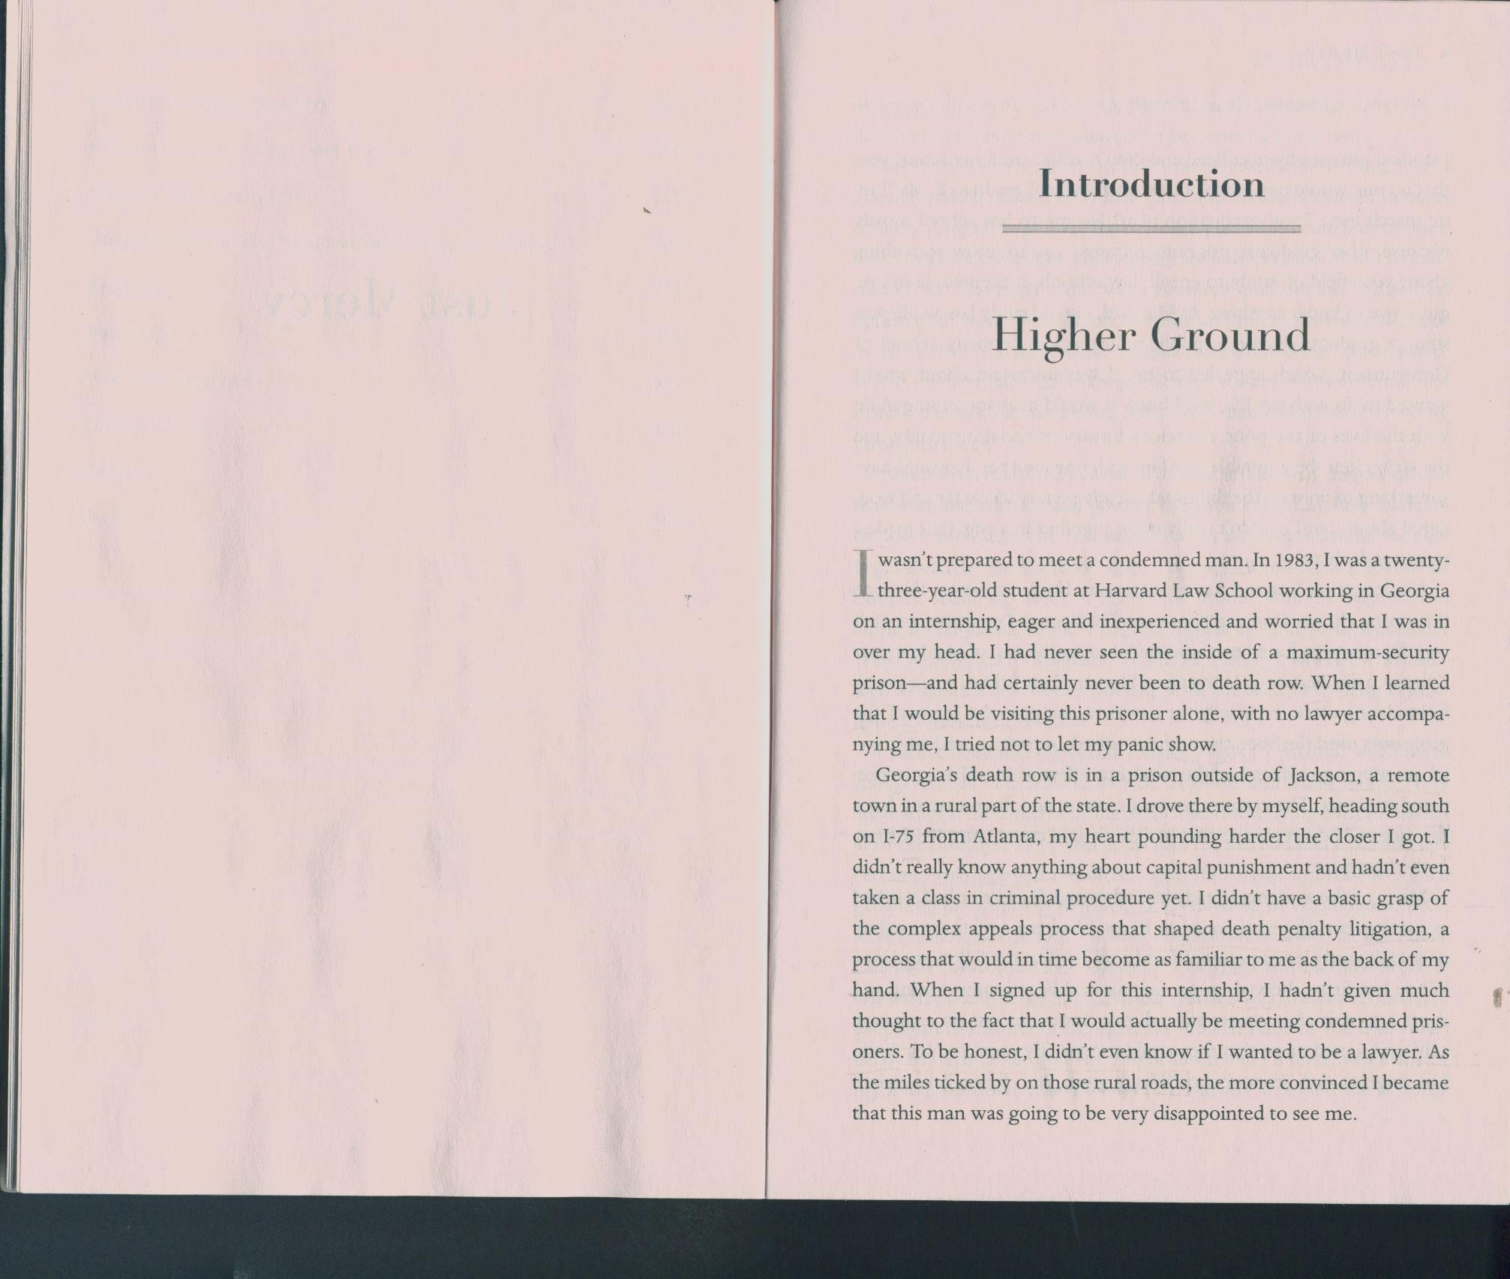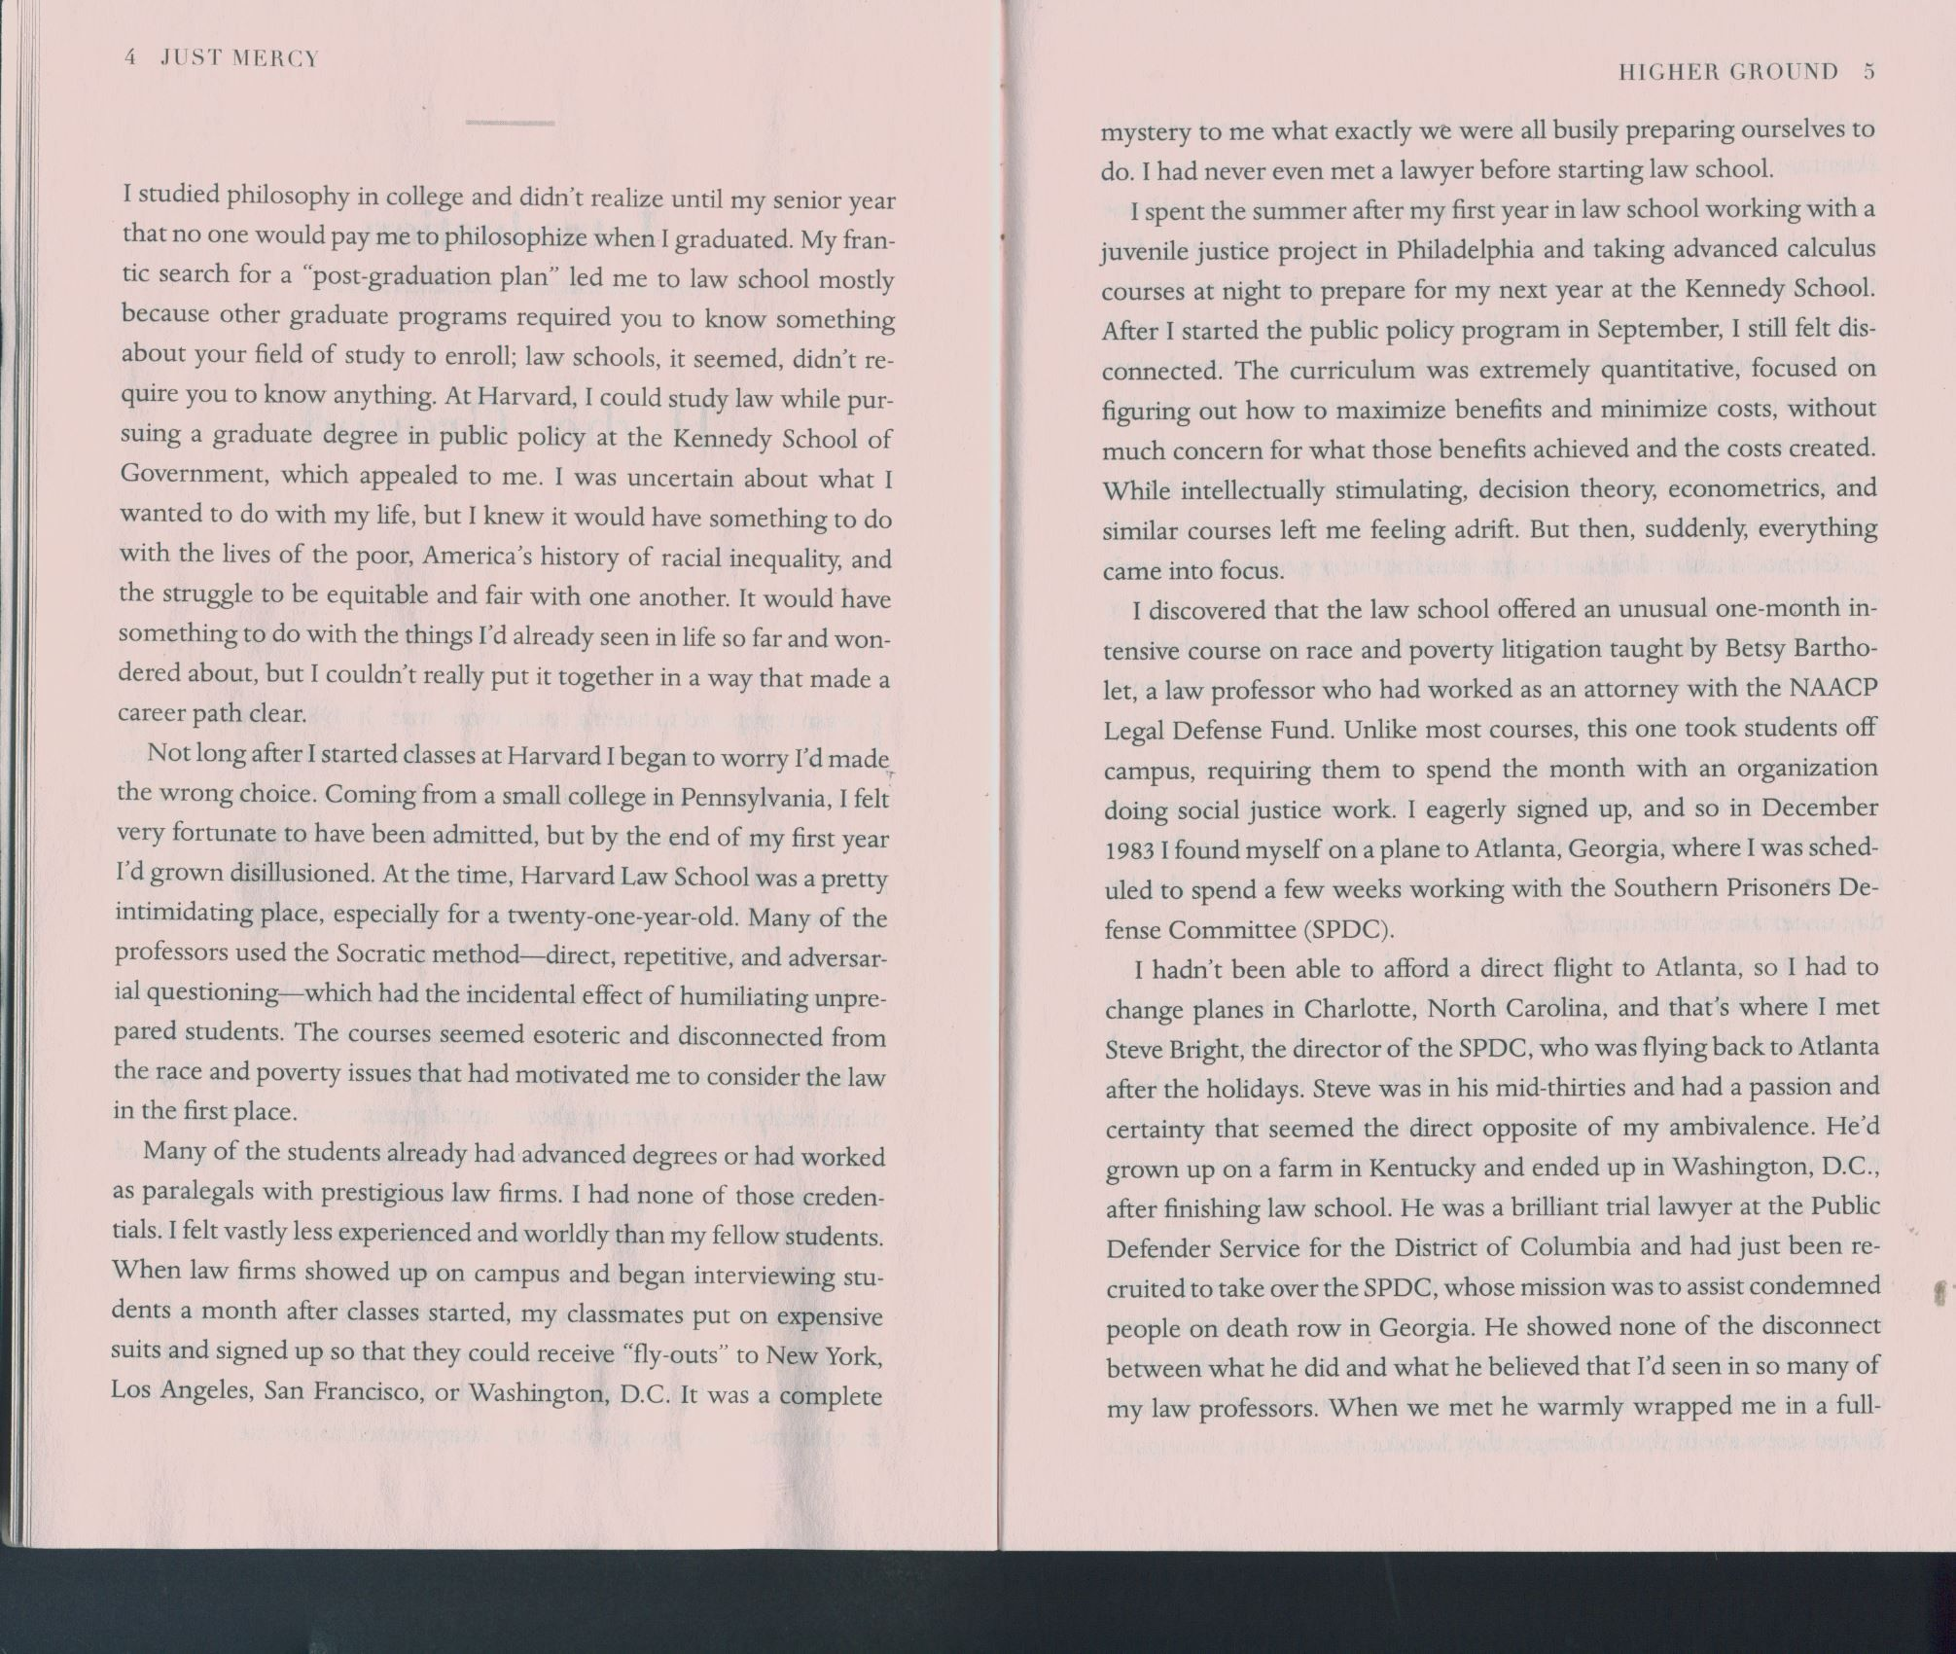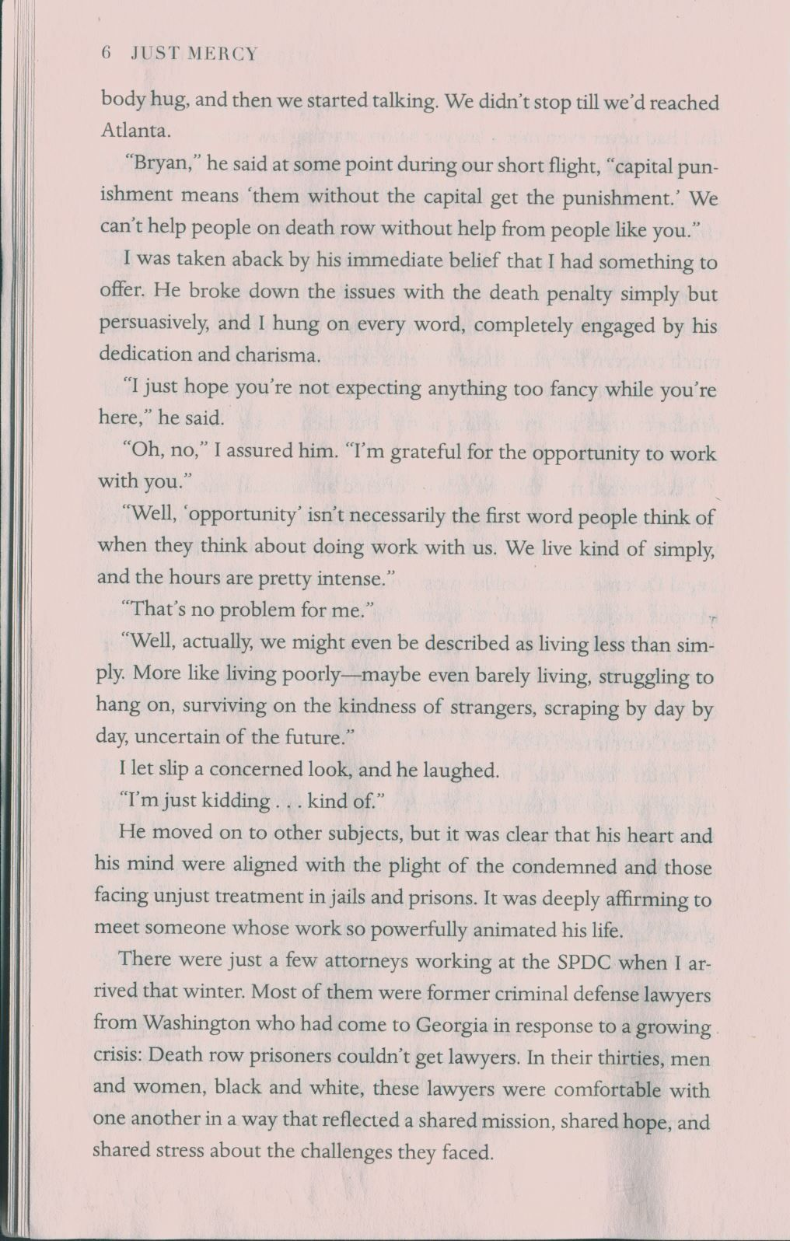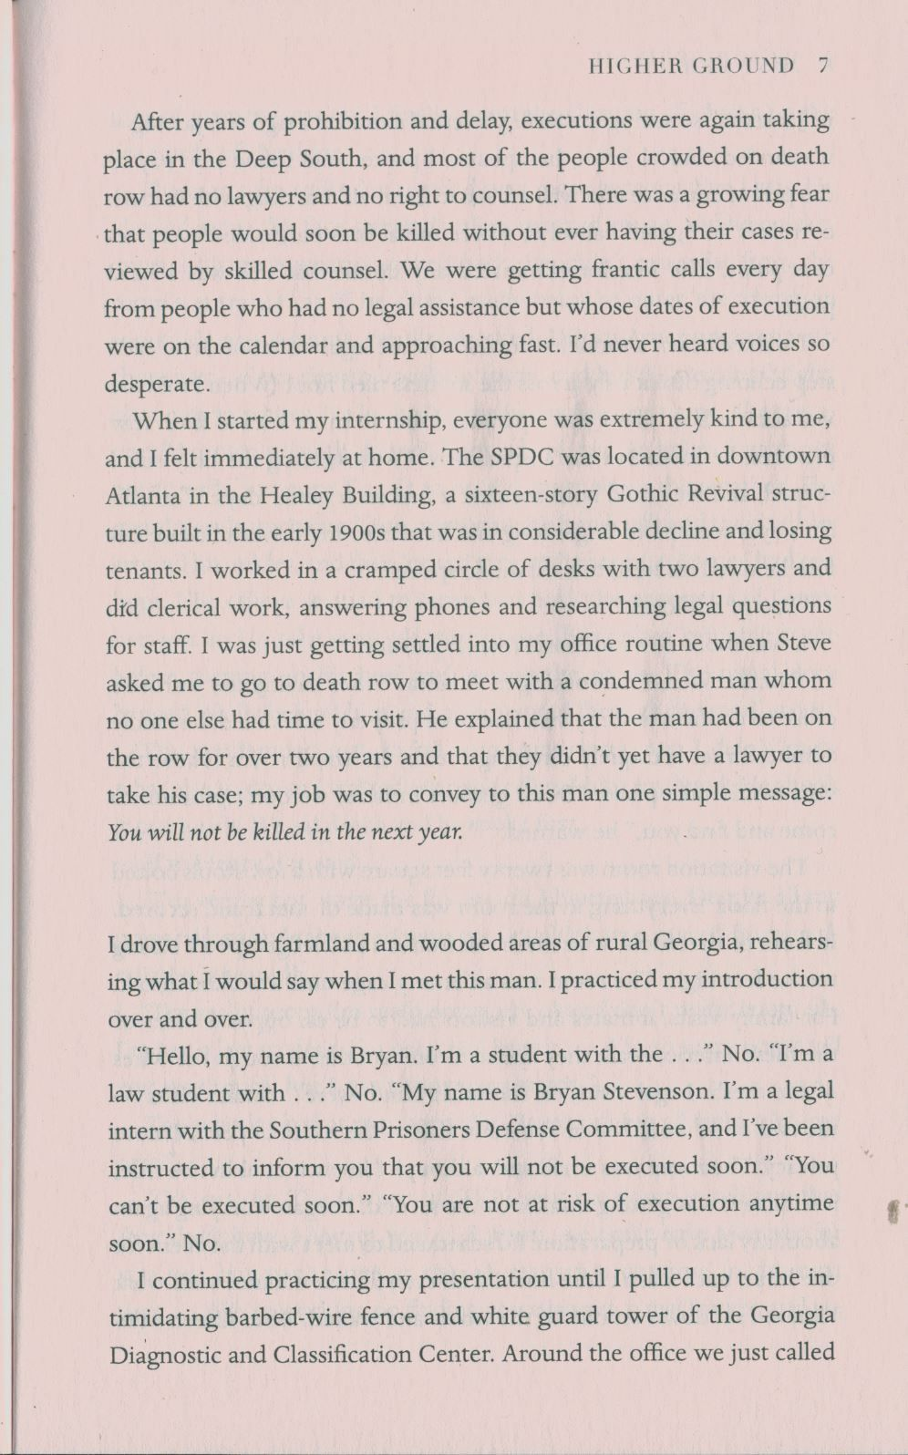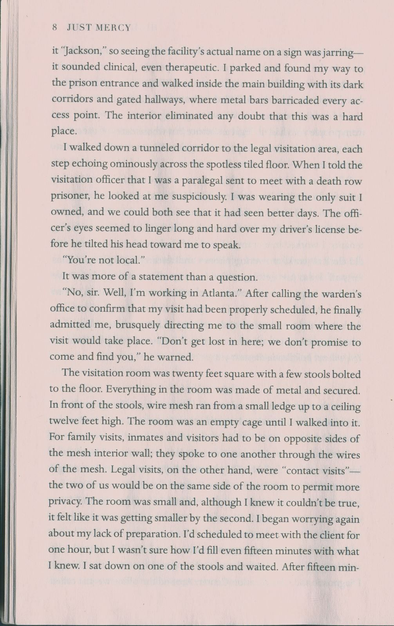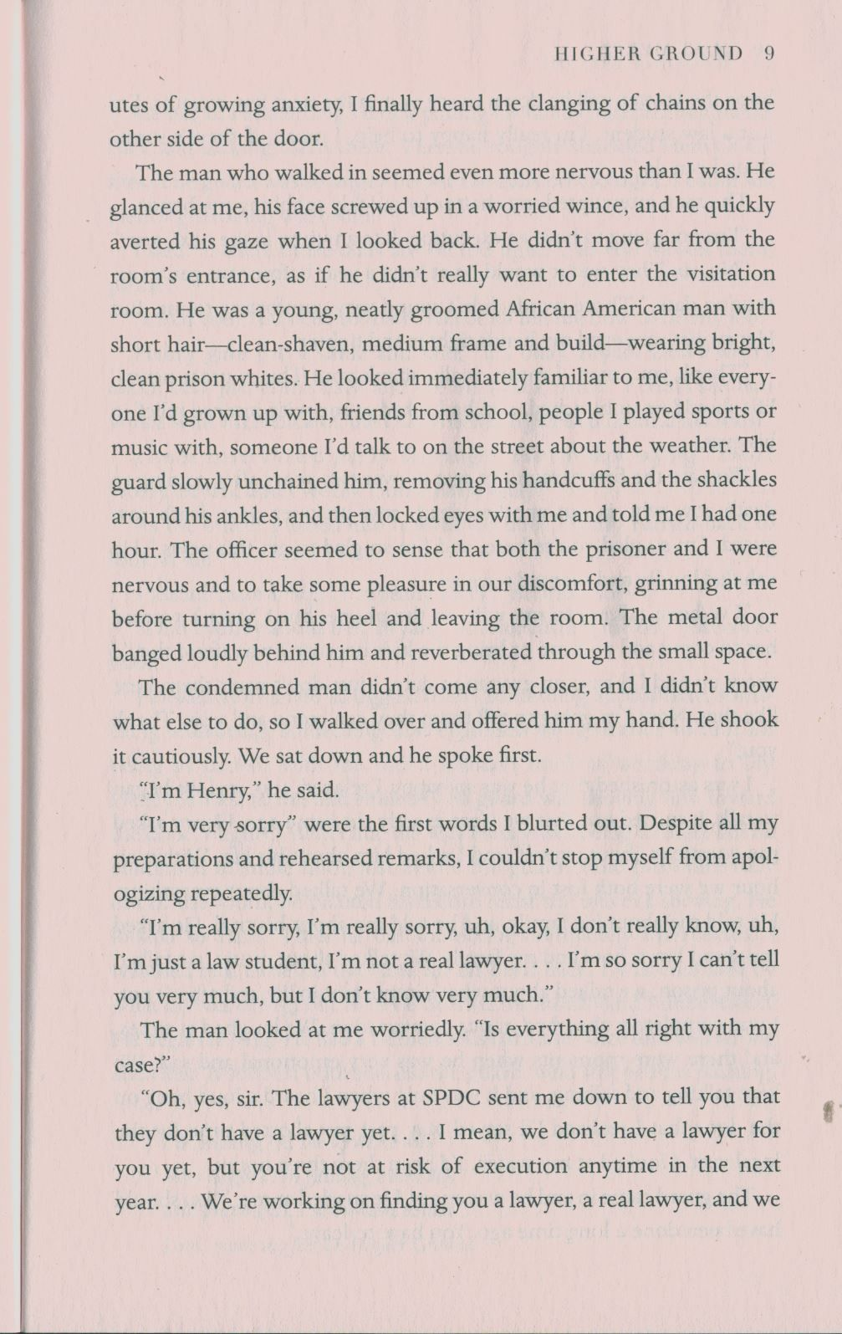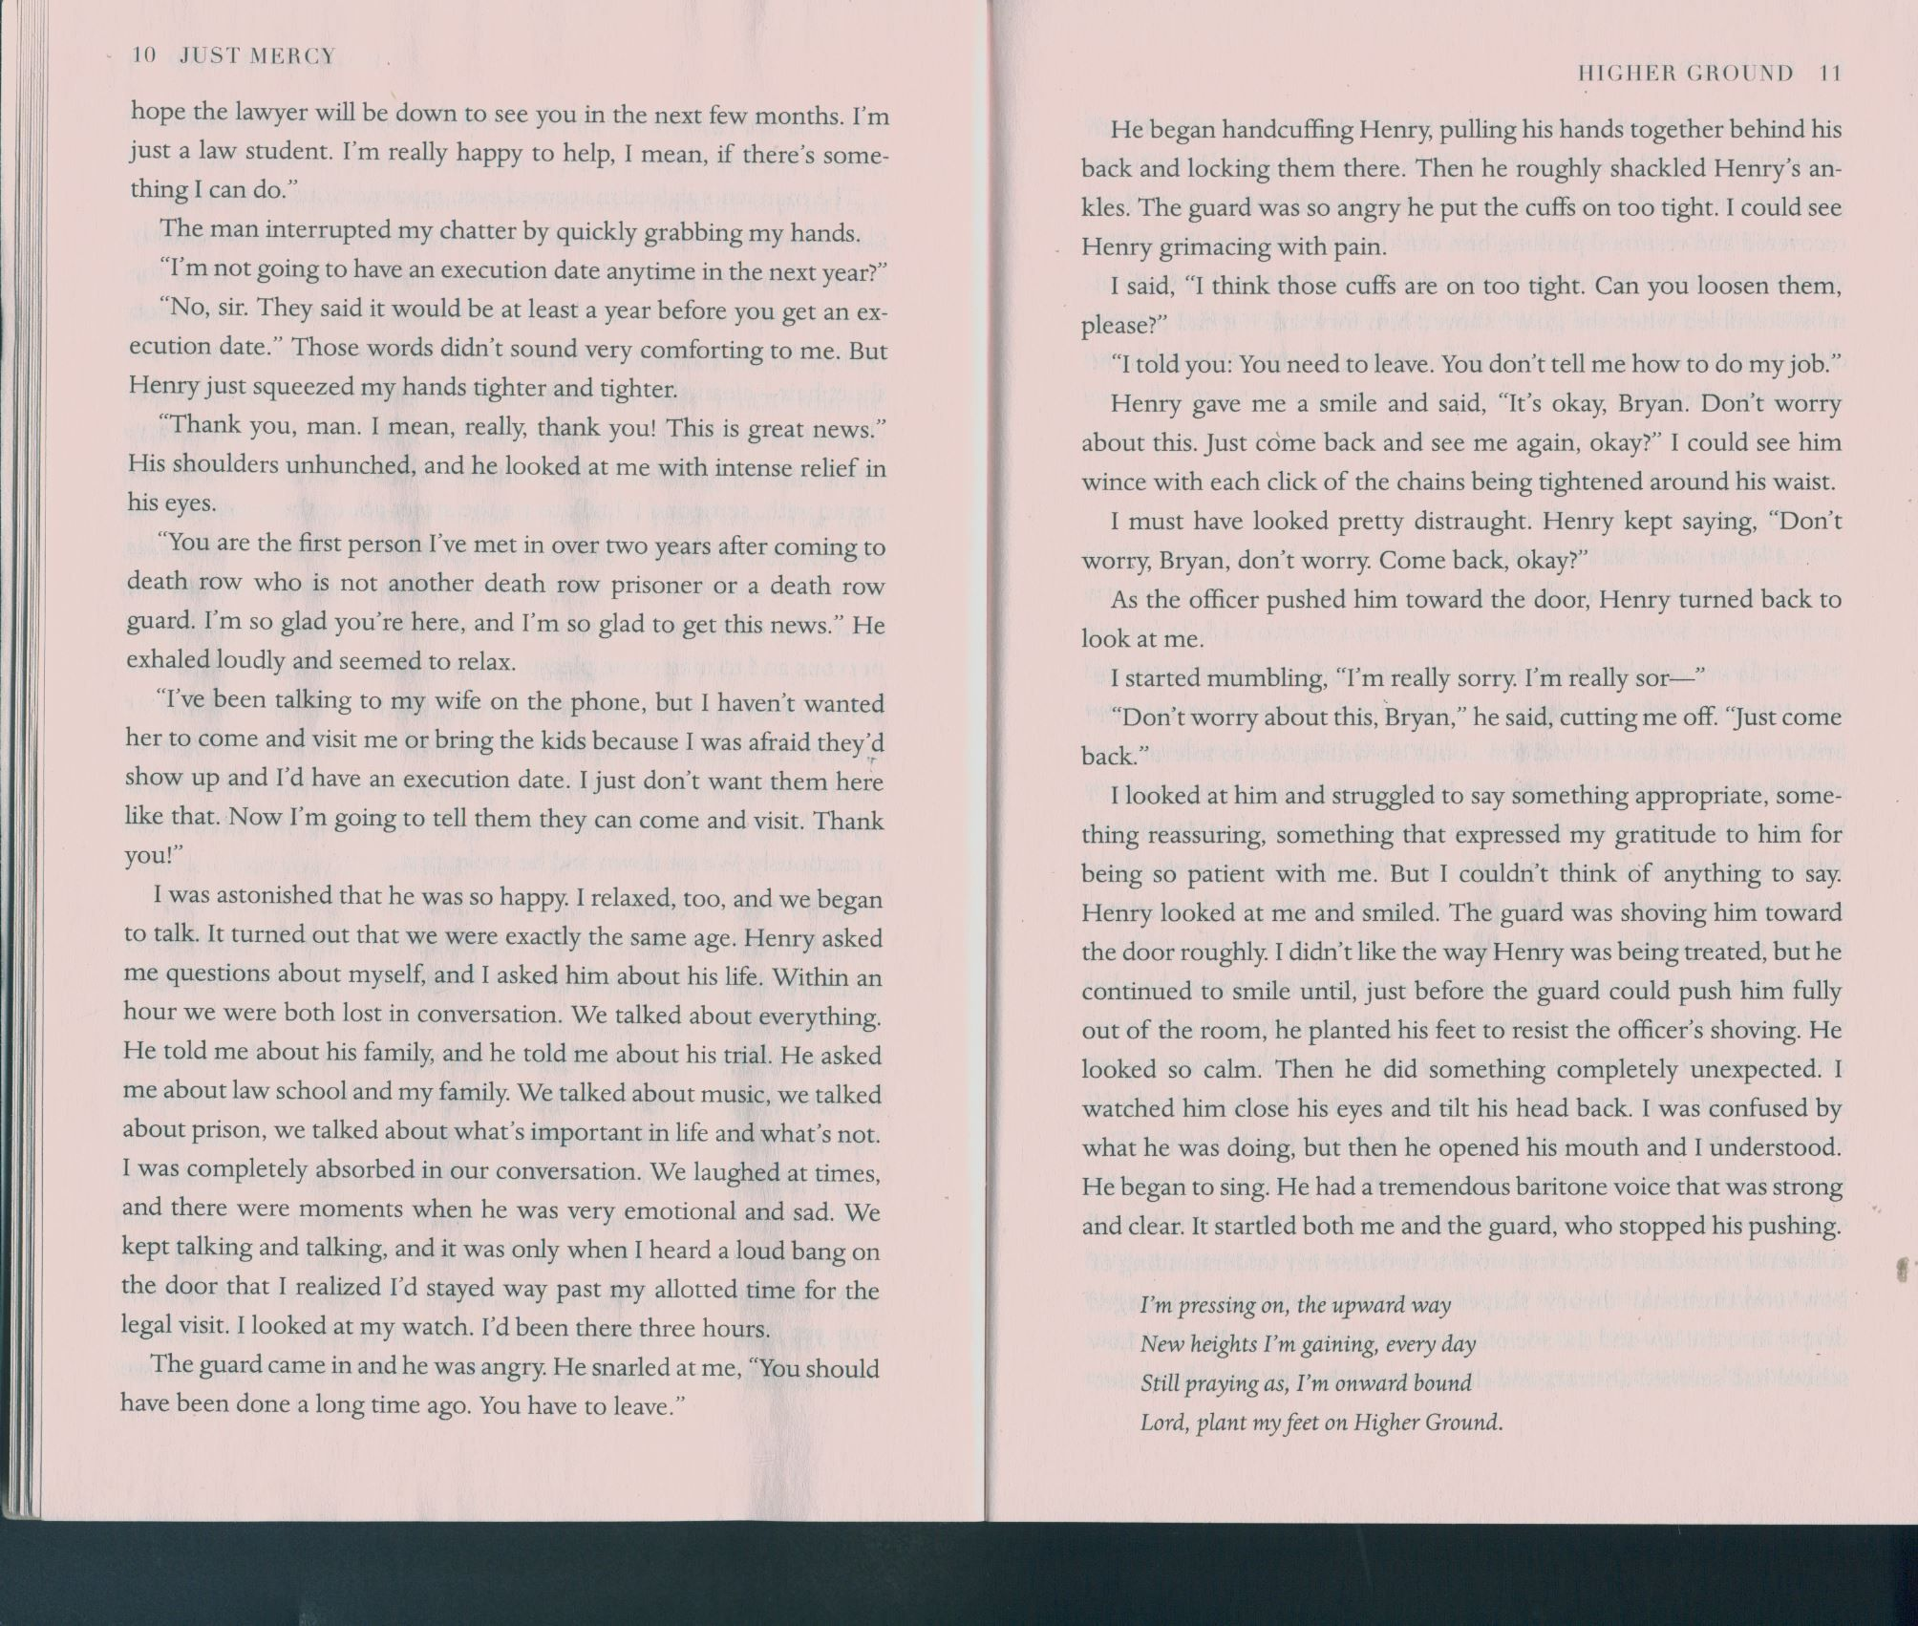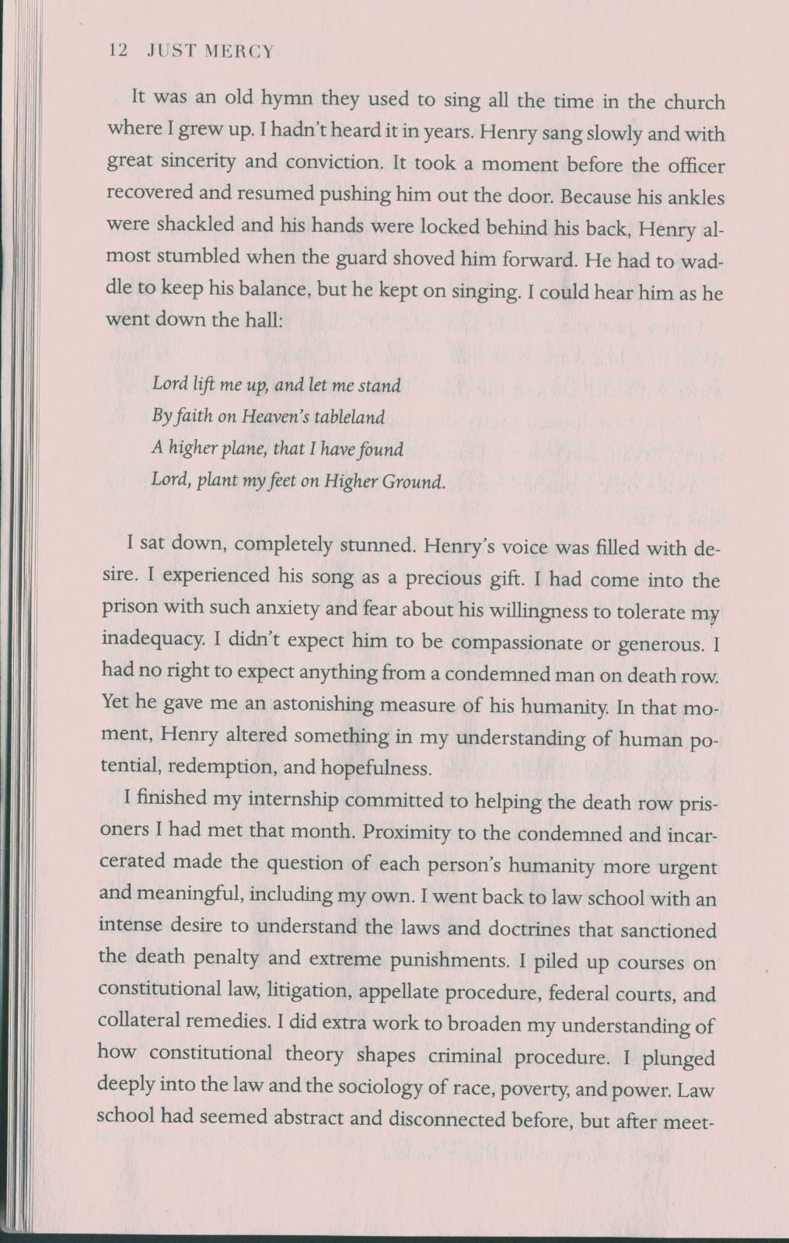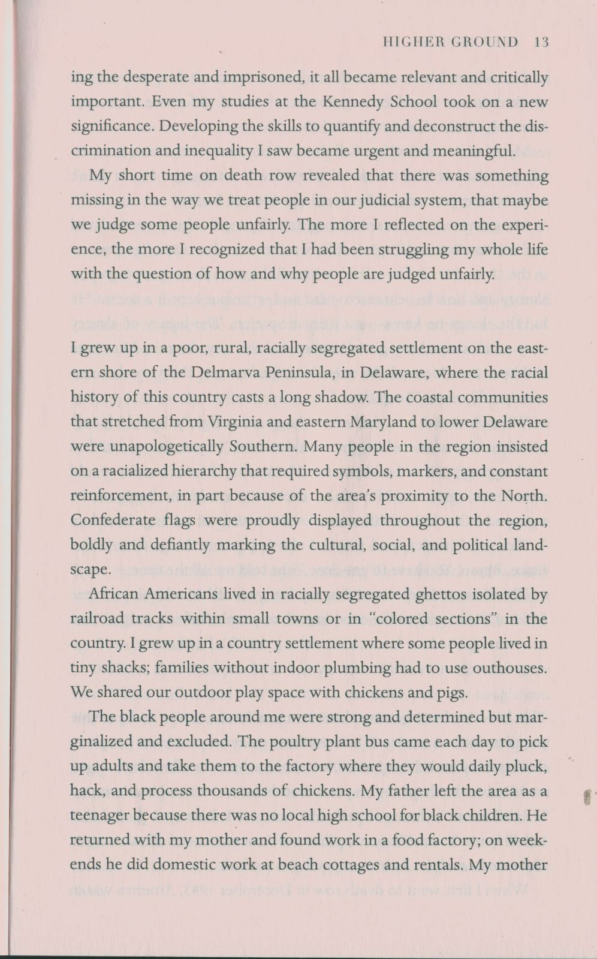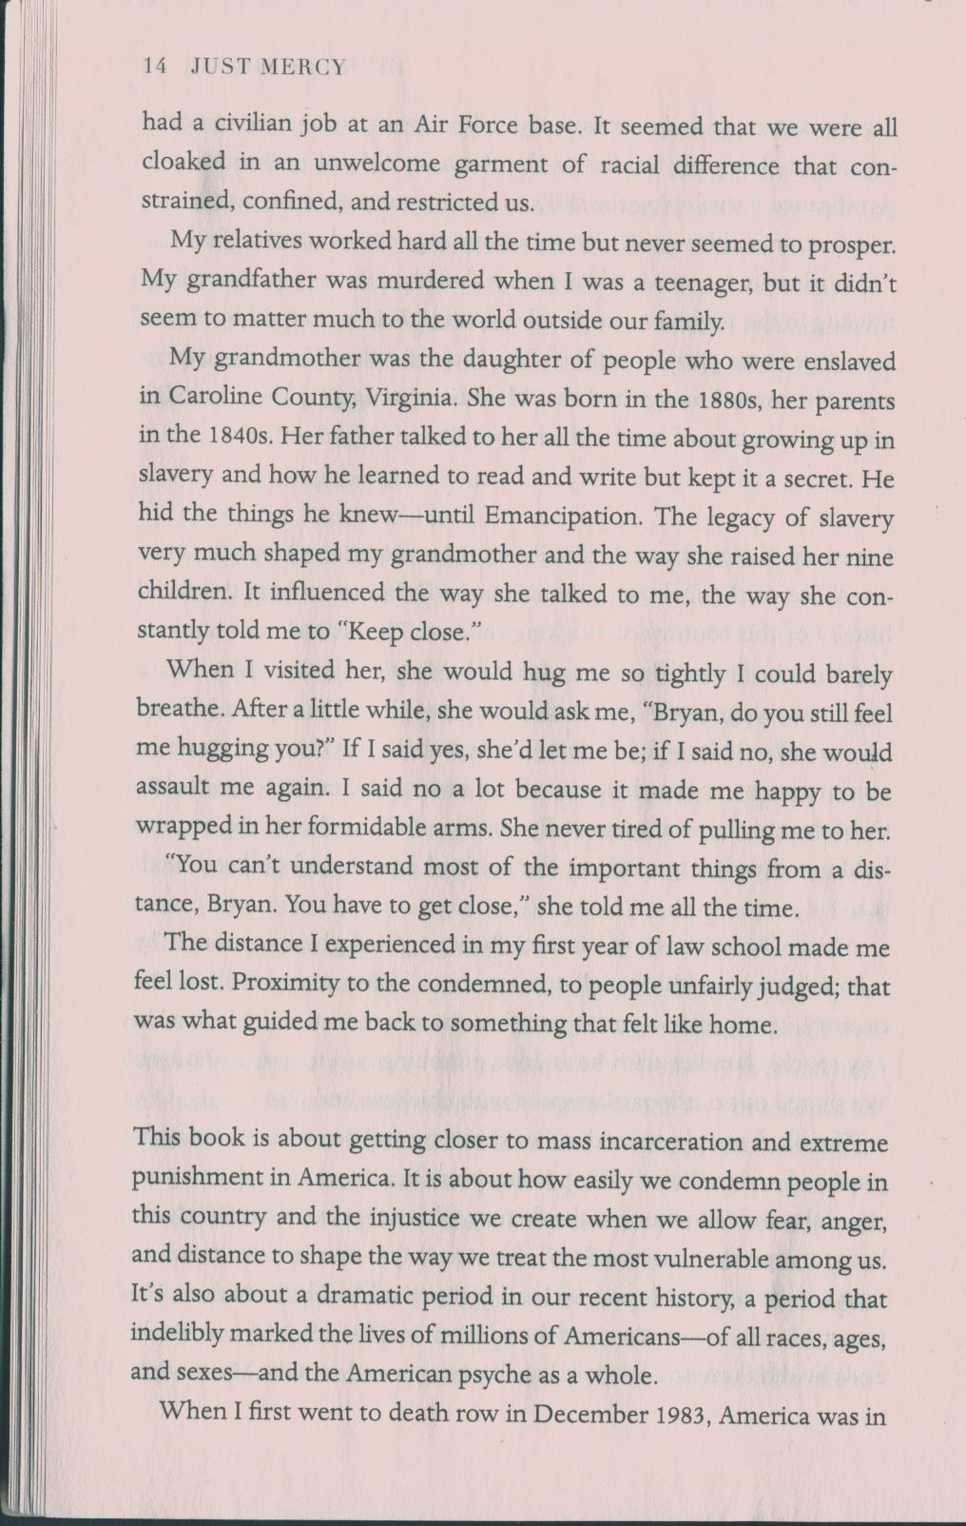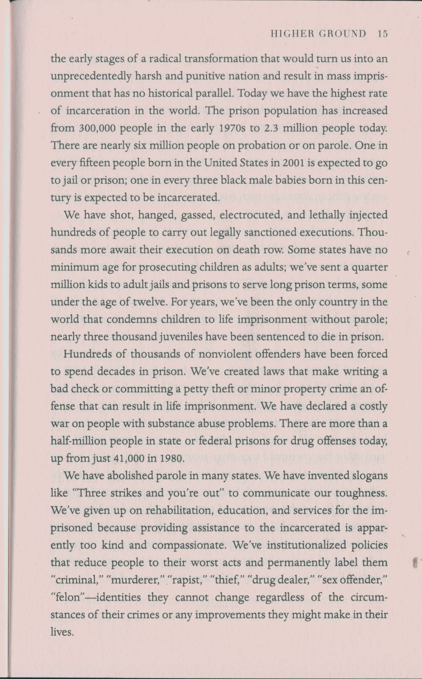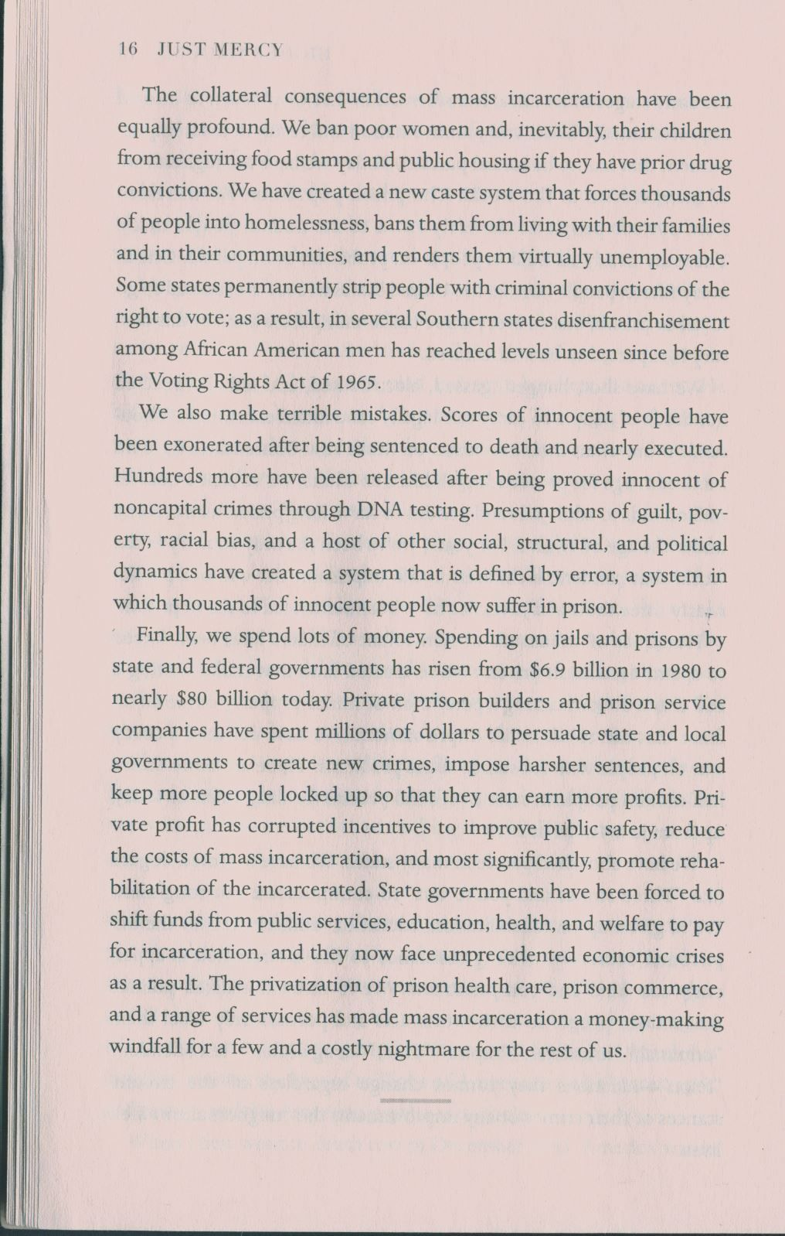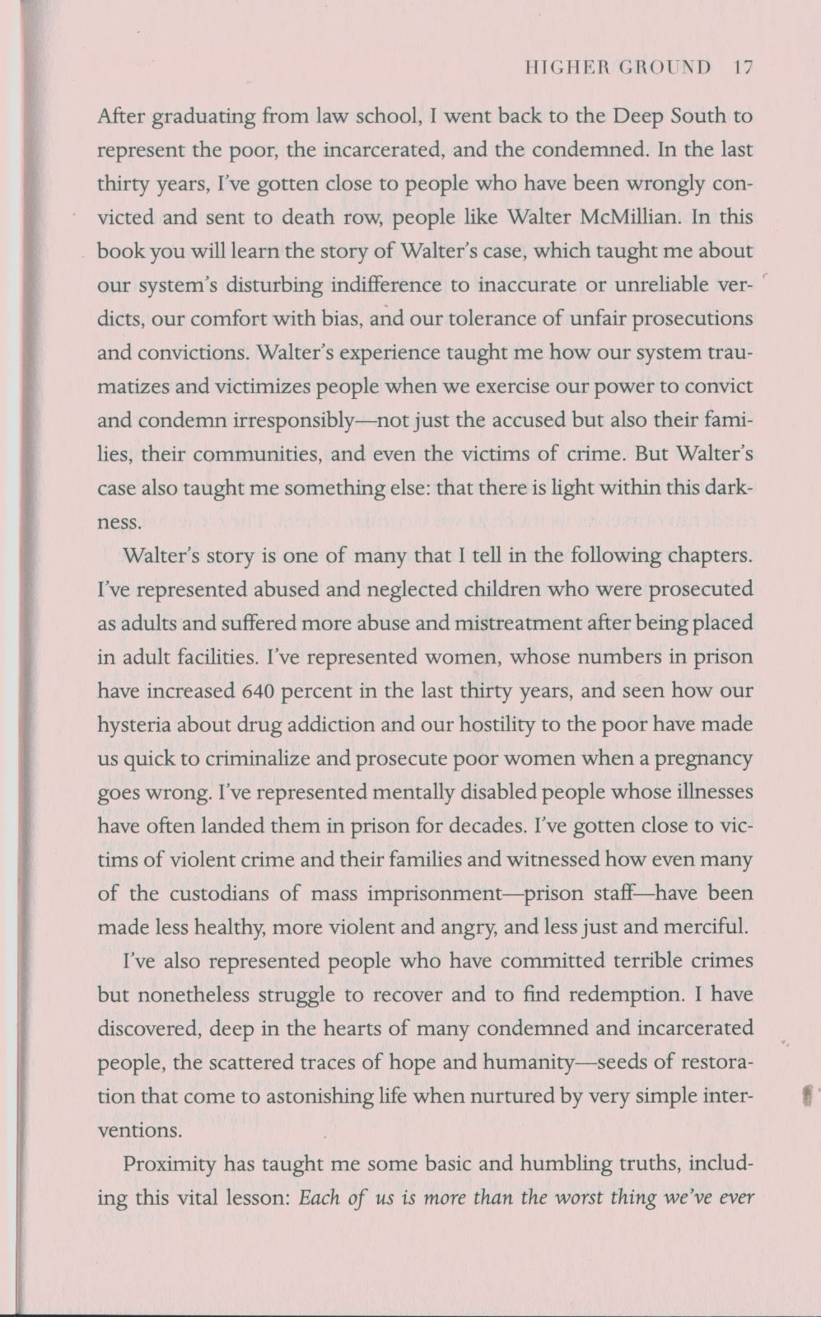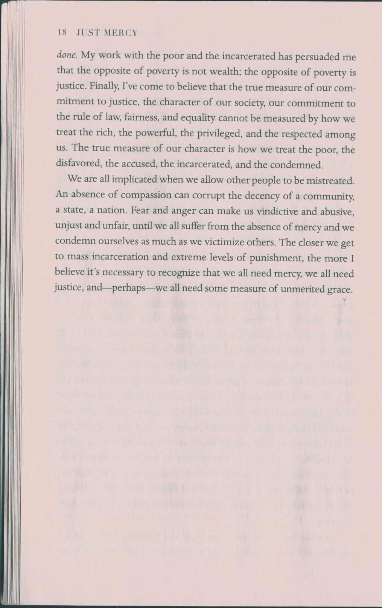

To this purpose, please ask your interviewees for permission to record the interview. Explain to them that it is a part of your writing assignment. If they refuse to give you this permission, you will have to find another person who won’t be against being recorded.
For the whole structure of peer review see Appendix 4.
The questions are taken from Writing Today Chapter 6.

