University of New Mexico
2017-2018 Lobo Reading Experience
Just Mercy by Bryan Stevenson

Department of English - Core Writing Program
ENGL 120-112: Annotated Bibliography + Argument + Proposal
Created by Sofya Tarabrina

ENGL 120-112: Annotated Bibliography + Argument + Proposal
This sequence is aimed at raising students' civic mindedness in the question of penal practices. To this purpose, they will have to choose a problem existing in the US prison system and arousing tension in US society, and conduct a small research project on it through the Internet. As a result they will come up with a proposal on solving this problem with an argument that will help them to shape their own ideas and position in the best way.

MWA – Proposal – will ask students to come up with a suggestion for this problem that will help them to shape their approach to the problem for their MWA. The proposal should contain a more or less detailed plan of what is supposed to be done in the direction of solving this problem and the explanation of why these steps are reasonable.

SWA A – Annotated Bibliography – for this assignment, the students will conduct research on the Internet, identifying the problem in the American penal system that interests them most of all, and collect the information that exists regarding the evolvement of this problem in American prison practice and especially how the opinions of the public towards this problem have changed or developed throughout its “history”.

SWA B – Argument – for this assignment, students will be asked to sum up the material they found on the problem on the Internet and in other sources and present it in the form of an argument. This assignment will help them to develop all the points of the problem, juxtaposing their expedience, moral part, and other possible factors that influence taking this or that side.

Skills to develop:
1. To read, understand, and analyze Internet sources critically and make the right choice among them depending on the purpose (SLO G – “use … research as a means of discovery”).
2. To summarize sources properly giving the reader (and the writer) a clear idea of how these sources are going to work for the final project of the sequence (SLO A – “considering the strategies, claims, evidence, and various mediums and technologies that are appropriate to the rhetorical situation”, C).
3. To master the genre of argument (invention and organization of content, choosing a style, creating a design.) (SLOs A – “compose … in a variety of genres”, B – to take into account “the social nature of composing”, C)
4. To master the genre of proposal (invention of a solution, organization of steps, choosing a style, creating a design.) (SLOs A – “compose … in a variety of genres”, B – to take into account “the social nature of composing”, C)
5. To work with ENGL 120 SLOs (all, except I and J.)

Sequence 2: Argument (Course Calendar)

Week | Date | In-class topic | Reading Due | Assignment Due
Week 1 | Monday  / | Intro to the Sequence  Intro to “Just Mercy” by Bryan Stevenson  “Walter McMillian on 60 Minutes”  https://www.youtube.com/watch?v=shzMjyuijRU  Intro to SWA A | “Introduction” Just Mercy (Appendix 1)
 | Wednesday  / | Analysis of a Student Research Paper  Group Brainstorming on Research Topics | Lives not Worth the Money by Katelyn Thompson (on Revel) | Revel Chapter 14  Find 2-4 research topics
 | Friday  / | Annotated Bibliography  Summary | http://www.wikihow.com/Write-a-Summary  Annotated Bibliography: The Fog of Revolution by Sara Rodriguez (on Learn) | Find an annotated bibliography on the Internet on your topic
 | Saturday  / |  |  | Revel Chapter 14 Quiz
Week 2 | Monday  / | SWA A Peer Review |  | Rough Draft of SWA A is due before the class
 | Tuesday  / |  |  | SWA A and SWA A Peer Review Follow Up (Appendix 2) are due by midnight via Learn
 | Wednesday  / | Intro to SWA B and MWA  Using Argumentative Strategies |  | Revel Chapter 22
 | Friday  / | Arguments | Death Penalty Eliminates the Risk of Future Violent Crimes by Katelyn Firkus (on Revel)  Excerpt from Ch. 14 JM about juvenile crime (Appendix 3) | Revel Chapter 11
 | Sunday  / |  |  | Revel Chapter 11 Quiz  Revel Chapter 22 Quiz
Week 3 | Monday  / | Developing Paragraphs and Sections | Excerpt from Ch. 15 JM about brokenness (Appendix 4) | Revel Chapter 20  First Draft of SWA B is due by midnight to your peer’s email
 | Tuesday  / |  |  | Revel Chapter 20 Quiz  At home SWA B peer review (Appendix 2)
 | Wednesday  / | SWA B Peer Review |  | Rough Draft of SWA B is due before the class
 | Thursday |  |  | SWA B and SWA B Peer Review Follow Up are due by midnight via Learn
 | Friday  / | Proposals | One Student Group Work: Proposals (on Revel)  Excerpt from Ch. 16 JM about race and poverty initiative (Appendix 5)  The ASU Department of English’s Prison Education Programming https://english.clas.asu.edu/research/community-university-initiatives/prison-english-program  Excerpt from Ch. 16 JM about an old woman’s initiative (Appendix 6) | Revel Chapter 12
Week 4 | Monday  / | Organizing and Drafting |  | Revel Chapter 16  Revel Chapter 12 Quiz
 | Wednesday  / | Presenting Your Work |  | Revel Chapter 16 Quiz  Revel Chapter 32
 | Friday  / | Presentations |  | Revel Chapter 32 Quiz  Get ready with your presentations of your proposals
Week 5 | Monday  / | Presentations |  | Get ready with your presentations of your proposals  First draft of MWA 2 is due by midnight to your peer’s email
 | Wednesday  / | Presentations |  | Get ready with your presentations of your proposals  At-home peer review of MWA. Email your review back by midnight.
 | Friday  / | MWA Peer Review |  | Rough Draft of MWA is due before the class
 | Saturday  / |  |  | MWA and MWA Peer Review Follow Up are due by midnight via Learn

Day by Day Calendar (chronological)
Week 1 M: / Intro to the Sequence. Lobo Reading. Intro to SWA A.

SLO B: Students get acquainted with a book that has a strong social message and learn how writing can enhance the world-changing effect of actions. They also learn that to write something really strong and mind-shaping, one needs to be part of it; that is, to write a good argument on a problem and a proposal on solving it, one should be highly interested in it.

- Class Discussion on Sequence 2 and Just Mercy (15 minutes):
- What is Lobo Reading (http://lre.unm.edu/);
- Bryan Stevenson and his book (www.bryanstevenson.com): he received numerous awards for his civil rights activity, and his book is a widely recognized bestseller;
- The problems raised in the book
- What are your impressions of the book? (based on the “Introduction” Appendix 1)
- The structure of the book
- “Walter McMillian on 60 Minutes” (24 minutes): the main characters of the book in the flesh plus the main plot of the book. What new has this video added to your impression from the book?
https://www.youtube.com/watch?v=shzMjyuijRU
- The problem of death row prisoners who were sentenced due to insufficient legal support and prejudice towards the black population is just one problem in the American penal system. But there are many more. Your task for this sequence is to find a problem in the American criminal justice system and single out a focus that is particularly interesting to you and with which you can get interest the larger of society. This problem should be important personally to you (or even relevant to this or that extent). Keeping in mind your topic, you will write an annotated bibliography on it (for SWA A). Based on your found focus, you will write an argument where you argue your opinion on this problem (for SWA B) and a detailed proposal on how to address this problem (for MWA).
- SWA A: to read individually (3 minutes), them discuss in groups questions and confusions.
- Class Discussion of SWA A (5 minutes).

H/W:
On the Internet, to look through the websites on the query “problems of the American criminal justice/prison/penal system” to find 2-4 research topic that might be interesting to you to work with for this sequence.
Read: Chapter 14 on Revel

Week 1 W: / Analysis of a Student Research Paper. Group Brainstorming on Research Topics

SLO A: Students study a new genre – a research paper and learn its conventions; also they learn its structure and peculiarities of design.
SLO B: They learn to choose a style depending on the purpose of the paper and the audience’s requirements.
SLO G: They touch upon research for the first time in this class.

- Class discussion on the main points of the chapter (10 minutes).
- Group Discussion on “Lives not Worth the Money” by Katelyn Thompson (a reading from the chapter) (8 minutes)
- Introduction. Can you identify the topic, purpose, thesis, background, and importance of this research? Explain them to the class.
- Body paragraphs. What pattern does the author use (issue by issue, argument by argument or chronological)? Can you identify the topic of each paragraph?
- Conclusion. How good is the transition between the body and the conclusion? How well is the main point restated? How well is the importance of the topic stressed? Do you get the answer to the so-what question?
- Works cited. What sources does the author use? How credible are they? How authoritative do they look?
- Style. What can you say about the usage of doers as subjects in the sentences? Weak sentence constructions? Similies/analogies? Is the length of the sentences appropriate?
- Design. Does the author provide a cover page? Use headings? How meaningful are they? How appropriate do you find the graphs, charts, images, if any? Does the length of the paragraphs add readability to the text?

- Class Discussion on Lives not Worth the Money by Katelyn Thompson (10 minutes)
- Group Brainstorming on Research Topics (10 minutes)
In your groups, discuss each other’s topics and try to decide what would be a good topic to work with based on the following criteria:
  - Researchability – how easy will it be to find publications (non-academic and academic) on this topic?
  - Difficulty – is this topic easily approachable without extensive specialized knowledge? (E.g., a topic such as “The relationship between verbal language abilities and specific criminal characteristics of adjudicated adolescent males” might require extensive knowledge in the field of criminology and neuropsychology)
  - Interest – is this topic interesting to you (the researcher) personally on some level?

- Class Discussion on research topics (Who wants to share?) (10 minutes)

H/W:
- Find an annotated bibliography on the Internet on your topic.

Week 1 F: 10/20 Annotated Bibliography. Summary

SLO A: Students study the convention of the genre of an annotated bibliography and its main component - summary.
SLO B: They learn how to make their summaries understandable and useful for their audience.
SLO C: They learn the main stages of the writing process in relation to annotated bibliographies.

- Group Discussion on annotated bibliographies and summaries based on http://www.wikihow.com/Write-a-Summary. What are the main stages and their components of making a summary? (7 minutes)
- Class Discussion/Mini-lecture on summaries (10 minutes)
- Group Discussion. “Peer review” of “The Fog of Revolution” by Sara Rodriguez (on Learn). Do the summaries make sense? I.e. can you get a clear understanding of what the article is about from its summary? (10 minutes)
- Class Discussion on “The Fog of Revolution” by Sara Rodriguez. (7 minutes)
- Freewrite “Peer Review” on the annotated bibliographies you found on your topic on the Internet (see the evaluation rubric from the SWA A prompt). Post in your Reflective Journal together with the links to the originals (10 minutes).

H/W:
Work on your annotated bibliographies and get ready for peer review on Monday.

Week 2 M SWA A Peer Review

SLO A/B: Students continue learning to use peer review as a good resource for improvement of their papers and get a chance to talk to their audience in person, getting feedback on the spot and immediately changing their texts accordingly.

- Review your peers’ annotated bibliographies according to the prompt’s rubric.
- Work time.

H/W:
SWA A and SWA A Peer Review Follow Up are due by Tuesday midnight via Learn.
Revel Chapter 22

Week 2 W: / Intro to SWA B and MWA. Using Argumentative Strategies

SLO A: Students learn useful techniques that can be used in different genres.

- Intro to SWA B and MWA. Group discussion of questions/confusions (5 minutes).
- Class Discussion of questions/confusions (5 minutes).
- Class discussion on the basis of the presentation (from Revel) (7 minutes).
- Group Discussion “Weird Claims – Weird Arguments”. With your group, generate arguments based on reason (employing logical statements and examples), authority, and emotion; on logical fallacy; on methods of rebuttal and refutation. Present your arguments to the class (10 minutes).
Claim | Reason | Authority | Emotion | Logical Fallacy | Rebuttal/  refutation
People should never listen to music.
The Earth is flat.
Cheese is a cure-all for all diseases.

- Class Discussion on the previous task (7 minutes).
- Freewrite. Think about your topic for this sequence and try to draft possible arguments using the strategies you just learned (7 minutes).

H/W:
Revel Chapter 11
To read Death Penalty Eliminates the Risk of Future Violent Crimes by Katelyn Firkus (from the chapter)
To read an excerpt from Ch. 14 JM about juvenile crime (on Learn)

Week 2 F: / Arguments

SLO A: Students get acquainted with a new genre – an argument – and learn its main features and moves.
SLO C: Students learn the main stages of developing the main point, organizing and drafting and revising and editing the argument.
SLO G: Students study how to apply research to their writing and learn to incorporate others’ opinions into their argument.

- Class discussion on the basis of the presentation (from Revel) (7 minutes).
- Group Discussion on “Death Penalty Eliminates the Risk of Future Violent Crimes” by Katelyn Firkus (7 minutes)
- What is the main claim (thesis)? What is the structure of this argument?
- What are the arguments for the author’s view? Summarize them.
- What are the arguments for the other side? What is their strength? Summarize them.
- What are the limitations of the opposing view (other side)?
- What the difference between the introduction and conclusion in this paper? Be specific.

- Class Discussion on “Death Penalty Eliminates the Risk of Future Violent Crimes” by Katelyn Firkus (7 minutes).
- Group Discussion on Excerpt from Ch. 14 JM about juvenile crime (7 minutes)
- What is the structure of the argument made by Bryan Stevenson and his team in the defense of juvenile delinquents? How different is this argument from the schemes described in the chapter?
- What are the main claims of this argument?
- What argumentative strategies are used here (those that you know from Chapter 22 on Revel)?
- What are the fortunate strategies that you noticed in this argument that can be helpful for your own argument?
- Class Discussion on the previous group work (7 minutes).
- Freewrite. Think again about the patterns of an argument represented in the chapter and try to analyze which of them suits best to your purposes for your SWA B. Explain your choice in the freewrite. Upload to your Reflective Journal.

H/W:
REVEL Chapters 11, 22 Quizzes by Sunday morning
REVEL Chapter 20 by Monday

Week 3 M: / Developing Paragraphs and Sections

SLO A/C: Students discuss strategies that they have been familiar with before and that are new to them. These strategies will help them, in particular, to organize and draft their argument and, in general, any other writing in the future.

- Class discussion on the basis of the presentation (from Revel) (10 minutes).
- Group Discussion. With your group, look through the excerpt from JM you have read for this class and and analyze any three of its paragraphs, identifying their topic sentences, support sentences, transition sentences, and point sentences. Then present to the class what you have come up with (7 minutes).
- Class Discussion on the previous group work (10 minutes).
- Group Discussion. With your group, choose any reading from Revel or from JM we have already taken and analyze it regarding the sections it is divided into. Try to identify the sections in the text. Look at each section carefully to determine what patterns are used. Which patterns for sections described in this chapter are most common? Are the sections following any patterns that aren’t shown in the chapter? Then present to the class what you have come up with (7 minutes).
- Class Discussion on the previous group work (10 minutes).

H/W:
Revel Chapter 20 Quiz
Work on your argument.
Get ready for tomorrow’s peer review as a reviewer (assess electronic version of your peer’s paper according to the rubric writing comments in the margins and providing an overall feedback at the end; send the evaluated paper back to your peer AND to your instructor by the next class by email) and a reviewee.

Week 3 W: / SWA B Peer Review

SLO A/B: Students continue learning to use peer review as a good resource for improvement of their papers and get a chance to talk to their audience in person getting their feedback on the spot and immediately changing their texts accordingly.

- Individual Work: Read your peer’s feedback on your SWA 4 and formulate questions to them (7 minutes).
- Work in Pairs: Discuss your papers with your reviewers (10 minutes).
- Work Time: Work on your SWA B till the end of class.

H/W:
SWA B and SWA B Peer Review Follow Up are due by Thursday midnight via Learn.
Revel Chapter 12 by Friday morning.

Week 3 F: / Proposals

SLO A/B: Students learn a new genre – proposals – and its main conventions.
SLO C: They also learn the main stages of the writing process regarding proposals.

- Intro to MWA. Group discussion of questions/confusions (5 minutes).
- Class Discussion of questions/confusions (5 minutes).
- Class discussion on the basis of the presentation (from Revel) (7 minutes).
- Group Discussion (5 minutes). Look again through the SCC Café Proposal you read for this class and discuss one of its aspects:
- What is the purpose of this proposal, how is the topic defined and linked to larger campus issues?
- What are the causes of this problem?
- What kind of research did the authors conduct to collect the data?
- What is the solution of the problem they propose? How clear is it if really implemented?
- What would be the benefits of implementing the proposed plan?
- What contribution does the design make to the effectiveness of this proposal?
- How can you evaluate the effectiveness of this proposal in whole?
- Class Discussion on the previous group work (7 minutes).
- Class Discussion on the examples of initiatives:
- on the level of non-profit organizations (an excerpt from Ch. 16 JM about race and poverty initiative);
- on the level of university (ASU English https://english.clas.asu.edu/research/community-university-initiatives/prison-english-program)
- on the level of an individual (an excerpt from Ch. 16 JM about an old woman’s initiative)
Which of these types of initiatives do you find more attractive to you: from the point of your personal inclinations and possibilities? Which of them suits better the problem in the US criminal justice system you have chosen for this sequence?
The conclusion:
The first and the second initiatives took a lot of effort of their initiators to persuade authorities in their necessity, but the impact was world-shaking. The last initiative has little impact but it is very easy for everyone to undertake something of such a kind.

H/W:
Revel Chapter 16
Revel Chapter 12 Quiz

Week 4 M: / Organizing and Drafting

SLO A/C: Students discuss organizing and drafting strategies that they have been familiar with before and that are new to them. These strategies will help them, in particular, to write their argument and, in general, any other paper in the future.

- Freewrite (7 minutes): Describe how you currently draft your papers. How much time do you usually devote to drafting? Which strategies or routines help you draft a paper? Next, offer some ideas for improving how you draft your documents. Which techniques for overcoming writer’s block in this chapter would be most helpful to you?
- Class Discussion: Share with class what you have written about (5 minutes) (on board).
- Class discussion on the basis of the presentation (from Revel) (7 minutes).
- Group Work (7 minutes): Find a document on the Internet (or on Revel/Learn that we have studied earlier in this class) and identify its introduction and conclusion. Discuss whether you think the introduction and conclusion are effective and how they could be improved. Present your findings to the class (to write them down into a table on board in bulleted points).
- Work Time (20 minutes): Regarding introduction and conclusion, consider particularly your SWA 4. Revise them on the basis of information you have learned from this chapter.

H/W:
Revel Chapter 16 Quiz
Revel Chapter 32

Week 4 W: / Presenting Your Work

SLO A: Students learn the technologies that will help them demonstrate any idea initially expressed in writing.
SLO B: They learn to sense their audience more sharply than in the case with writing and to get adjusted to it in the process of drafting their presentation and delivering it.

- Class discussion on the basis of the presentation (from Revel) (7 minutes).
- Group discussion. With your group, choose three things from this chapter that you would like to use to improve your presentation skills. Then, tell to the class what you have come up with (7 minutes).
- Class Discussion on the previous group work (7 minutes).
- Freewrite/Worktime. Start drafting your presentation. Ask and answer for yourself the following questions:
- How can I attract the attention of my classmates?
- What technology will work better for my purpose?
- What topics am I going to cover in my presentation?
- What questions may arise after my presentation?
- What problems do I usually experience while preparing my presentations and while delivering them? How am I planning to improve my presentation skills?
- How am I going to practice and rehearse my presentation?

H/W:
Revel Chapter 32 Quiz
Work on your proposals.
Get ready with your presentations of your proposals.
Sign up for presentations on Learn.

Week 4 F

Week 5 MW: / Presentations of Proposals

SLO B: Students learn to transform their written proposals to visual presentations. They solve problems on how to enhance the meaningfulness of their ideas through visual devices and audial accompaniment.

Guidelines:

- Make sure that you get quick access to your PowerPoints, Prezis, Google Slides, etc. To this purpose, upload them on the Discussion Board, forum “Proposals” before class.
- Each presenter will have 5 minutes to talk about his/her proposal. Time your speech accordingly.
- Other students need to come up with a question to the author on what else they would like to learn about this organization, or with a constructive idea concerning the resource. Write these questions or ideas on the provided sheets of paper and give to the author after their presentation.
- You may use any notes during your presentation (but do not rely much on them).
- Do not use any videos (just to save time.)
H/W:
First draft of MWA is due by Monday midnight to your peer’s email.
At-home peer review of MWA. Email your review back by Wednesday midnight.

Week 5 F: / MWA Peer Review. Work Time

SLO A/B: Students continue learning to use peer review as a good resource for improvement of their papers and get a chance to talk to their audience in person getting feedback on the spot and immediately changing their texts accordingly.

- Individual Work: Read your peer’s feedback on your MWA and formulate questions to them (7 minutes).
- Work in Pairs: Discuss your papers with your reviewers (10 minutes).
- Work Time: Work on your MWA till the end of class.

H/W:
MWA and MWA Peer Review Follow Up are due by Saturday midnight via Learn
SWA A: Annotated Bibliography
English 120-112

Format: Annotated bibliography
Due dates:
Length: Paper: 3-4 entries, each 150-200 words long, excluding bibliographical information.
Reflection: 150-200 words
Points worth: TBD

Description
For SWA A you will choose a problem that interests you most regarding the American penal system and that requires attention from the public and authorities. You will research your topic, choose 3 or 4 Internet sources you find most relevant and informative, and write an annotated bibliography entry for each of the sources.

Audience
Your audience is yourself (as you will use your findings for your next writing assignments), your peers and your instructor. Your bibliography should give a clear idea of your topic and provide all of us with an accurate and brief description of your sources.

Guidelines
The paper should have a 1-2 sentence introduction describing your topic.
The bibliography itself should include the source’s bibliographical information (as in the Works Cited page) and a short description of the source.
In the description, you need to briefly summarize the source:
- provide an outline of the source’s main claims;
- its focus
- its methods (if applicable);
- what it says concerning your topic.
Also, take note of the names of scholars who develop this or that problem. You might search for their articles in UNM Libraries for your further writing assignments in this sequence.
The annotation needs to be 1.5-spaced throughout, and the entries should be in alphabetical order, by authors’ last names.
You may use any citation style that works best for you.

Reflection
For your reflection, think back about your writing, thinking, and research processes that you went through while working on this paper and tell me about it. From your reflection, I should get a fairly good idea of your experience with writing SWA A.

SWA A Grading Rubric

Element | Description and Point Value (tentative)
Content | 25-23 points | 22-19 points | 18-15 points | 14-0 points
 | The paper presents relevant and accurate research. The annotations give clear, accurate, and concise summary of the sources, covering all of the main points of each source. | The paper presents relevant research. Most annotations give accurate summary of the sources, covering the most important points of the source. | The paper presents research that might not be completely accurate or relevant to the topic. Some summaries might not be clear or accurate or might miss some of the important sides of the source. | The paper presents research that is inaccurate and / or irrelevant to the topic, or the paper might present research that is not academic. The summaries do not represent the sources in any clear way.
Organization, Formatting and Clarity | 10 points | 9 points | 8-6 points | 5-0 points
 | The paper is organized effectively and in accordance with the chosen format (MLA or APA). All entries have accurate bibliographical information.  All sentences are easy to follow. The writer provides sufficient detail to explain his or her main points. | The paper is organized in accordance with the chosen formatting style (MLA or APA), but there might be some minor issues with the accuracy of the bibliographical information or formatting. Most sentences are easy to follow. The writer generally provides sufficient detail to explain his or her main points. | The paper has some issues with following the formatting style, both minor and major. Some sentences are easy to understand, but many are unclear. The writer provides some detail to explain his or her main points, but more is necessary. | The paper does not follow any formatting style (MLA or APA) correctly. The ideas lack clarity due to flaws in sentence structure and organization and lack of detail.
Grammar and mechanics | 5 points | 4 points | 3-2 points | 1-0 points
 | The writing is free of distracting spelling, punctuation, and grammatical errors. | The writing is mostly free of distracting spelling, punctuation, and grammatical errors. | The writing contains some spelling, punctuation, and grammatical errors, major and minor. | The writing is distracting and/or hard to follow due to numerous spelling, punctuation, and grammatical errors.
Reflection | 5 points | 4 points | 3-2 points | 1-0 points
 | The reflection memes represent clear and thoughtful consideration of your ideas about your topic. | The reflection memes show your ideas about your topic in understandable terms. | The reflection memes include some useful insights, but need deeper consideration or clarification. | The reflection section is unclear, superficial, and/or of insufficient length or is missing completely.
Total Points | /45

SWA B: Argument
English 120-112

Due Dates: TBD
Length: 700-900 words.
Reflection: 150-200 words
Points worth: TBD
Research: at least 1 scholarly source and those you used for your annotated bibliography

Rhetorical situation:
You want to write to the Daily Lobo on a controversial topic related to criminal justice that is important to you and on which you have a strong opinion. Your purpose is to provide useful information to your readers and to influence their current opinions on this topic. To sound even more persuasive, think about how this problem affects the Albuquerque community and what changes might occur within it in case the problem is addressed in one or another way. Also, feel free to use any visuals and also hyperlinks that you find appropriate to your topic. Since you want to impress your readers with your argument, it should be really strong so you want to make sure that it flows well and is supported by scholarly publications and online sources.

Description and guidelines
For this project, you will need to make a knowledgeable and intelligible argument on the topic you chose for this sequence. You will need to choose one side of a controversial issue and argue for (or against) it. You can use secondary sources both to support your opinion and to demonstrate an opposing view. You argument should have the following elements:
- An introduction where you identify the issue, why it is important for your audience, and your position regarding it. The introduction should also start with an attention grabber that would get your audience interested in the topic.
- Arguments supporting your position on the issue. Your arguments should be strengthened by relevant secondary sources.
- Opposing views that would go against your position. You will need to explain what these opposing views are, and do it in a manner that is reasonable and considerate.
- You will then need to explain the limitations and shortcomings of these opposing views and demonstrate how your position might be stronger or better.
- Finally, in your conclusion, you will need to restate your position and the key points you made in the body of the paper to make a strong final statement for your argument.
- Use subheadings!!! (for your peers and instructor)

All outside sources should be cited properly in either APA or MLA format.
Finally, the rubric also includes a “multimodality” element for extra credit: you are welcome to create your argument as a webpage or a blog entry and/or use a variety of visual elements to prove your points. All of the multimodal components used should be relevant to your audience and to your topic.

Reflection:
Choose two SLOs to talk about in more detail: what part(s) of completing this assignment do you think was helpful in order to move towards these SLOs? What parts of these SLOs are the most relevant to this assignment, in your opinion? Be as descriptive as possible.

SWA B Grading Rubric

Element | Description and Point Value (tentative)
Title | 5 points | 4 points | 3-2 points | 1-0 points
 | The title reflects the topic and the main point of the argument. It is creative and grabs the readers’ attention. | The title reflects both the issue and the main point of the argument and grabs the readers’ attention. | The title reflects the issue of the argument but may not reflect its main point. | The title fails to reflect the topic and/or main point of the argument.
Introduction | 10 points | 9-8 points | 7-6 points | 5-0 points
 | The introduction clearly identifies the issue and the main points of the argument; it also grabs the readers’ attention in a creative and engaging manner. | The introduction identifies the issue and the argument’s main points, as well as grabs the readers’ attention. | The introduction identifies the issue and the writer’s main claims, but may be not engaging for the readers. Thesis statement might be unclear or not representative of the writer’s main claims. | The introduction fails to identify the article and/or the writer’s claims and does not engage the readers’ attention.
Conclusion | 10 points | 9-8 points | 7-6 points | 5-0 points
 | The conclusion sums up the argument and establishes a clear sense of finality. | The conclusion sums up the argument somewhat but not completely and/or leaves the paper without a clear ending point. | The conclusion sums up the argument but may be too long, too abrupt, or introduce new information that should have been introduced earlier. | The conclusion is not evident or does not fit the rest of the argument.
Content | 40-35 points | 34-31 points | 30-25 points | 24-0 points
 | The paper covers all of the assignment prompt in a mature and effective manner. The argument presents an insightful and detailed exploration of the issue and all of the debates that surround it. The writer makes a very convincing argument for his/her point of view while also considering and rebutting the opposing views in a mature manner. The research is valid and appropriate and is incorporated in an effective and ethical way. | The paper covers most of the assignment prompt effectively, offering a fairly detailed exploration of the issue. The writer makes an overall convincing argument, and the opposing points of view are considered.  The research components are appropriate. | The paper covers some of the assignment prompt but may overlook some important aspects of the issue. The argument might lack in depth or persuasiveness. Other publications on the issue are mentioned but not discussed in sufficient detail. | The paper does not address the assignment prompt in an efficient manner and/or overlooks some crucial aspects of the issue. The argument is not convincing and ineffective; the writer does not mention other publications on the topic. The research components are inadequate.
Organization and Clarity | 25-23 points | 22-20 points | 19-17 points | 16-0 points
 | The body paragraphs progress logically from one to another. Transitions between different ideas are clear and seamless.  All sentences are easy to follow. The writer provides sufficient detail to explain his or her main points. | The paragraphs and sentences progress logically from one idea to the next for the most part. Most of the transitions are clear. Most sentences are easy to follow. The writer generally provides sufficient detail to explain his or her main points. | Some of the paragraphs and sentences progress logically from one idea to the next. Some sentences are easy to understand, but many are unclear. The writer provides some detail to explain his or her main points, but more is necessary. | The ideas lack clarity due to flaws in sentence structure and organization and/or lack of detail.
Grammar and mechanics | 15-14 points | 13-11 points | 10-8 points | 7-0 points
 | The writing is free of distracting spelling, punctuation, and grammatical errors. | The writing is mostly free of distracting spelling, punctuation, and grammatical errors. | The writing contains some spelling, punctuation, and grammatical errors, major and minor. | The writing is distracting and/or hard to follow due to numerous spelling, punctuation, and grammatical errors.
Multimodality | +10-9 points | +8-7 points | +6-5 points | 0 points
 | The writer used various multimodal components (pictures, videos, web tools, etc.) to enhance the argument effectively. | The writer incorporated some multimodal components. Most of them work effectively to promote the argument. | The writer utilized some multimodal components, but they might not work effectively to promote the writer’s argument. | The writer did not use any multimodal components to enhance the argument.
Reflection | 20-19 points | 18-15 points | 14-10 points | 9-0 points
 | The reflection section is a clear and thoughtful consideration of your writing process. | The reflection section shows your writing process in understandable terms. | The reflection section includes some useful insights, but needs deeper consideration or clarification. | The reflection section is unclear, superficial, and/or of insufficient length
Total Points  /125 | Comments:

MWA: Proposal
English 120-112

Due Dates: TBD
Length: 1200-1400 words for the proposal
Reflection: 200-250 words
Points worth: TBD
Research: at least 3 scholarly sources in addition to the ones you used for your SWA A and B

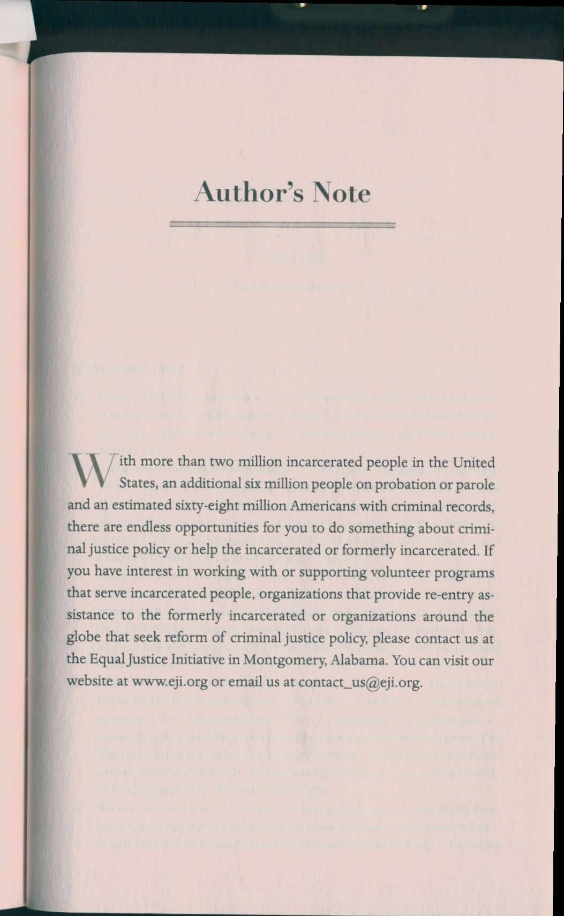
Description and guidelines
In this MWA, you will propose what you can do for improvement of the criminal justice system of the USA, that is, how you personally can help prisoners, former prisoners, and/or their families. To this purpose, you might want to explore what organizations already exist in Albuquerque that pursue these activities and try to find something you would like to stick to (on the basis of the problem you have chosen for your SWAs). OR you may find a new niche and start thinking of a new organization that needs to be established to address the problem that is on your mind. Imagine that you are writing a letter to Bryan Stevenson where you explain what you are planning to do in this field, how you plan to do it, and why you want to do it (i.e., why you want to bring your contribution to the decision of this problem and why you think you will be helpful). You will need to use at least 3 scholarly sources (in addition to the one you used for your SWA B and to the Internet sources you used for your SWA A) to demonstrate that you have done some research on the topic and you know what’s already out there in terms of publications on your topic and what other people have written about it. Feel free to ask him for advice if you see that you are stuck at some point of the design of the service you are proposing or its practical realization.

Your proposal should answer the following questions:
- What is your topic, and what is the issue you are planning to address?
- Why this topic, and why now? What is the significance of this issue? Why do you think it’s important to take action about it now? How will your actions affect the community of Albuquerque?
- What have you found by doing the research for this issue? What do your scholarly and non-scholarly sources say about this issue, and how does it fit with what you are planning to do?
- What is your plan of action for this project? How feasible do you think it is? What resources are you going to involve in it? You can even provide a step-by-step description and/or schedule of your activity.
- Can you already foresee some difficulties of your plan that you suppose to be a serious obstacle on the way of its realization? How would you formulate them?

Your proposal should have a proper introduction and a conclusion. All sources must be cited properly using APA or MLA format.

Reflection
For the reflection, choose two SLOs and describe the challenges you encountered while writing for this assignment and the ways you worked toward the SLOs.

MWA Grading Rubric

Element | Description and Point Value (tentative)
Content | 30-27 points | 26-23 points | 22-17 points | 16-0 points
 | The proposal provides a detailed, thoughtful, and clear outline of the project. The writer addresses all of the assignment prompt thoroughly and effectively. | The proposal provides a fairly clear and detailed outline of the project. Most of the assignment prompt is addressed effectively. | The proposal provides an outline of the project, but it might lack in clarity and fail to provide sufficient explanation. Some of the assignment prompt is addressed effectively, but some are not. | The proposal’s outline is unclear and/or insufficient in length. Most of the assignment prompt is not addressed.
Organization and Clarity | 25-22 points | 21-17 points | 16-11 points | 10-0 points
 | All of the ideas of the paper progress logically from one to another. The formatting and citing are done correctly and appropriately.  All sentences are easy to follow. The writer provides sufficient detail to explain his or her main points. | Most of the ideas progress logically from one to another. The formatting and citing are mostly done correctly. Most sentences are easy to follow. The writer generally provides sufficient detail to explain his or her main points. | Some of the paragraphs and sentences progress logically from one idea to the next. There are some issues with formatting and/or citing. Some sentences are easy to understand, but many are unclear. The writer provides some detail to explain his or her main points, but more is necessary. | The ideas lack clarity due to flaws in sentence structure and organization and lack of detail. Formatting and/or citing are done incorrectly.
Grammar and mechanics | 10 points | 8 points | 5 points | 4-0 points
 | The writing is free of distracting spelling, punctuation, and grammatical errors. | The writing is mostly free of distracting spelling, punctuation, and grammatical errors. | The writing contains some spelling, punctuation, and grammatical errors, major and minor. | The writing is distracting and/or hard to follow due to numerous spelling, punctuation, and grammatical errors.
Reflection | 10 points | 8 points | 5 points | 5-0 points
 | The reflection section gives a clear and thoughtful evaluation of the paper. | The reflection section gives a fairly accurate evaluation of the paper but may miss certain important points. | The reflective evaluation includes some useful insights, but lacks clarity and accuracy. | The reflection section is unclear, superficial, and/or of insufficient length.
Total Points | /75

Appendix 1

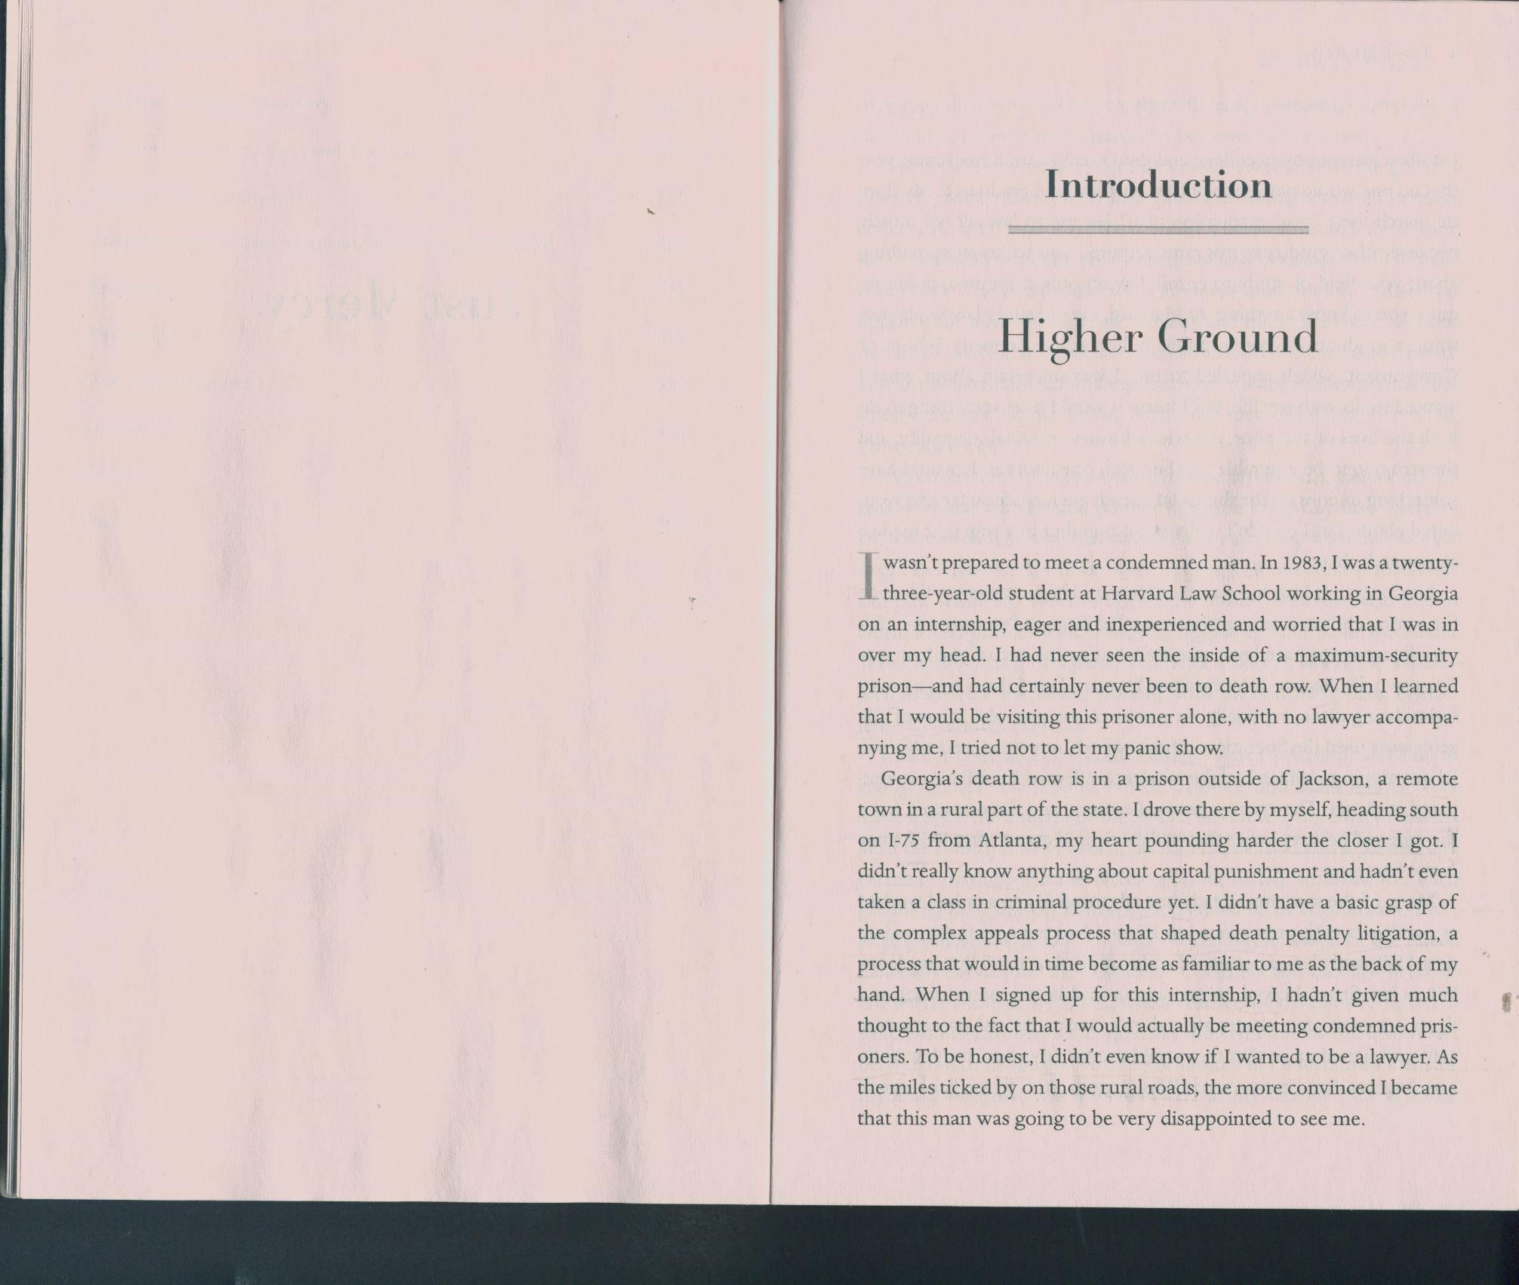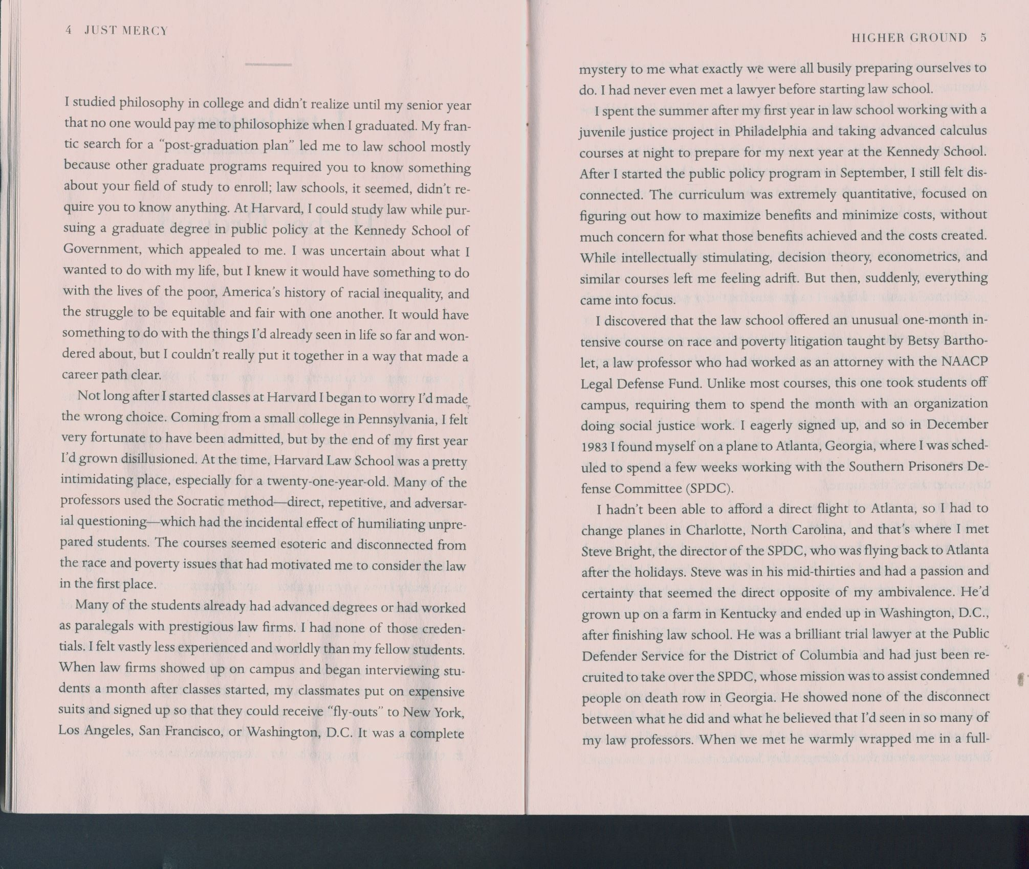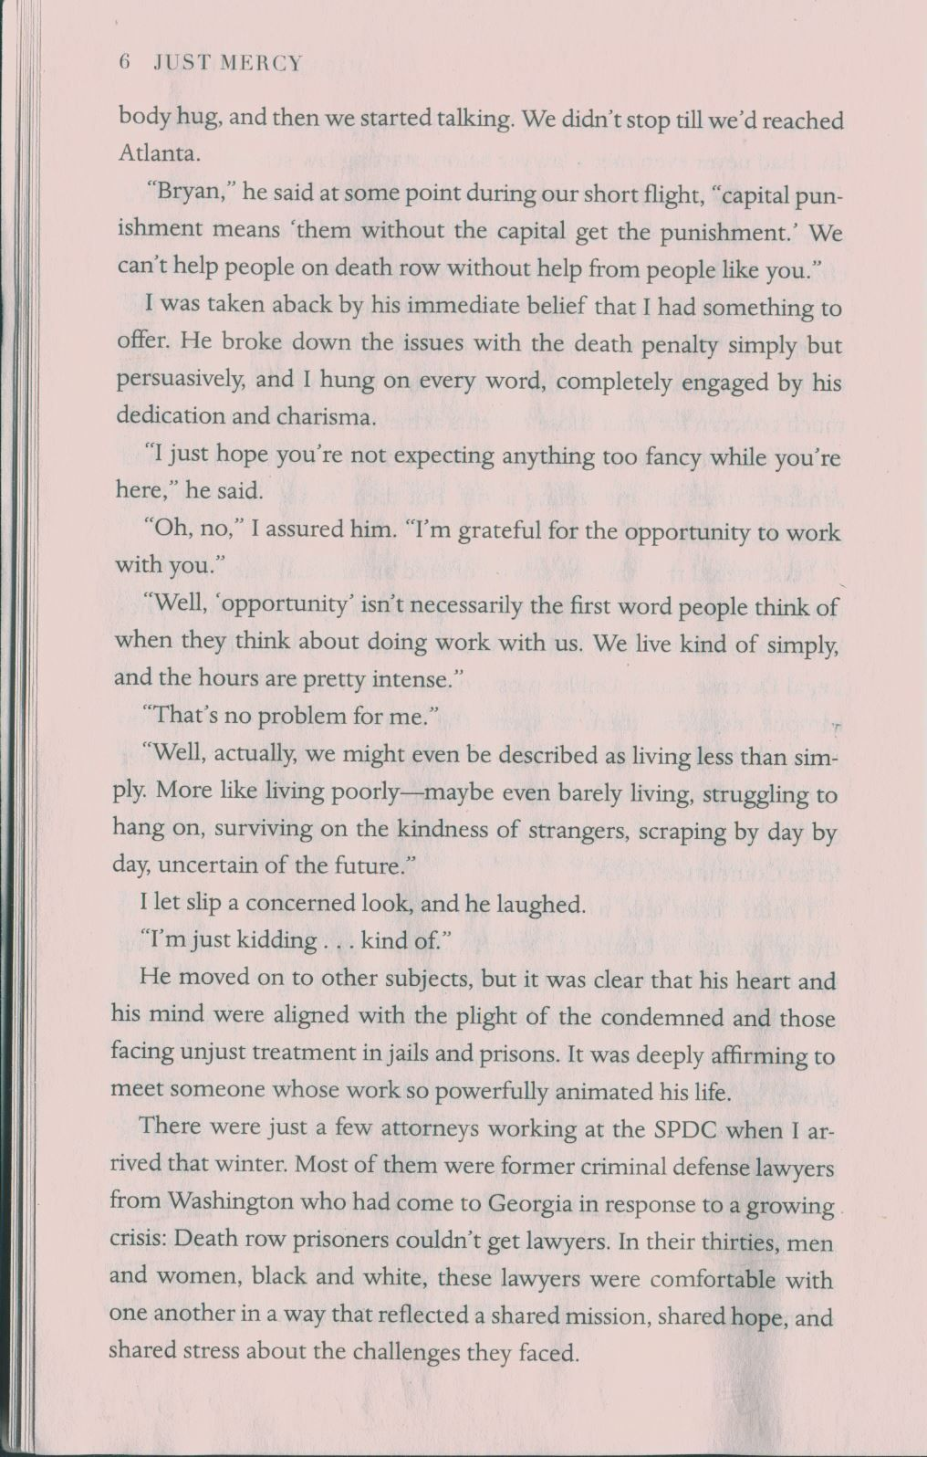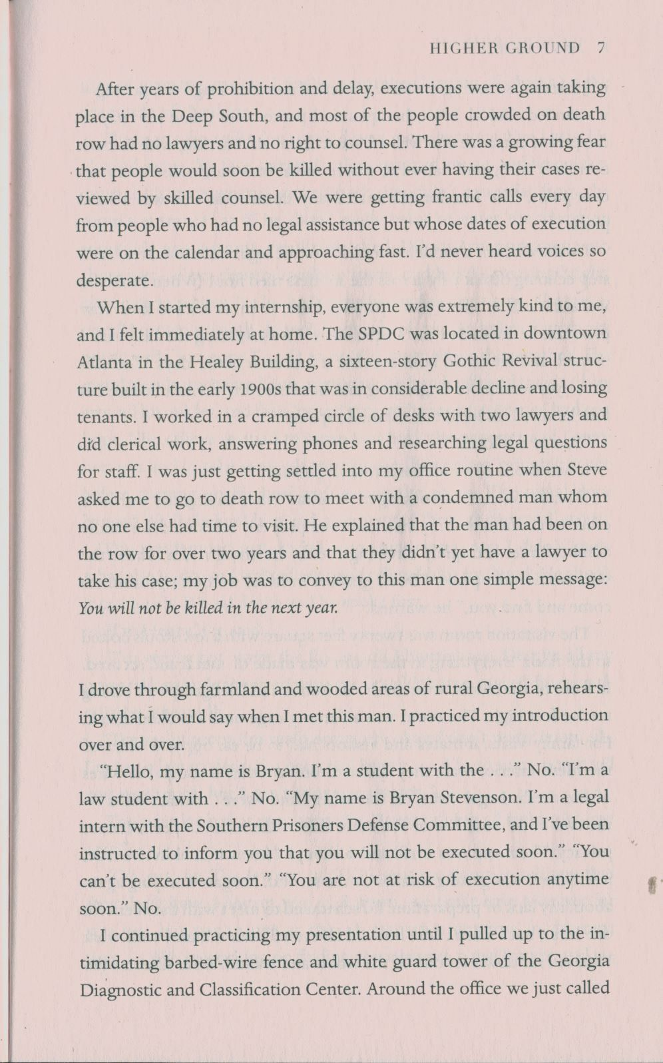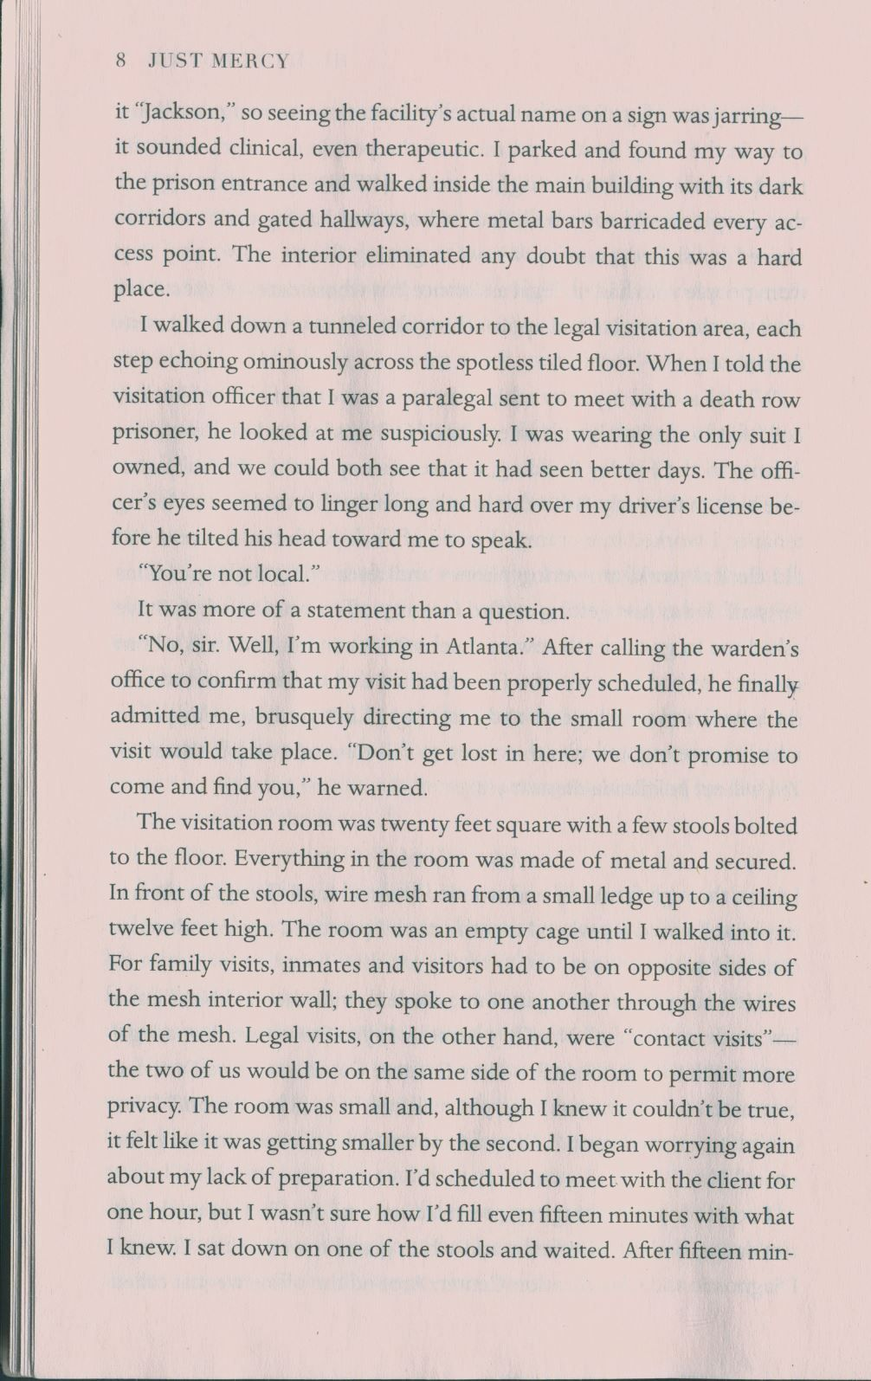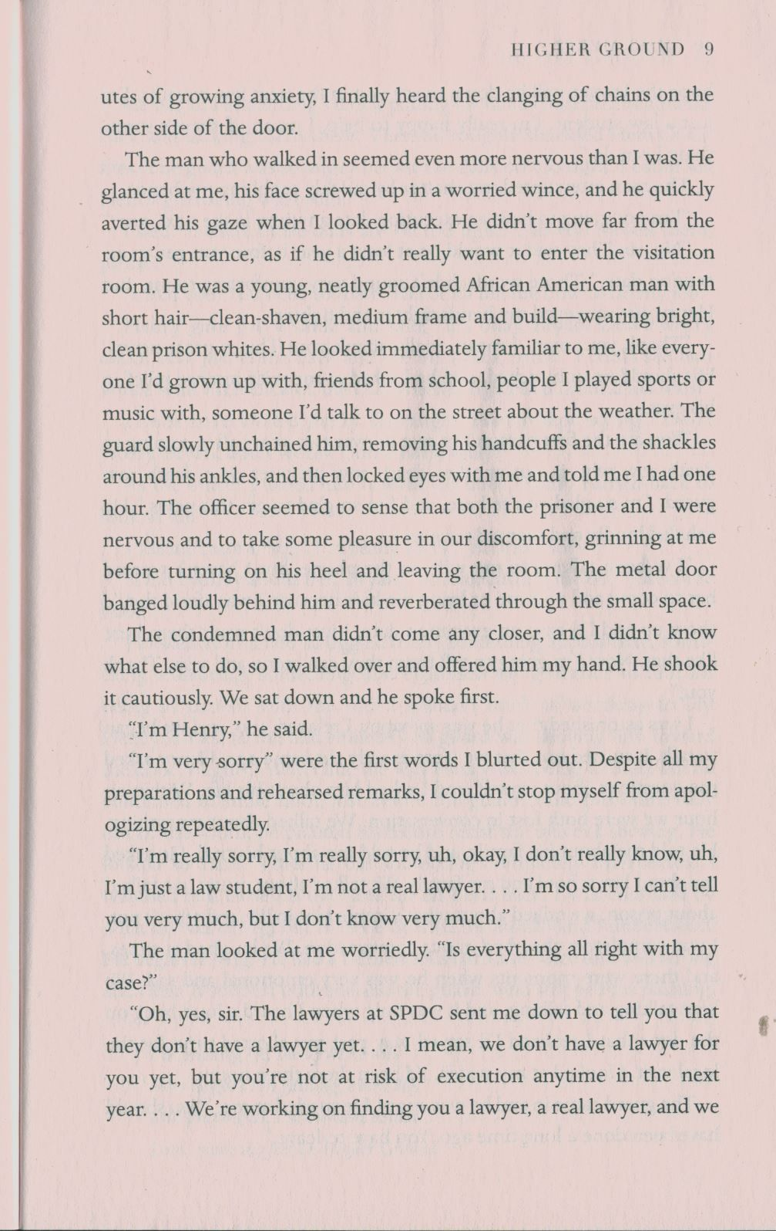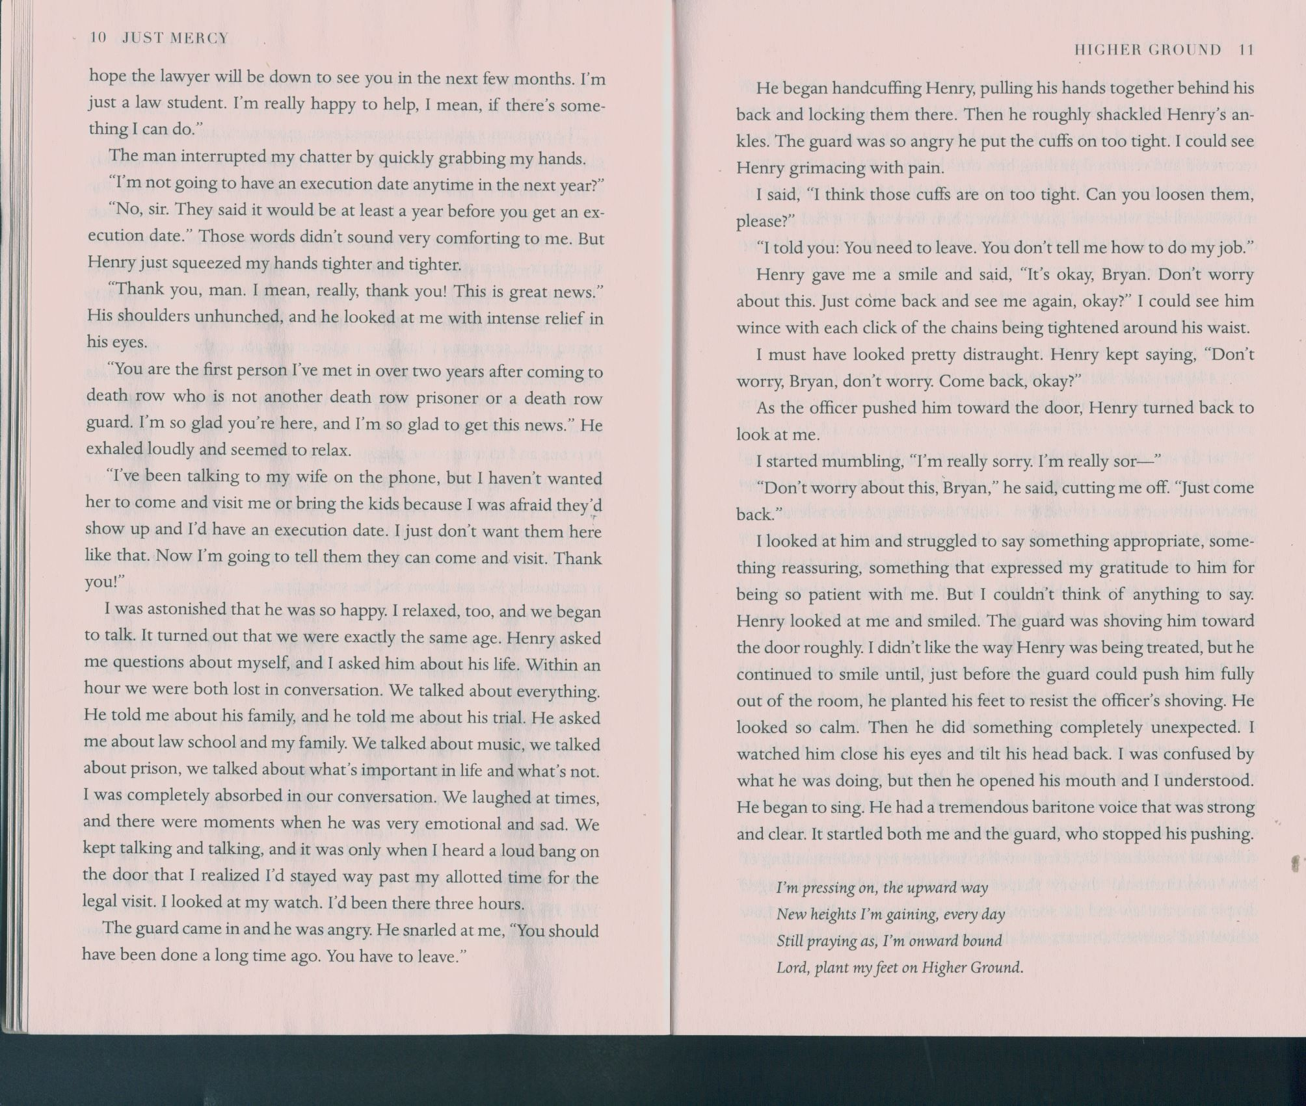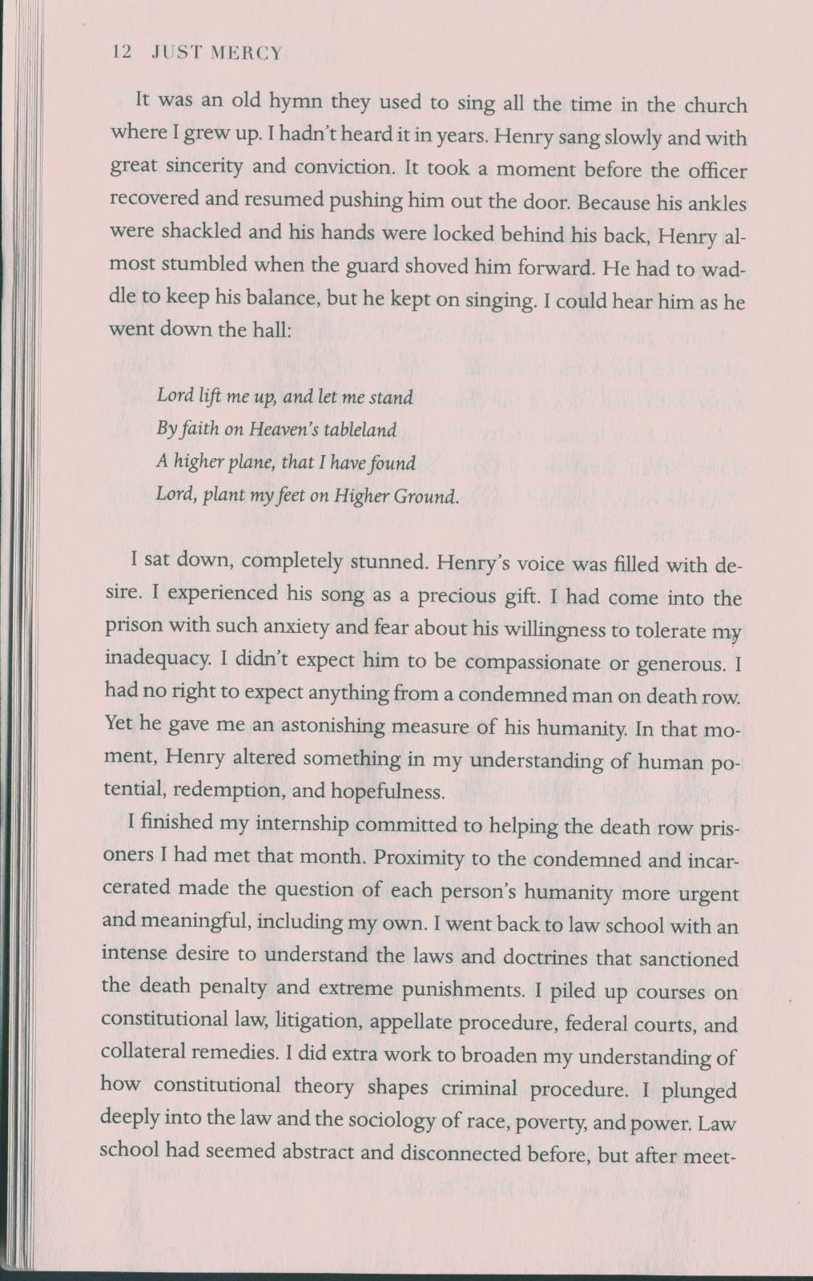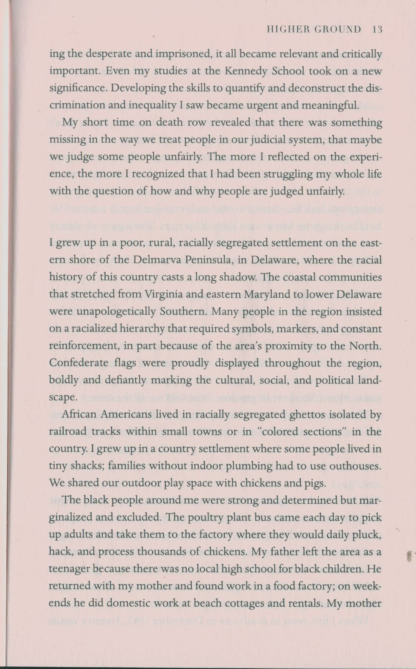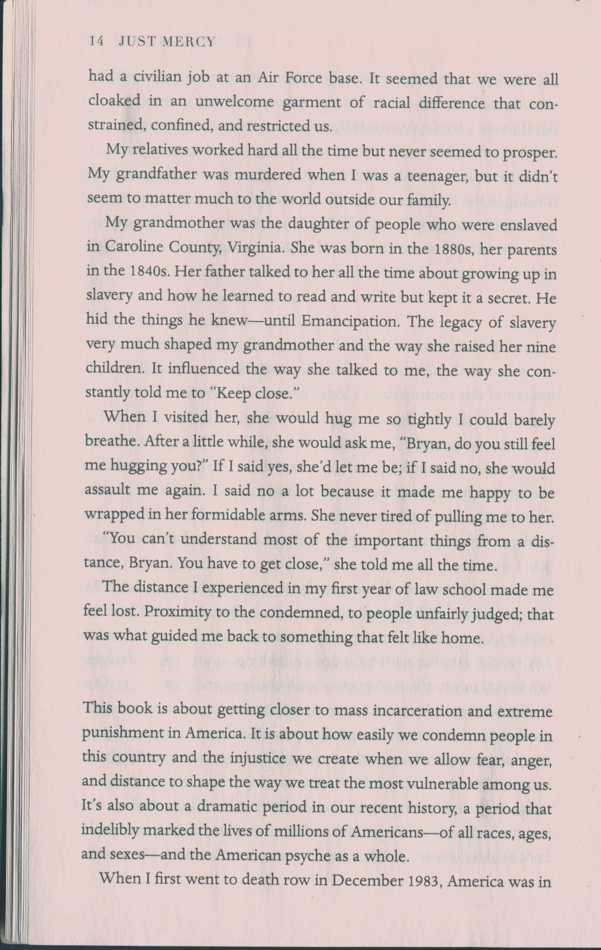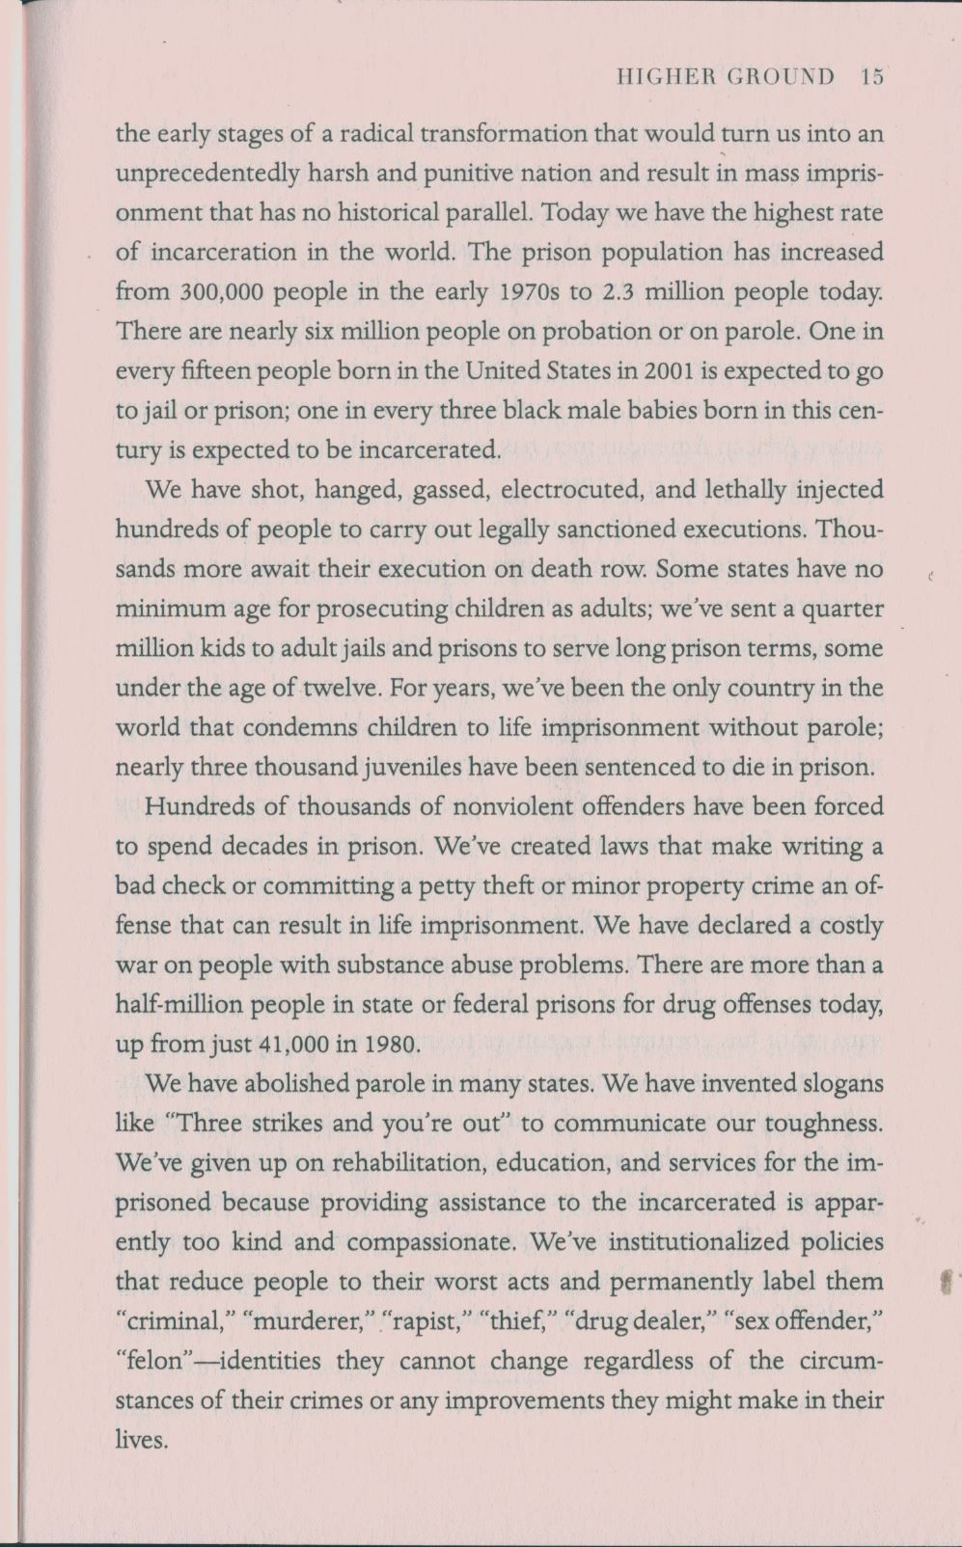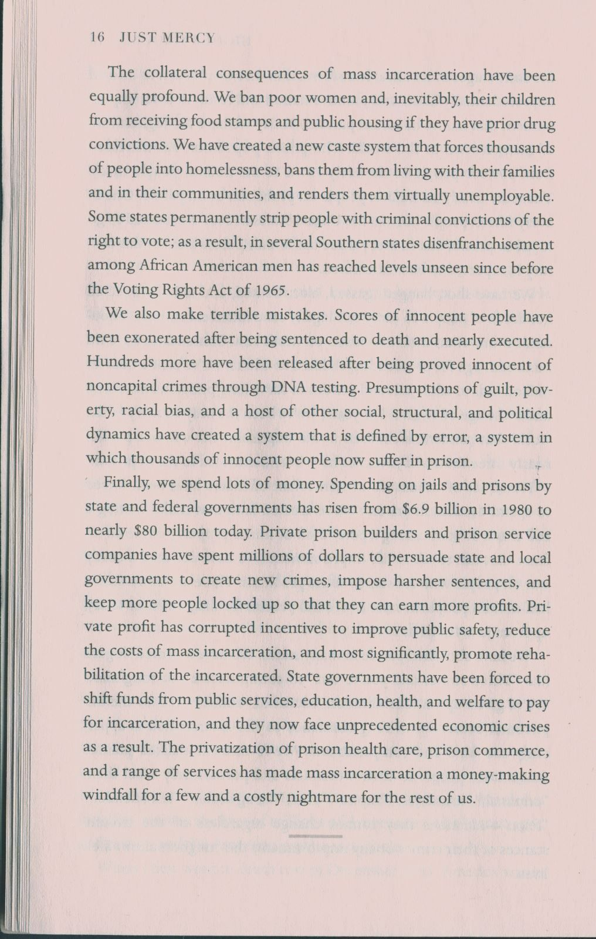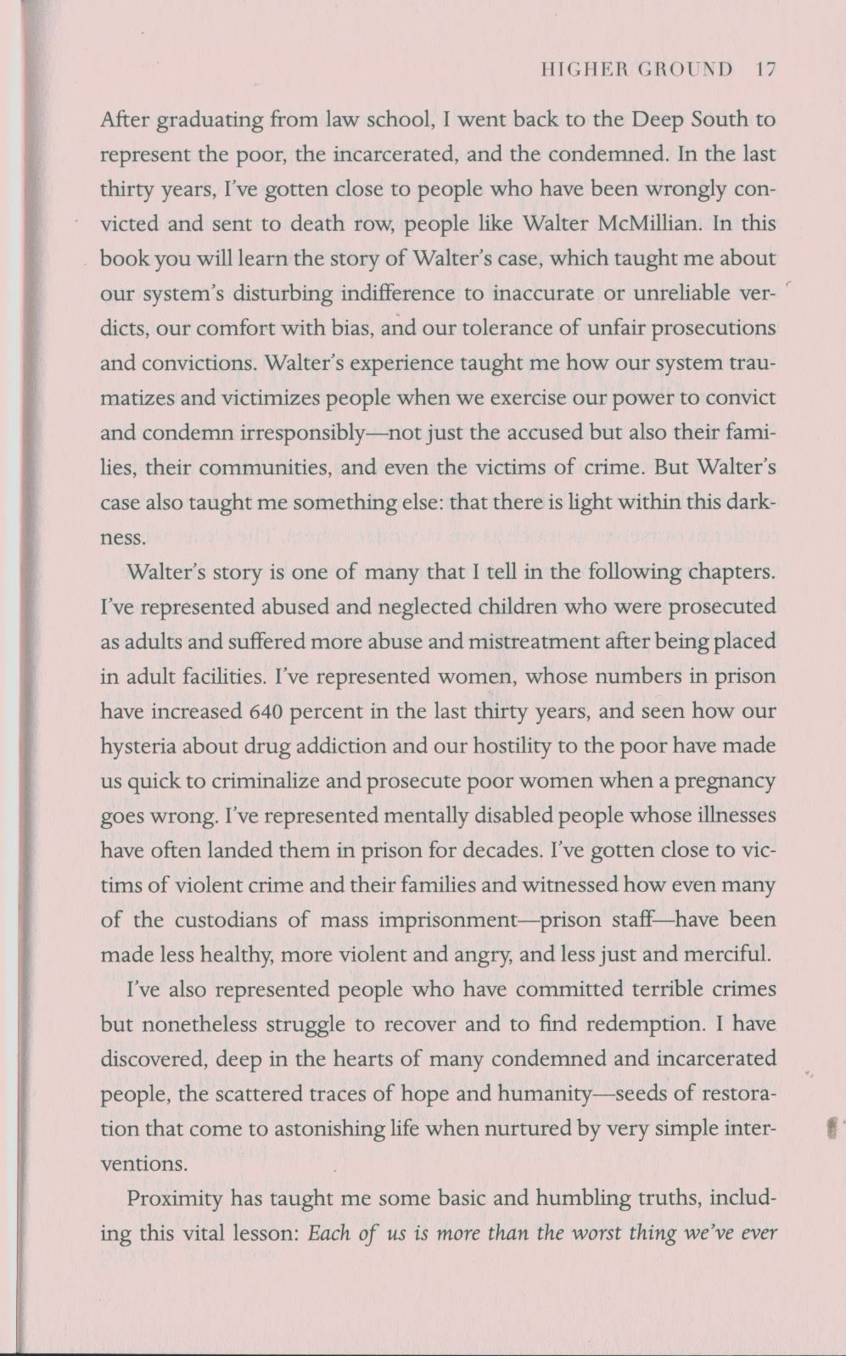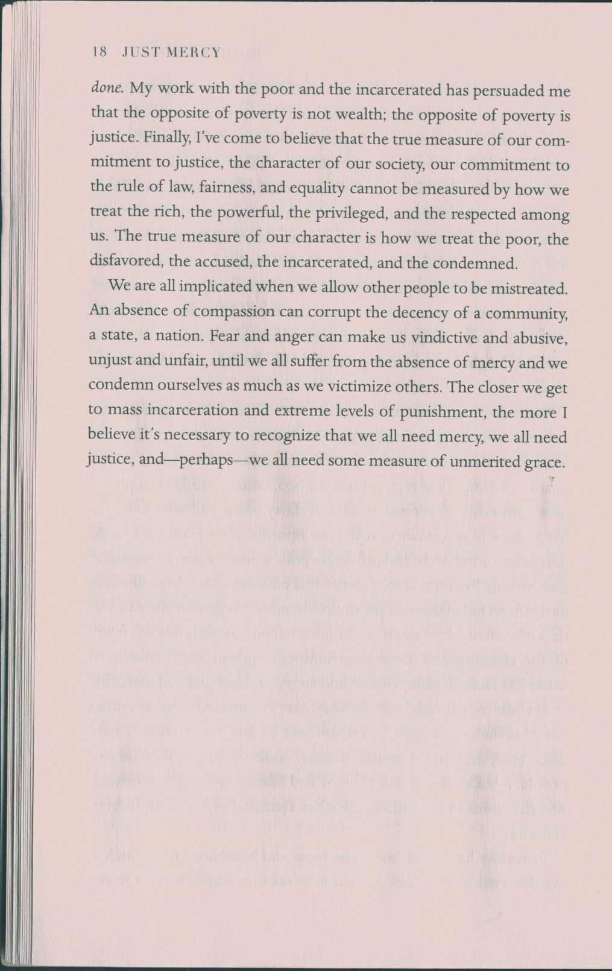

Appendix 2

PEER REVIEW IN ENGL 110/120, 111-112

Stage 1. Virtual peer review. Students are grouped in pairs and assigned to review each other’s papers as a home assignment via the Internet making comments in the textual file (in the margins and inside or using track changes) and then writing a letter to the author with suggestions including the instructor into these conversations.
Stage 2. Face-to-face meeting. After virtual peer review, groups meet in class and discuss their papers with each other, specifying what the reviewer meant and asking each other questions.
- Introduction of peer review follow up and class discussion on it.

Peer Review Follow Up
In this follow up, expand on how your paper has been reviewed by your peers and how you yourself have done the peer review.
- What were the points that your peers marked in your paper? Do you agree with them? Are you going to make appropriate changes to your paper on the basis of the comments? Why?
- How are you satisfied with the peer review you have done yourself? Have you tried your best? Do you think your peers will find your comments really helpful for improvement of their papers? Please grade your own work on this peer review and the work of your peer using the evaluation rubric below.

PEER REVIEW RUBRIC
 | 4 | 3 | 2 | 1 | Total
Participation | Student consistently participates in group work | Student participates in group work most of the time | Student participates in group work some of the time | Student does not participate in group work
Role Performance | Student effectively performs assigned role within the group:  - actively provides valuable and respectful comments;  - actively invites contribution from others;  - disagrees respectfully. | Student adequately performs assigned role on a consistent basis:  - provides valuable and respectful comments most of the time;  - invites contribution from others most of the time;  - disagrees adequately. | Student adequately performs assigned role some of the time:  - provides few valuable comments and sometimes sounds derogatively;  - reluctantly invites contribution from others;  - painfully reacts to criticism. | Student does not perform assigned role within the group:  - provides no valuable feedback; - invites no contributions from others;  - can’t handle criticism at all.
Works Towards Team Goals | Student consistently works toward team goals | Student works toward team goals most of the time | Student works toward team goals some of the time | Student does not work toward team goals
Cooperation | Student interacts well within the group and respects other group members | Student interacts adequately within the group and respects other group members | Student interacts not always adequately within the group and does not respect other group members | Student does not cooperate with other group members or makes a personal attack
Comments |  |  |  |  | /16

Appendix 3

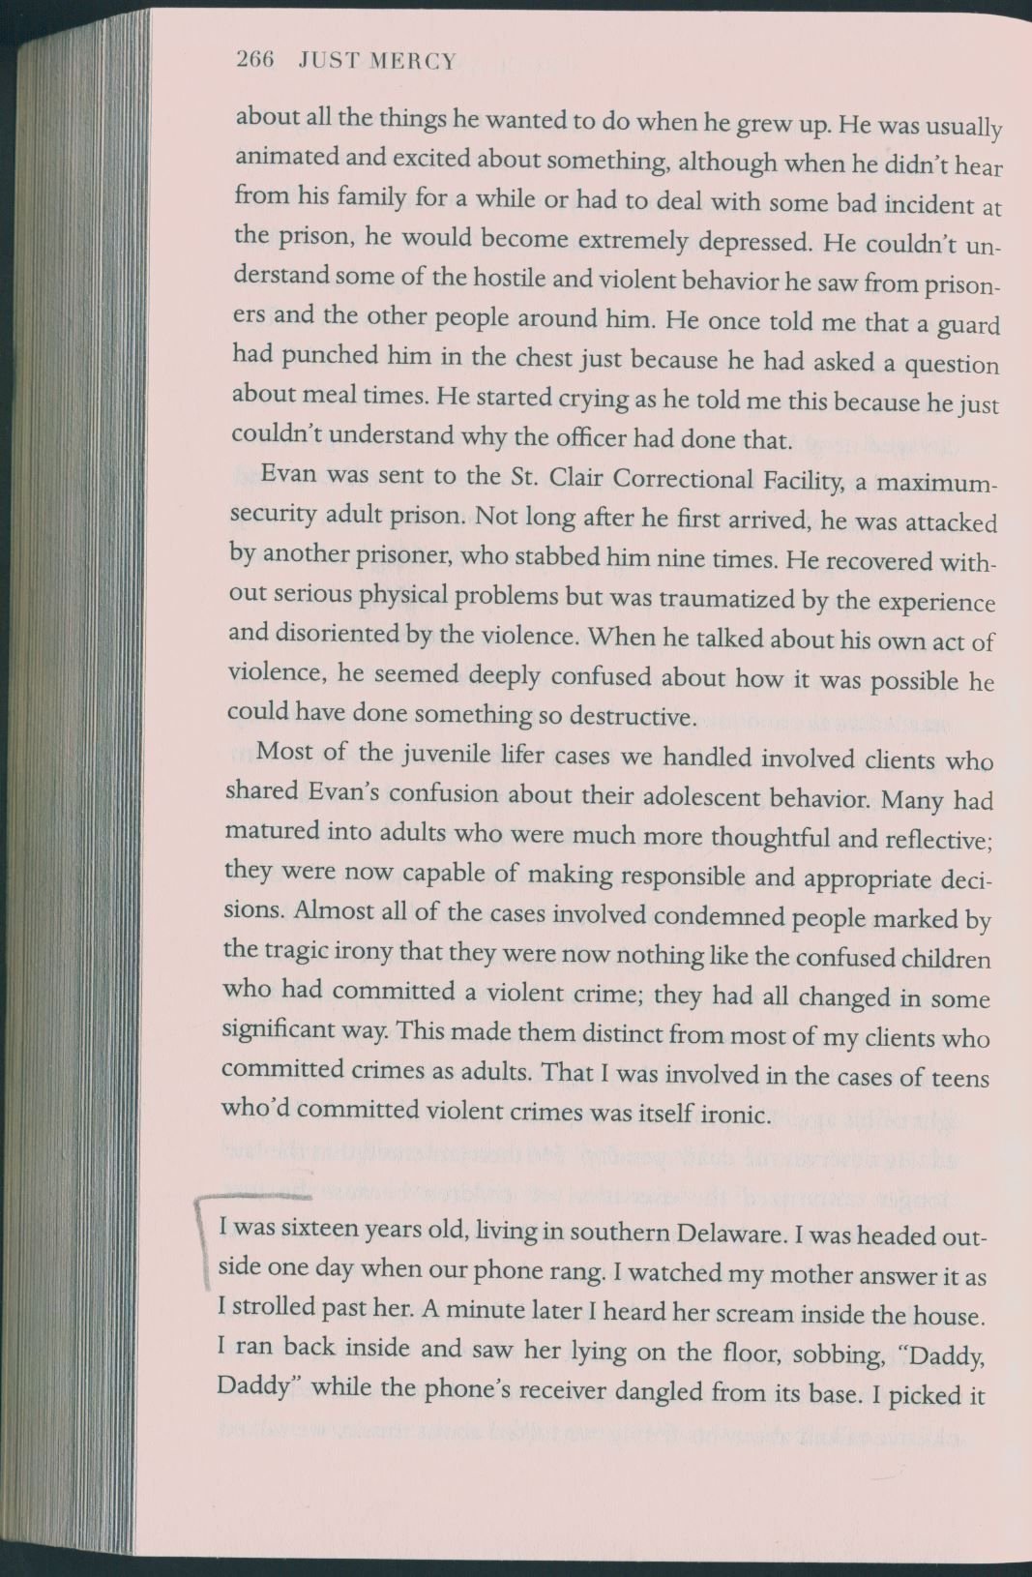
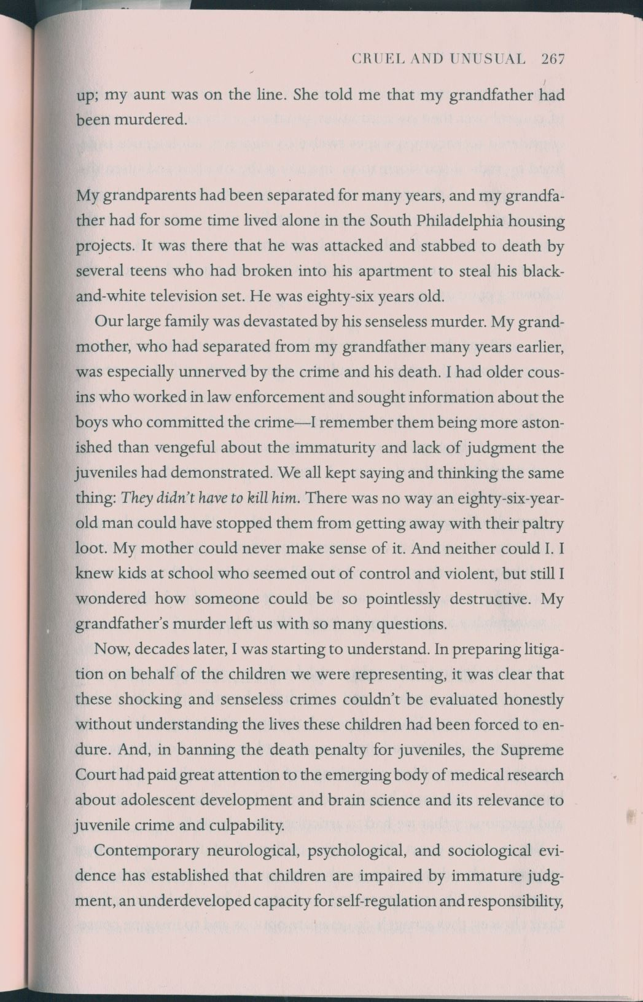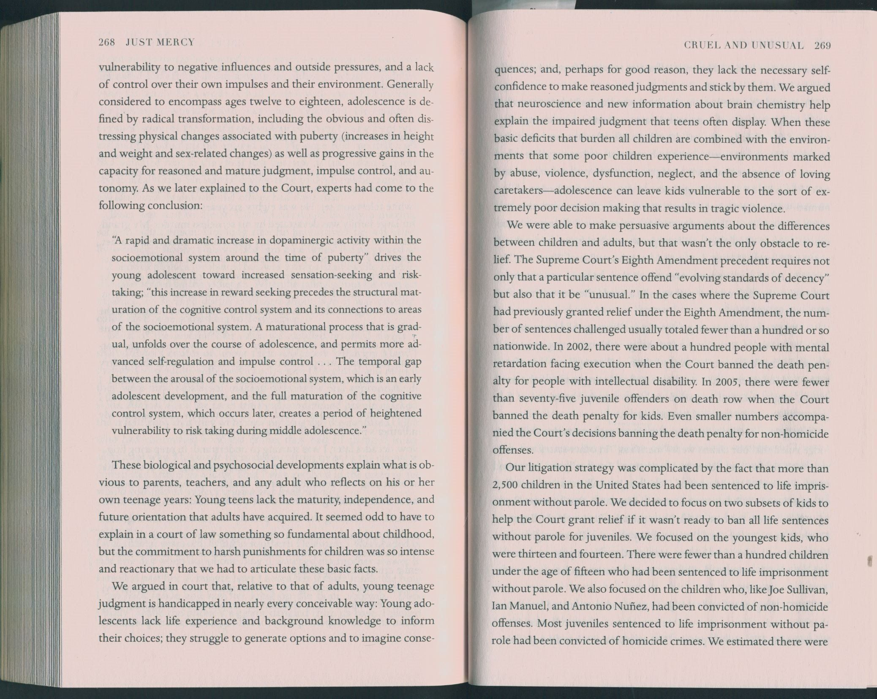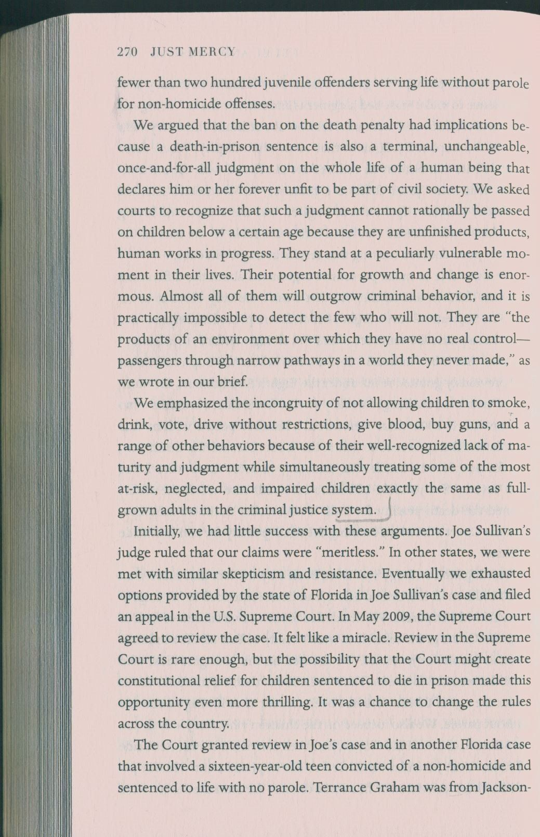

Appendix 4

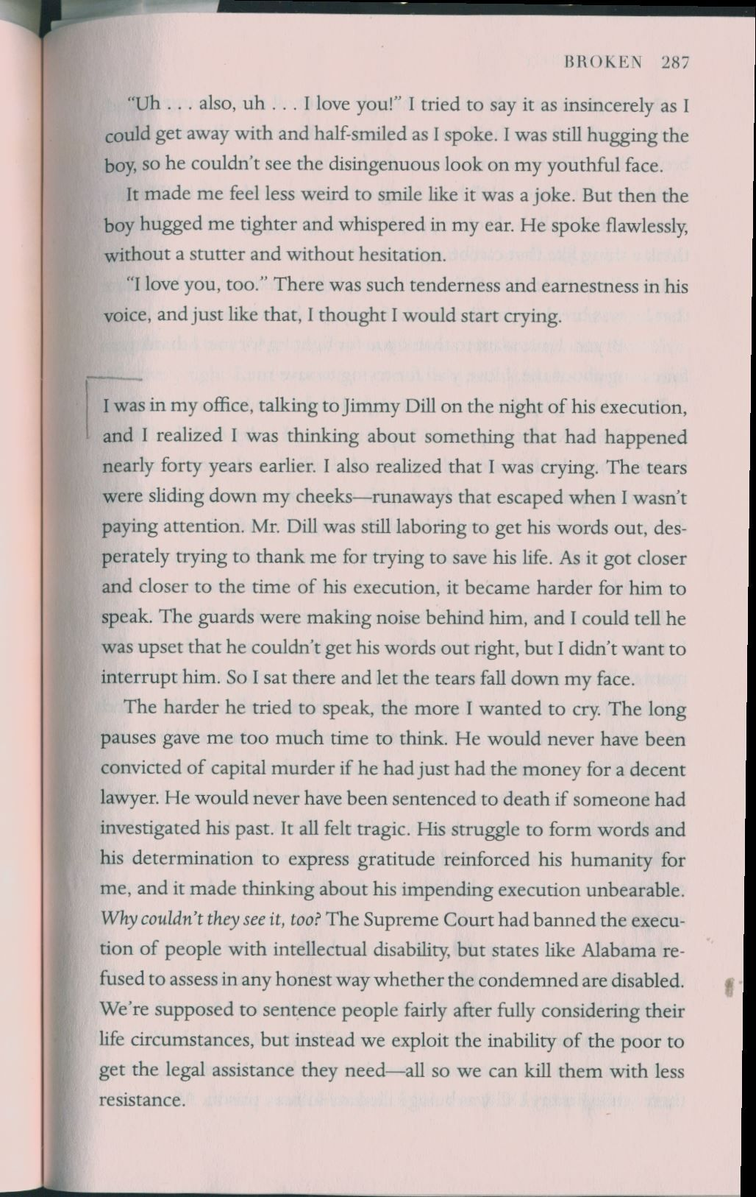
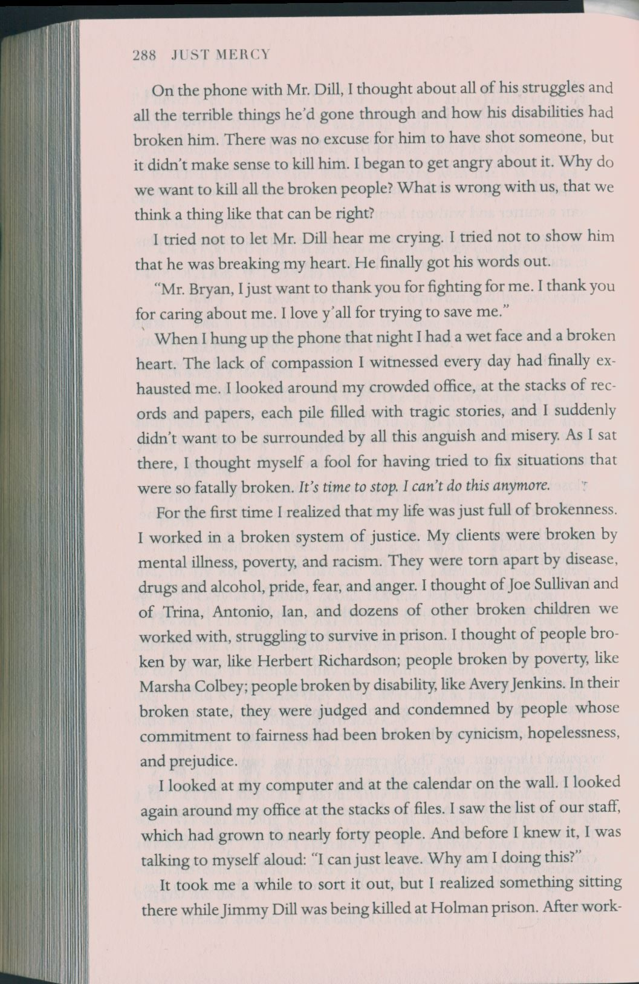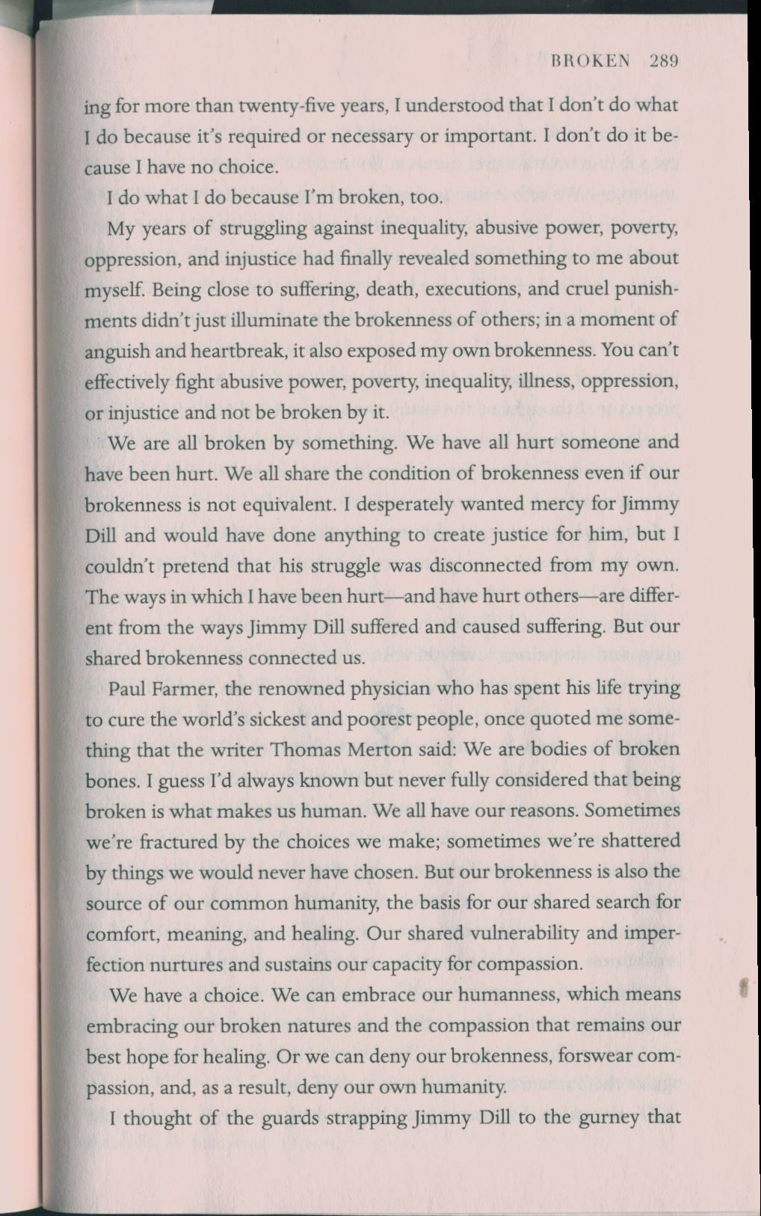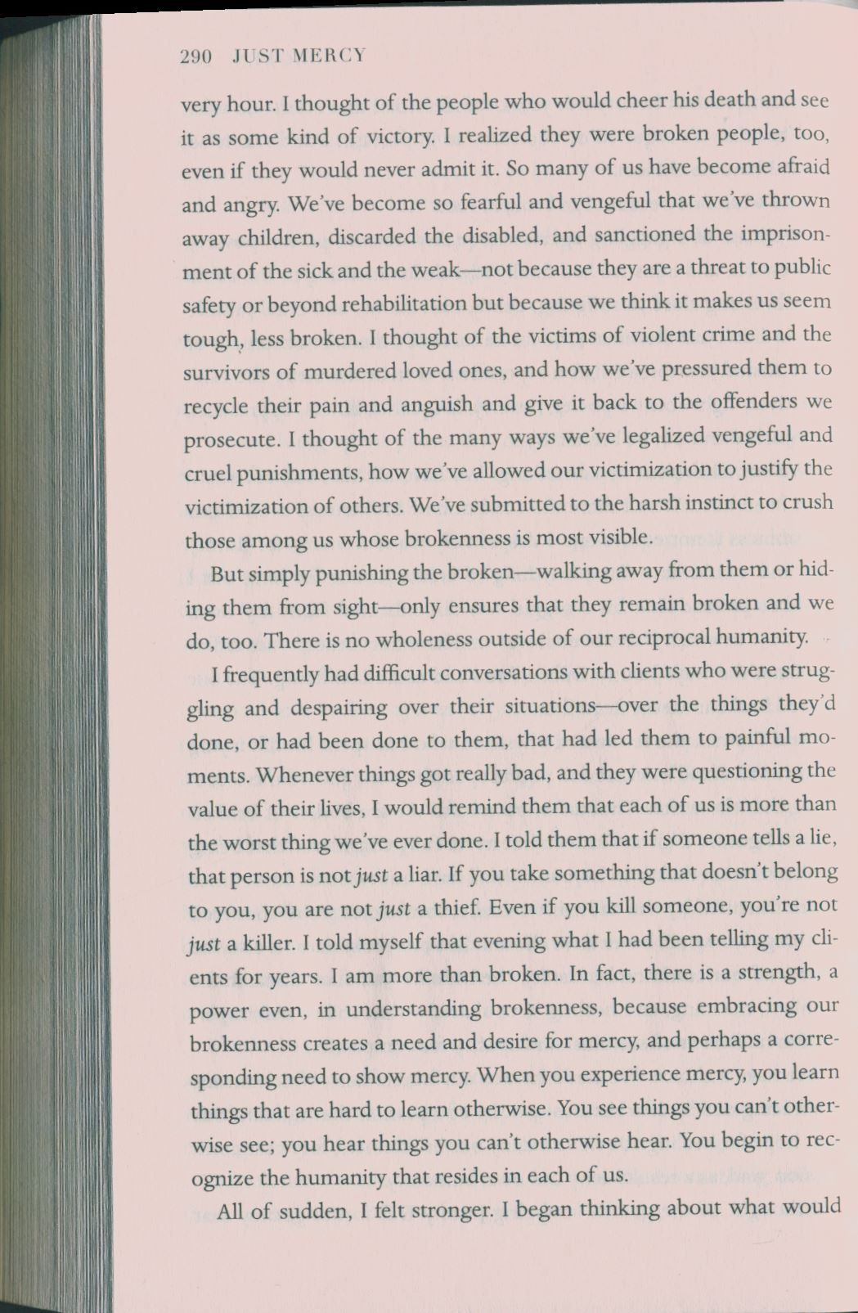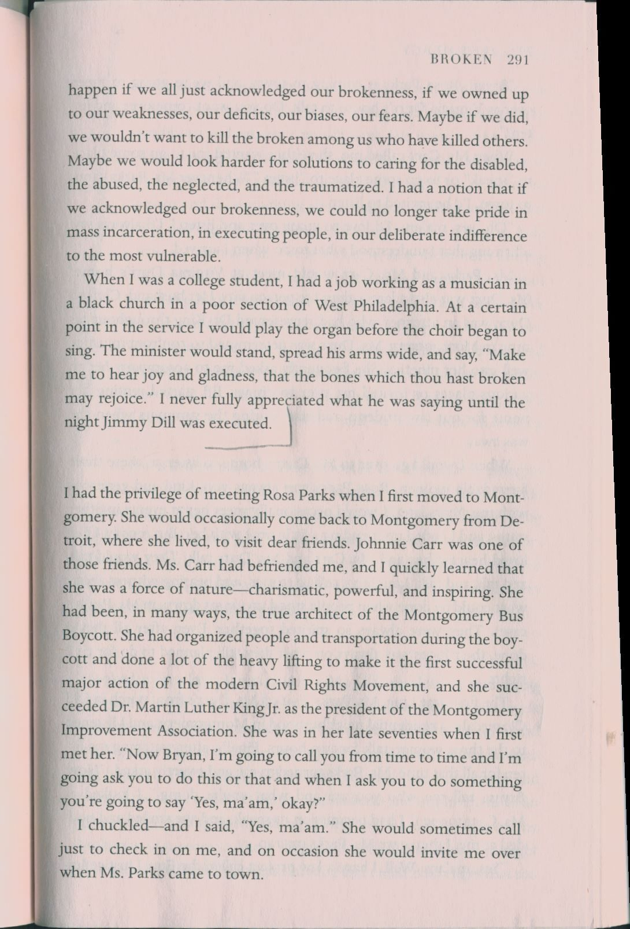

Appendix 5

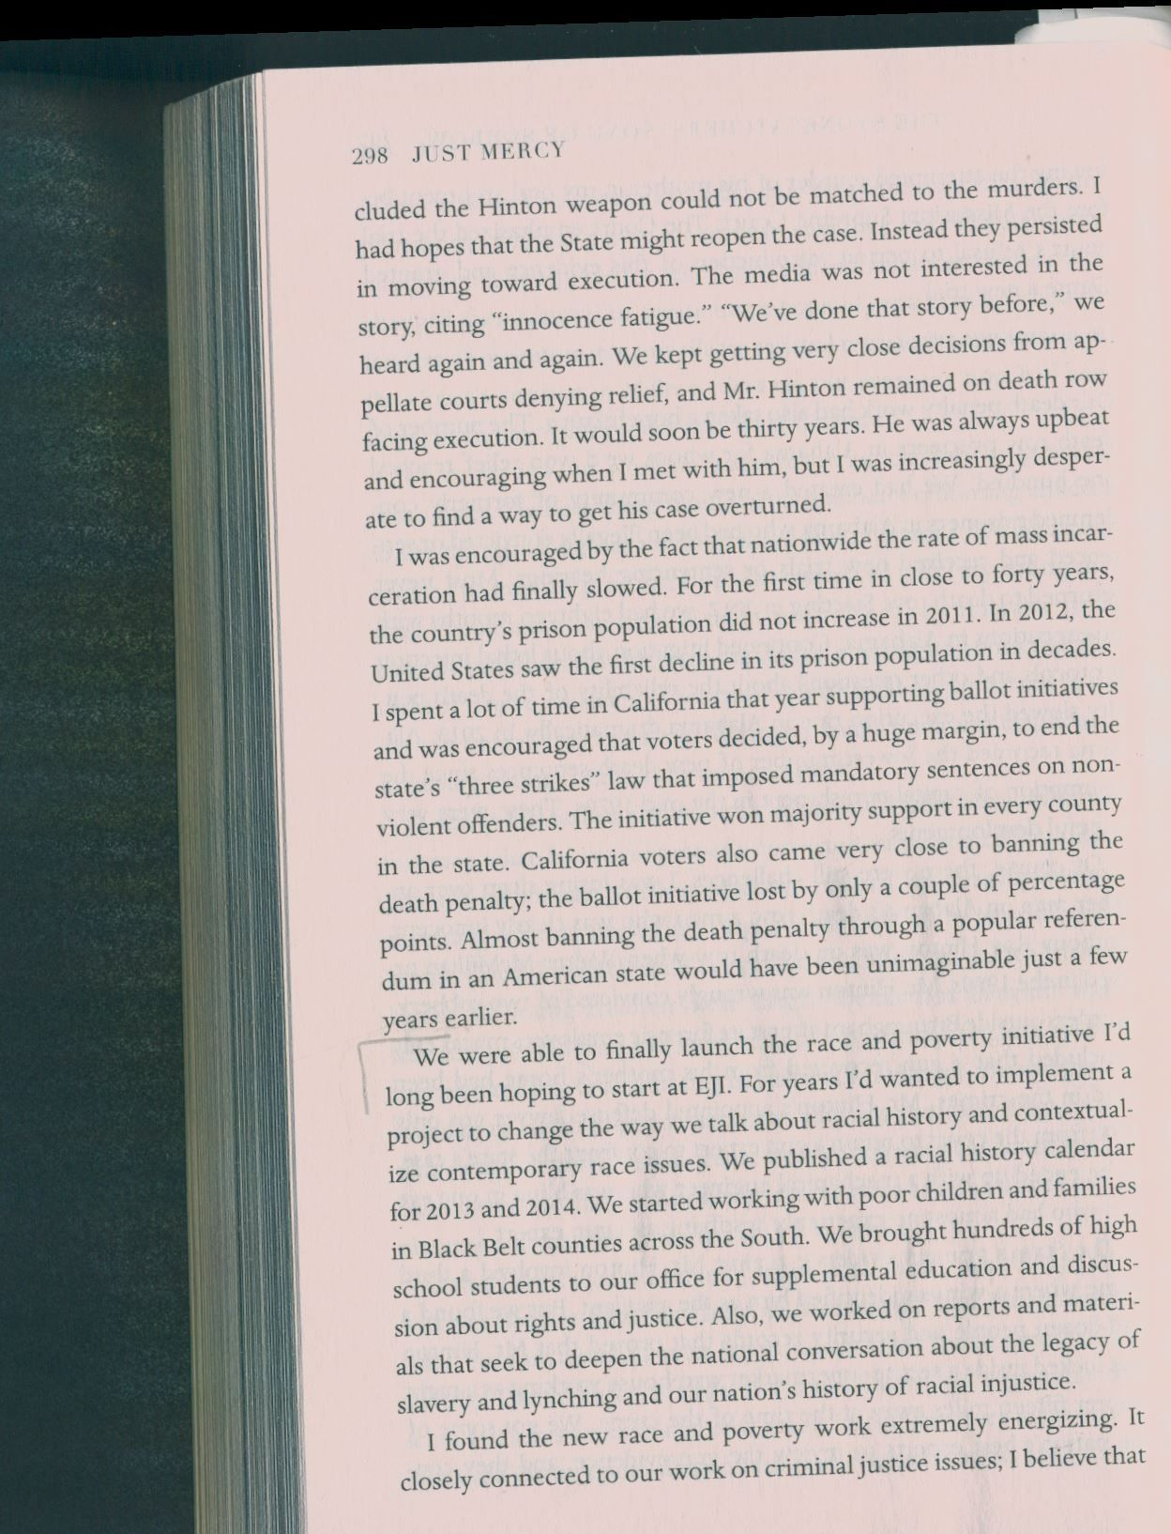
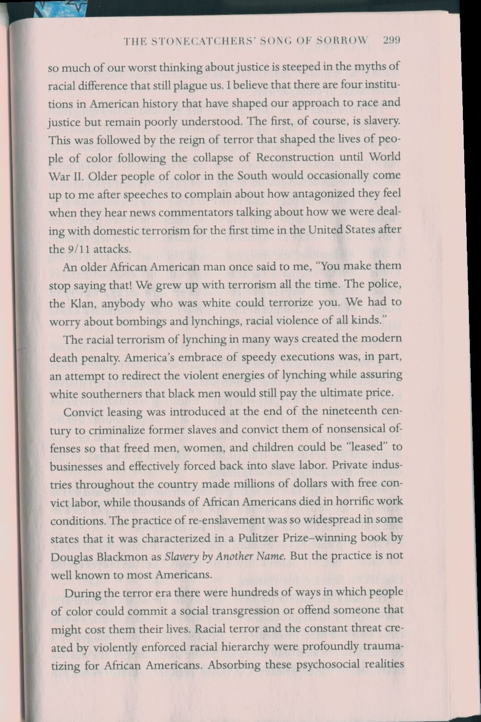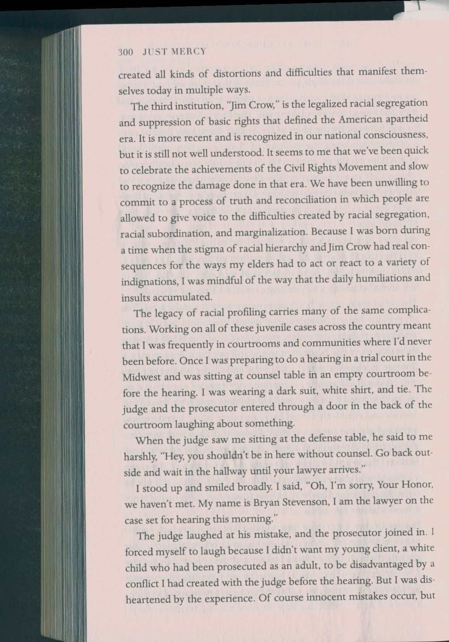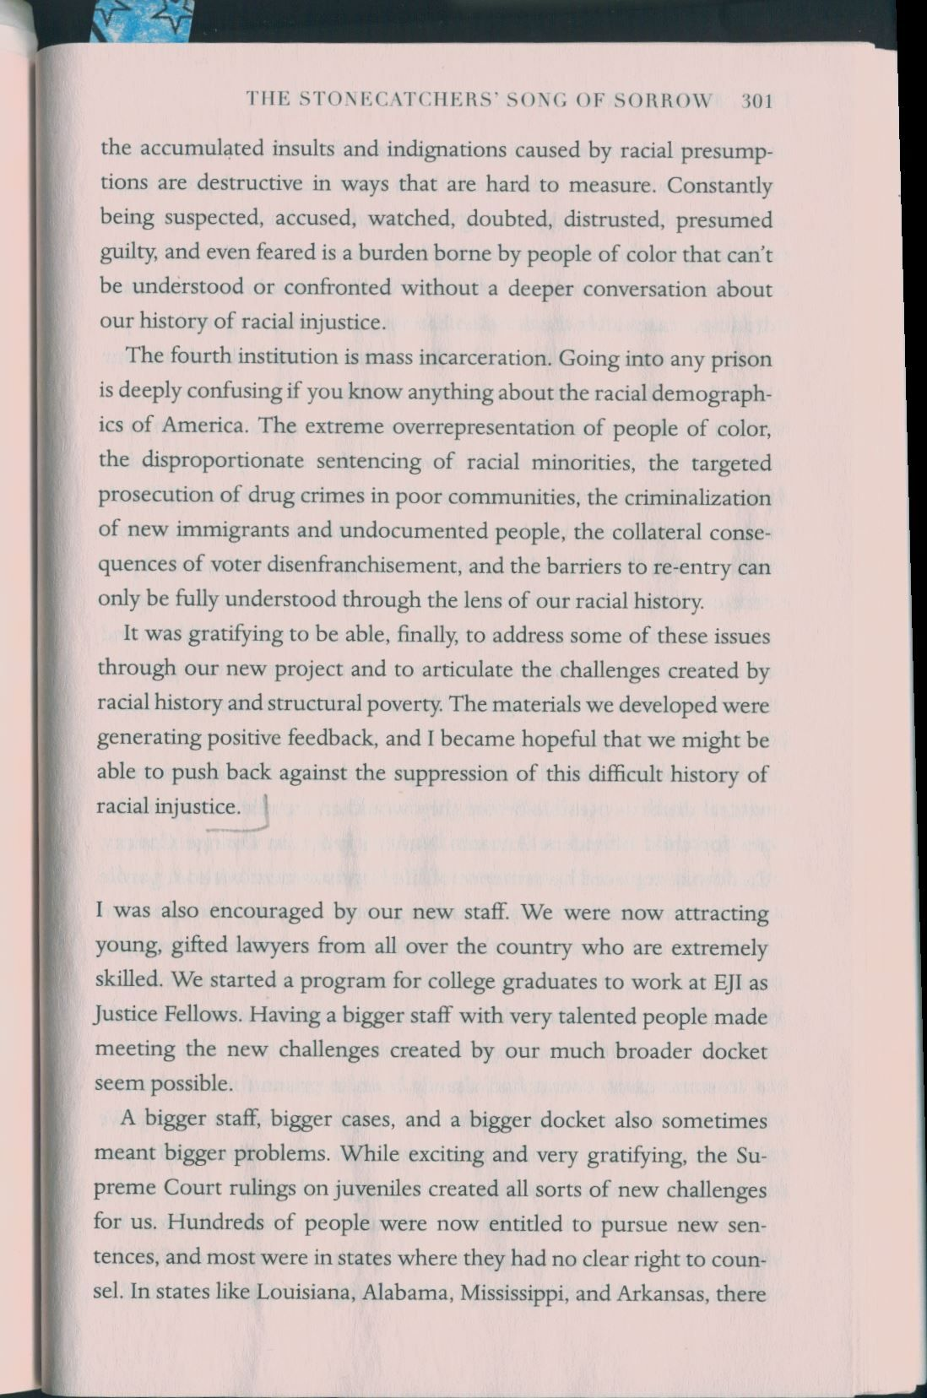

Appendix 6

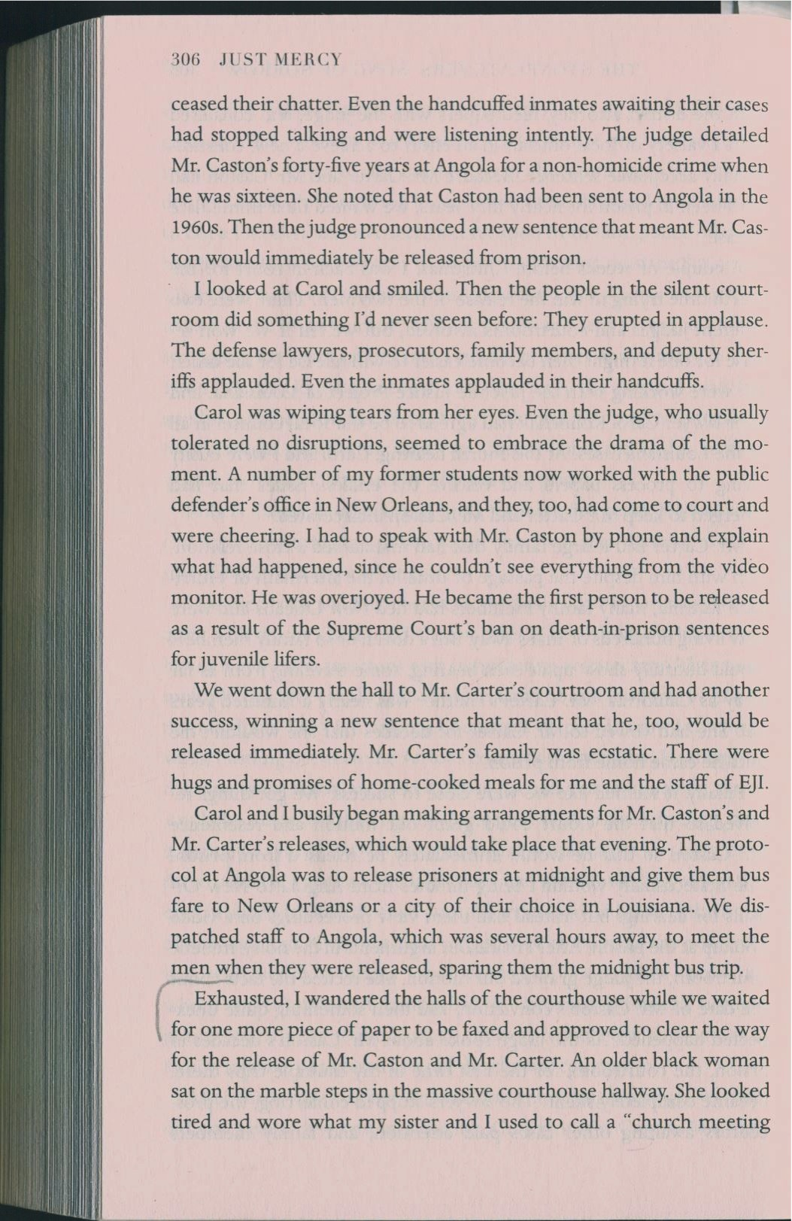
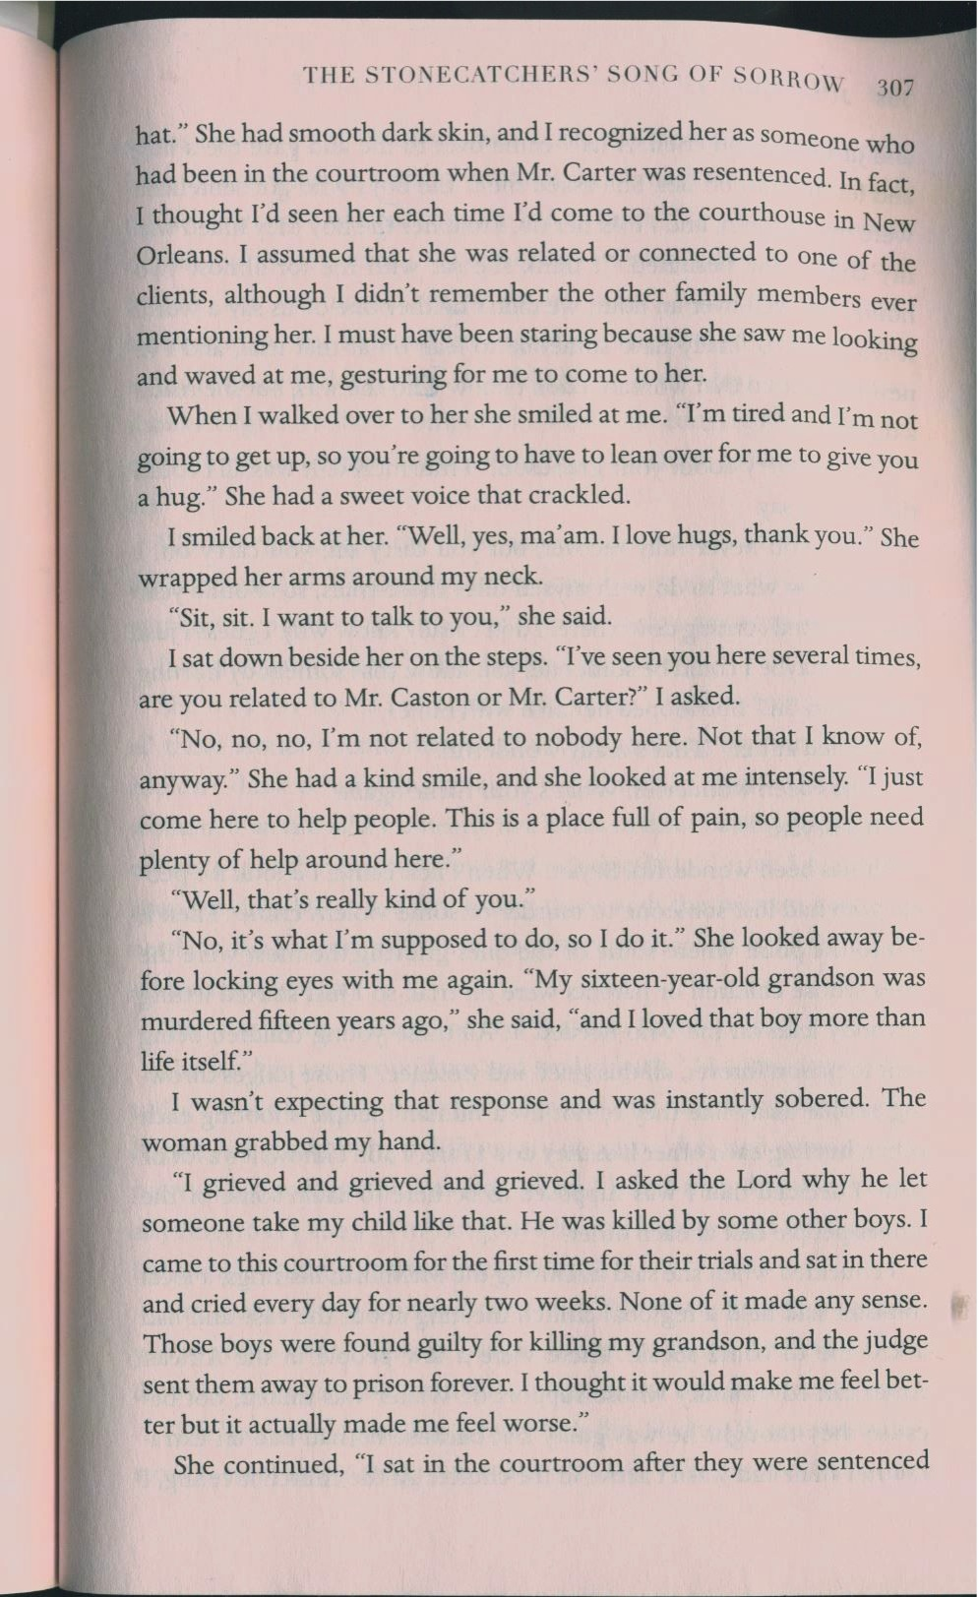
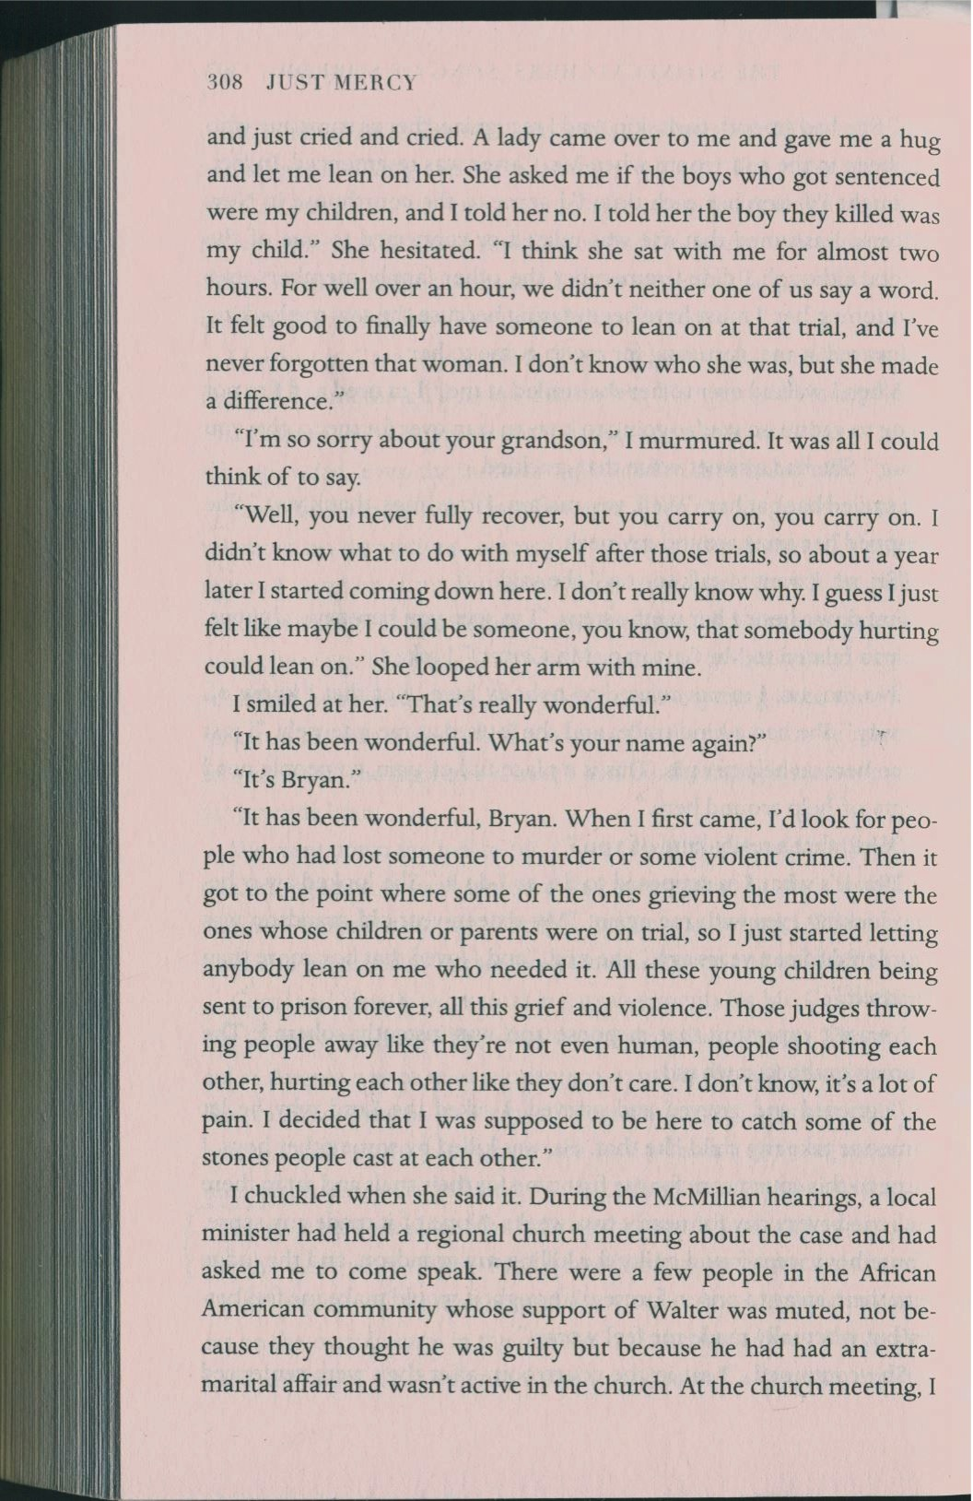
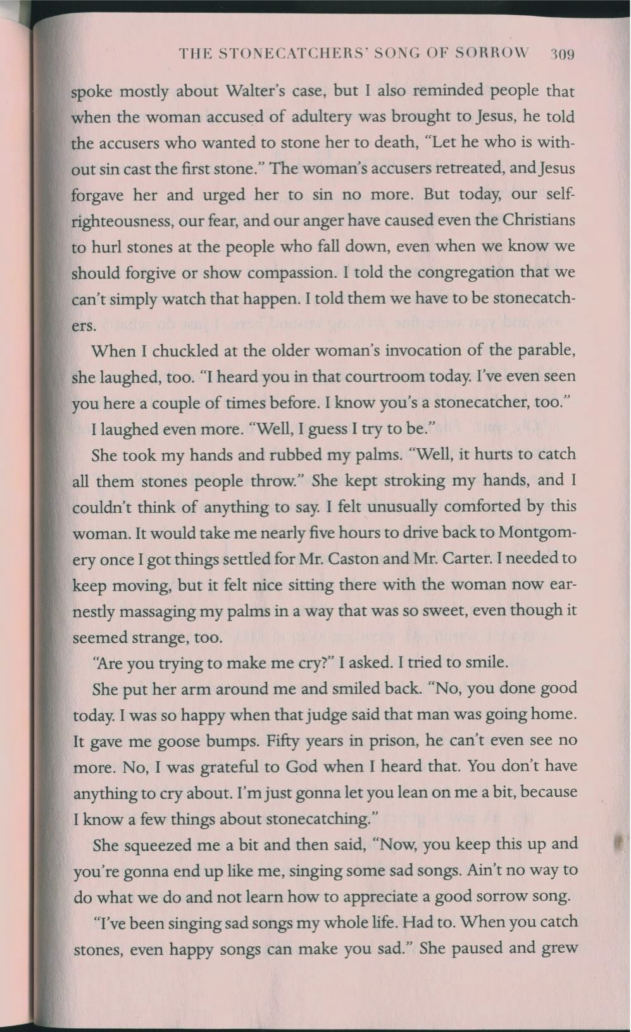
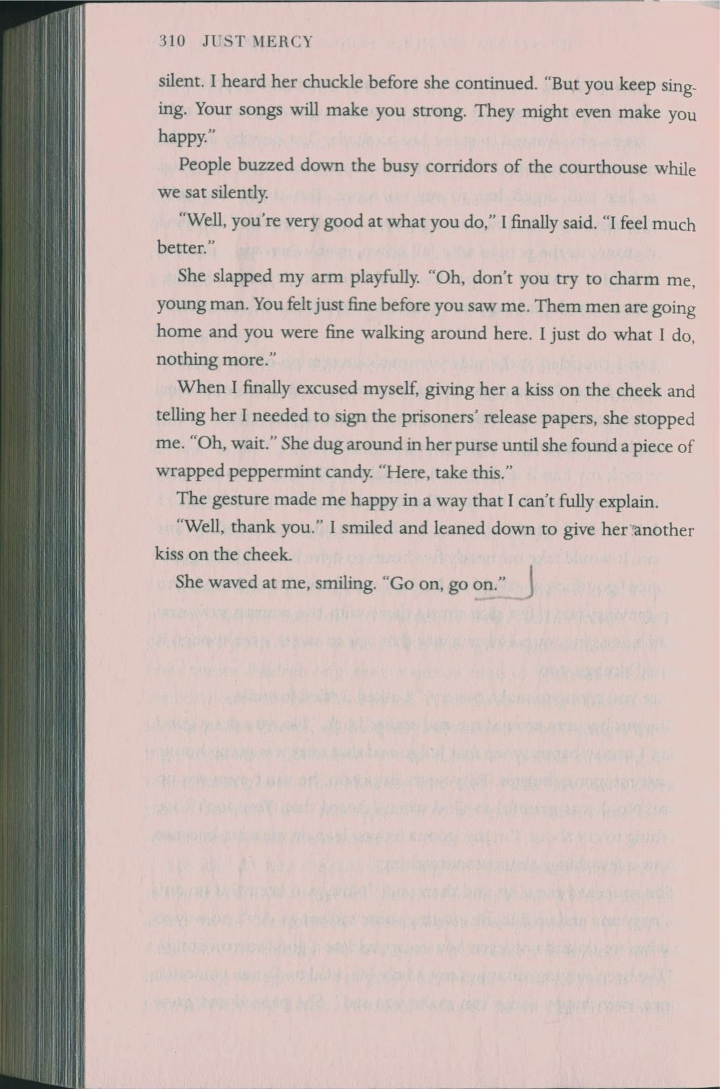

For the whole structure of peer review see Appendix.
Get ready for tomorrow’s peer review as a reviewer (assess electronic version of your peer’s paper according to the rubric writing comments in the margins and providing an overall feedback at the end; send the evaluated paper back to your peer AND to your instructor by the next class by email) and a reviewee.

